The genus Miltoniopsis consists of five species from Central and western South America. They are often referred to as the Pansy Orchids because of their large showy flowers. Miltoniopsis plants are epiphytes or lithophytes. Their pseudobulbs are tightly clustered and laterally flattened, usually subtended by leaf-like sheaths. One leaf arises from the apex of the pseudobulbs. The leaves are linear or strap shaped and usually pale green or gray-green. The erect or arching inflorescences are axillary and unbranched, bearing up to ten flowers..
The flowers are large, wide and flat. The colors range from white to lavender with red or pink markings. The sepals and petals are similar although the petals are somewhat reflexed in the middle. The lip is large and flat. It bears small horns at its base that curl up and around the column. The lip is often marked with red or purple radiating lines and has tooth or rib-like projections at its base. The column is short with a distinct terminal cap. Pollinia are two.
There are five recognized species, three of which have been used in thousands of orchid hybrids.

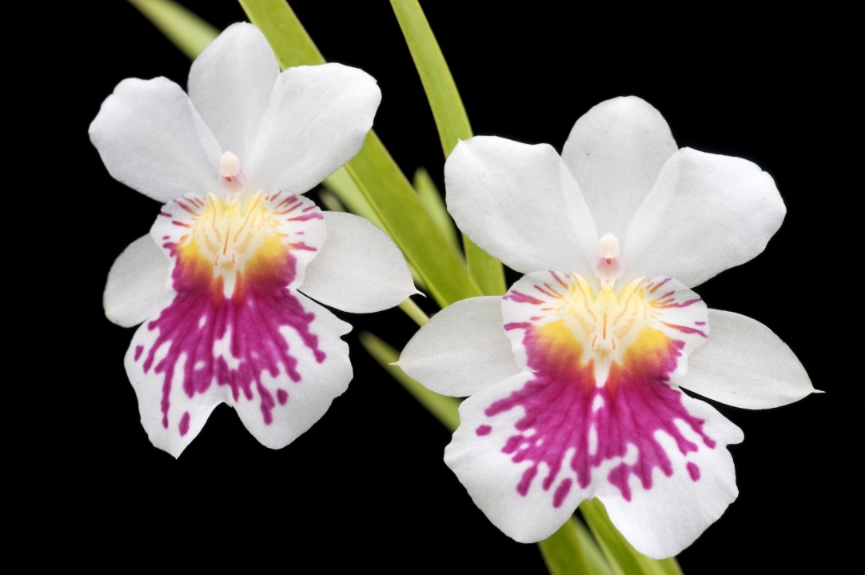
Miltoniopsis Phalaenopsis ‘Golden Gate’

