Significant Hybrid Genera using Miltoniopsis
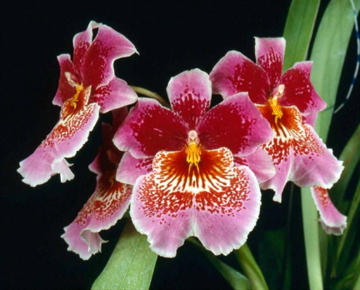
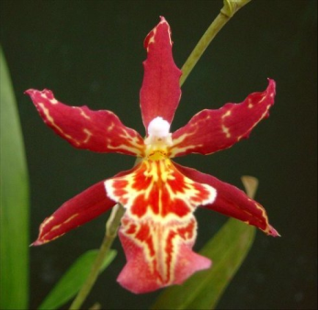
Of all of the progeny of the Miltoniopsis building block species (phalaenopsis-1795, roezlii-2429, vexillaria-2593), 1806 are crosses within the genus Miltoniopsis. Except for crosses with Oncidium, the genus Miltoniopsis has not been a great sexual partner in the orchid world. Oncidopsis (Miltoniopsis X Oncidium) is the only significant hybrid genus using Miltoniopsis with 712 registered hybrids. Photographs or Award Descriptions are scarce for the 440 crosses made before 1070. Of the 275 later crosses, a few observations can be made. The characteristics passed on to the progeny range from very Oncidium looking flowers, as in Oncidopsis Oncidopsis Fire Engine Fire Engine, to very pansy like forms as in Oncidopsis Memoria Martin Orenstein and everything in between. The waterfall pattern of the Miltoniopsis lip seems be fairly dominant in in most of the hybrids. The more open form of Oncidium is evident in many of the intermediate forms. A dozen or so other hybrid genera using Miltoniopsis have been created, but in numbers, progeny and awards, they are insignificant. Oncostelopsis (Miltoniopsis x Phynocostyle x Oncidium) has 24 registered hybrids. Milmiltonia (Miltonia x Miltoniopsis) has 25 crosses and Cyrtoniopsis (Miltoniopsis x Cyrtochilum) with 17 hybrids registered. In spite of this lack of promiscuousness, crosses within the genus Miltoniopsis are greatly varied and beautiful .

Oncidopsis Memoria Martin Orenstein

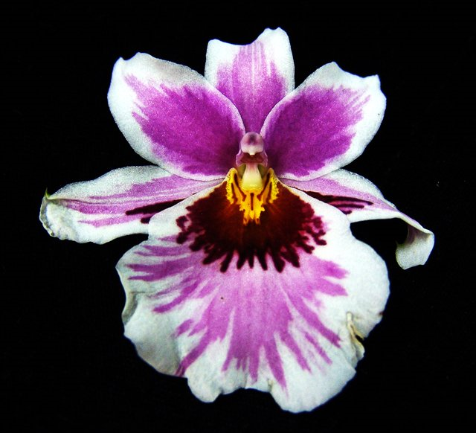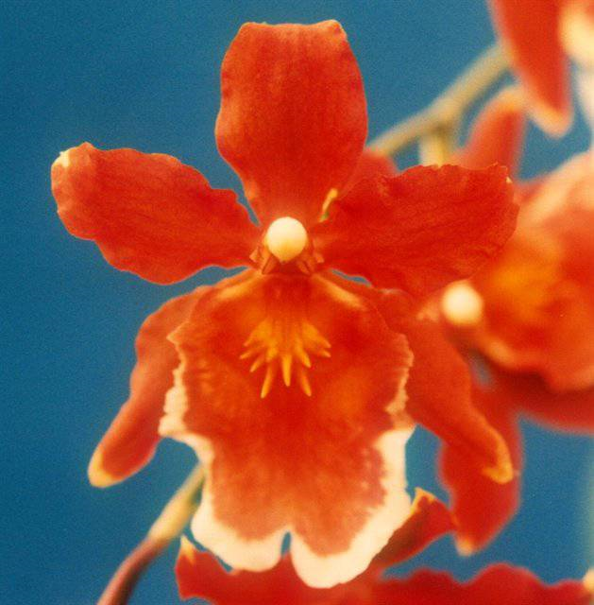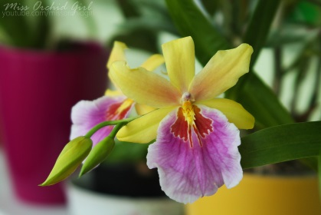
Cyrtoniopsis Futuresque Oncostelopsis Fiona Isler Milmiltonia Sunset 6

