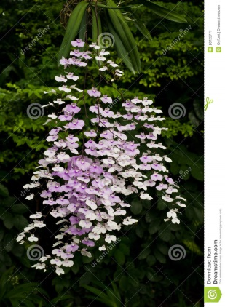
Ionopsis utricularioiodes – HCC
Two hundres and twenty flowers on two arched, branched inflorescences; flowers white suffused pink, faintly striped fuchsia; lip lavender proximally, column white; substance light; texture matte; flower slightly fragrant.

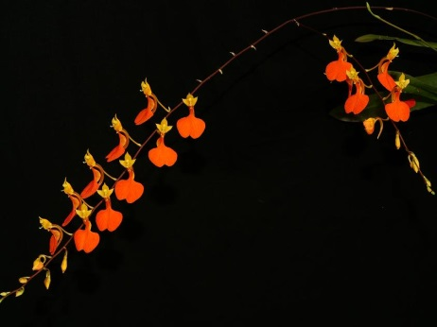
Comparetta ignea – CBR
Fourteen flowers and eleven buds on one branched inflorescence; sepals and petals lemon yellow, faintly striped orange; lip flat, brilliant orange, spur light orange; substance firm; texture matte; recognized for rarity.

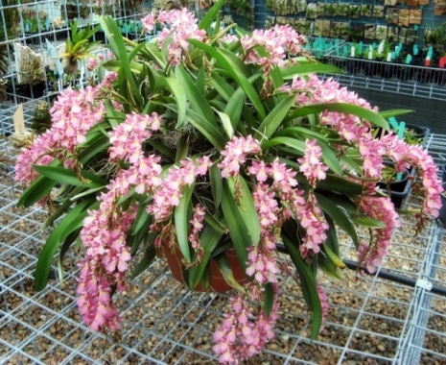
Rodriguezia Burgundy – CCM
Two hundred and thirty flowers on fourteen arching inflorescences on a well grown plant; flowers rose-pink; petals rose, darker toward the margins; lip rose with yellow callus, grading to orange at the tip; substance medium; texture crystalline.

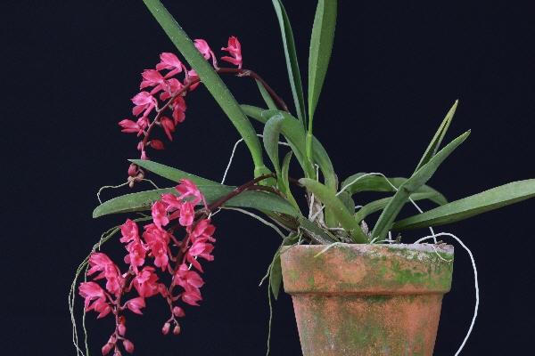
Rodriguezia lanceolata – AM
Thirty two flowers and seventeen buds on three pendulous inflorescences; flowers medium coral with lighter pink medially on sepals and petals; fused lateral sepals darker coral; lip rose-pink, lighter at base, callus yellow, anther cap white; substance firm; texture crystalline.

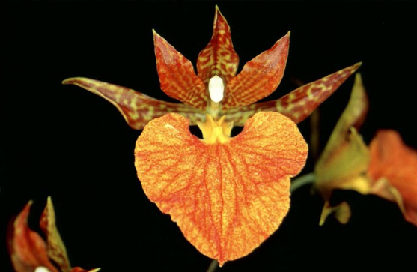
Rhynchorettia Mandarine – HCC
Eleven flowers on two inflorescences; sepals yellow-green, spotted orange, lateral petals yellow-green, spotted and lined orange; lip light yellow, orange veined; column green, anther cap white; substance good; texture matte.

