BUILDING BLOCK DATA

Species Comparetta falcata
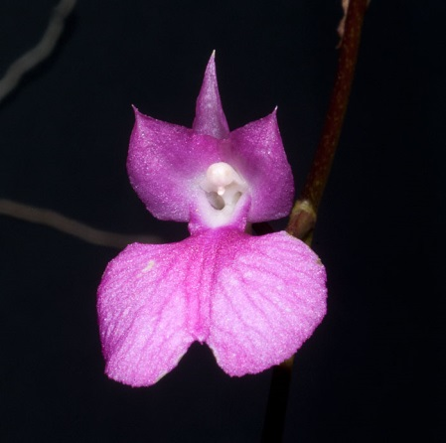

Botanical Varieties (if any):

Synonyms: Burlingtonia venusta, B. fragrans, B. knowlesii, Rodriguezia flavida

Awards: None

Origin | HCC | AM | FCC | CCA | CCM | ACC | Total
Years
Other awards and when given:

Outstanding clones of species and reason they are considered outstanding:

F-1 Hybrids:
Before  1940 | 1940-49 | 1950-59 | 1960-69 | 1970-79 | 1980-89 | 1990-99 | After 1999
 |  | 2 | 5 | 3 | 8 | 7 | 16
Total Progeny:
Before  1940 | 1940-49 | 1950-59 | 1960-69 | 1970-79 | 1980-89 | 1990-99 | After 1999
 |  | 2 | 5 | 8 | 20 | 38 | 222

Outstanding progeny and reason they are considered outstanding:
Gometta is a cross between Compretta falcate and Gomesa echinata. The yellow genes of echinata and the pink of falcate have produced a beautiful red in Royal Marble.

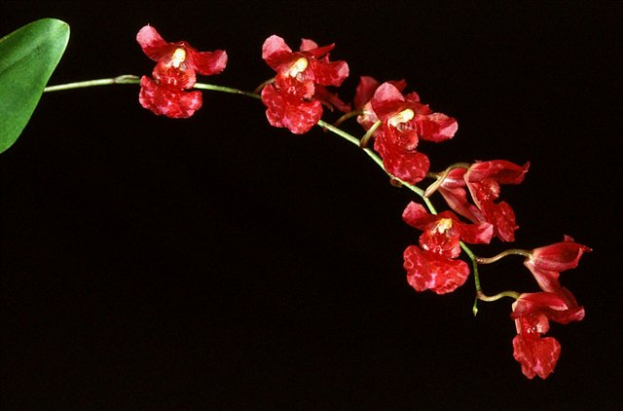
Gomettia Royal Marble AD/AOS

Desirable characteristics which can be passed to progeny:
It is hard to say what characteristics are passed on because of scarce photos, descriptions or literature for this group.

Undesirable characteristics which can be passed to progeny:

Other information:

