BUILDING BLOCK DATA

Species Comparetta macroplectron

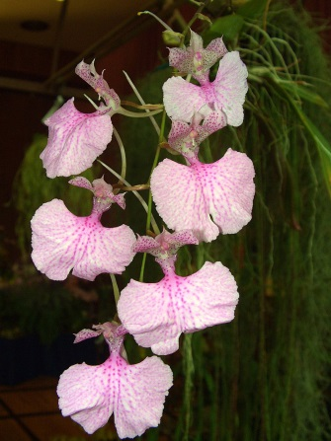
Botanical Varieties (if any):

Synonyms: Burlingtonia venusta, B. fragrans, B. knowlesii, Rodriguezia flavida

Awards:

Origin | HCC | AM | CBM | CCA | CCM | AWD | Total
 | 3 | 5 | 2 | 0 | 3 | 2
Years | 1980-2010 | 1977-2013 | 1967-1977 |  | 1973-1981 | 2007-2015
Other awards and when given:

Outstanding clones of species and reason they are considered outstanding

F-1 Hybrids:
Before  1940 | 1940-49 | 1950-59 | 1960-69 | 1970-79 | 1980-89 | 1990-99 | After 1999
 |  |  | 1 | 8 | 10 | 3 | 4
Total Progeny:
Before  1940 | 1940-49 | 1950-59 | 1960-69 | 1970-79 | 1980-89 | 1990-99 | After 1999
 |  |  | 1 | 8 | 14 | 4 | 9

Outstanding progeny and reason they are considered outstanding:
This cross is another interesting combination of a yellow Gomesa echinata and a pink Compretta that produces a bright red hybrid. The form of the Gomesa comes through as does the spotting of the Compretta.
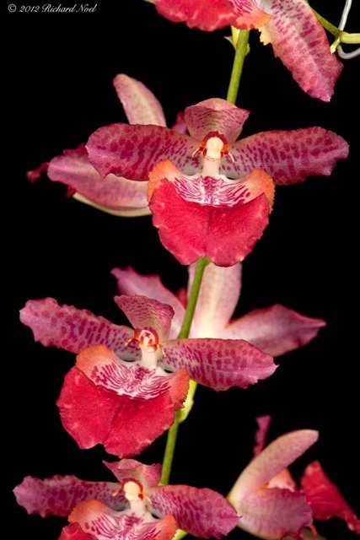
Gometta Tropical Jujubees ‘Malcolm’ AM/AOS

Desirable characteristics which can be passed to progeny:
As with the other Comprettia hybrids, there are few photos or descriptions to help.

Undesirable characteristics which can be passed to progeny:

Other information:

