BUILDING BLOCK DATA

Species Comparettia speciosa

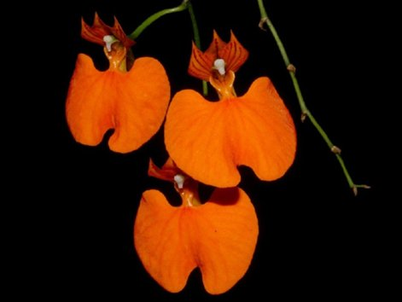
Botanical Varieties (if any):

Synonyms:

Awards:

Origin | HCC | AM | FCC | CCA | CCM | ACC | Total
 | 4 | 2 | 0 | 1 | 11 | 3
Years | 1977-2011 | 1982-1990 |  | 1958 | 1960-2011 | 1993-1999
Other awards and when given:

Outstanding clones of species and reason they are considered outstanding:

F-1 Hybrids:
Before  1940 | 1940-49 | 1950-59 | 1960-69 | 1970-79 | 1980-89 | 1990-99 | After 1999
 |  |  | 8 | 4 | 14 | 9 | 12
Total Progeny:
Before  1940 | 1940-49 | 1950-59 | 1960-69 | 1970-79 | 1980-89 | 1990-99 | After 1999
 |  |  | 8 | 8 | 16 | 12 | 13

Outstanding progeny and reason they are considered outstanding:
This cross between Rhynchostele bictoniensis and Comprettia speciosa has won 13 awards including 1 AM, 5 HCC and 2 JC’s. Its great color and venation patterning was commended.

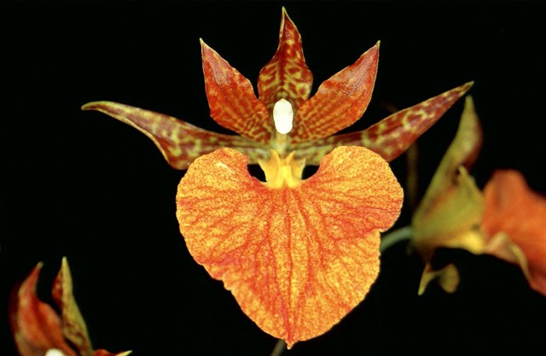
Rhynchorettia Mandarine ‘Orange Jewell’ HCC/NZOS

This hybris is 75% C. speciosa with a quarter Rhynchostele uro-skinneri. It gets its great color from speciosa and form and form more from uro-skinneri.

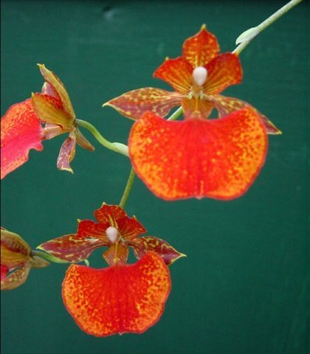
Rhynchorettia Ronald Ciesinski ‘Once and Again’ AM/AOS

Desirable characteristics which can be passed to progeny:
The color is the most obvious trait to be passed on.

Undesirable characteristics which can be passed to progeny:
None of the hybrids have many offspring so infertility problems may be assumed.

Other information:

