BUILDING BLOCK DATA

Species Ionopsis utricularioides

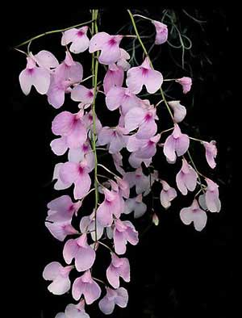
Botanical Varieties: I. utricularioides var. latifolia, angustifolia, parvifolia, virginalis

Synonyms: Ionopsis tenera, I. pallidiflora, I. gardneri, I. pulchella, Iantha pallidiflora, Cybelion pallidiflorum, C. tenerum, C. pulchellum, C. utricularie

Awards:

Origin | HCC | AM | CHM | CCA | CCM | JC | Total
 | 2 | 2 | 1 | 1 | 2 | 3
Years | 1999-2003 | 1987-1009 | 1981 | 1958 | 1981-1987 | 1971
Other awards and when given: 3 AWD 2009-2014

Outstanding clones of species and reason they are considered outstanding:

F-1 Hybrids:
Before  1940 | 1940-49 | 1950-59 | 1960-69 | 1970-79 | 1980-89 | 1990-99 | After 1999
 |  |  | 4 | 6 | 1 | 1 | 7

Total Progeny
Before  1940 | 1940-49 | 1950-59 | 1960-69 | 1970-79 | 1980-89 | 1990-99 | After 1999
 |  |  | 4 | 7 | 1 | 1 | 16

Outstanding progeny and reason they are considered outstanding:
I wouldn’t call either Ionopsis hybrid outstanding, but they are the only awarded crosses for the species. Inomesa is a cross with Gomesa flexuosa (the new name for Oncidium flexuosum). It brings a nice yellow tint and spotting to the cross. On the other hand, Ionummia Cuisine is a definite improvement on the species. The color is more intense and the floriferousness is probably doubled.

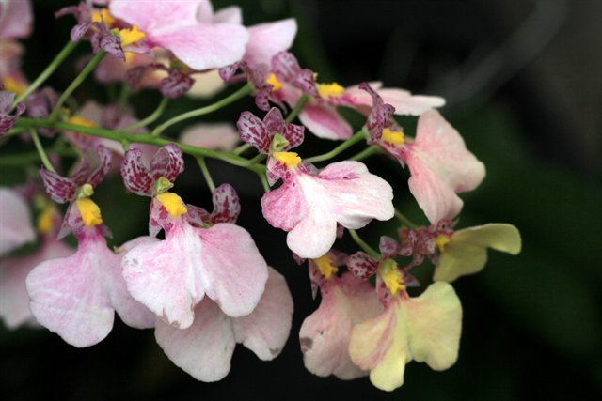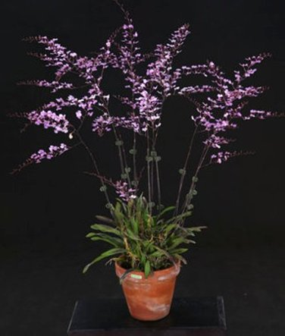
Ionmesa Popcorn ‘Hauari’ Ionummia Cuisine

Desirable characteristics which can be passed to progeny:
Because photos are available for only 3 of the crosses and award description for 2, it is hard to discern what is passed on to progeny. The pink color is the only obvious choice.

Undesirable characteristics which can be passed to progeny:

Other information:

