BUILDING BLOCK DATA

Species Rodriguezia lanceolata

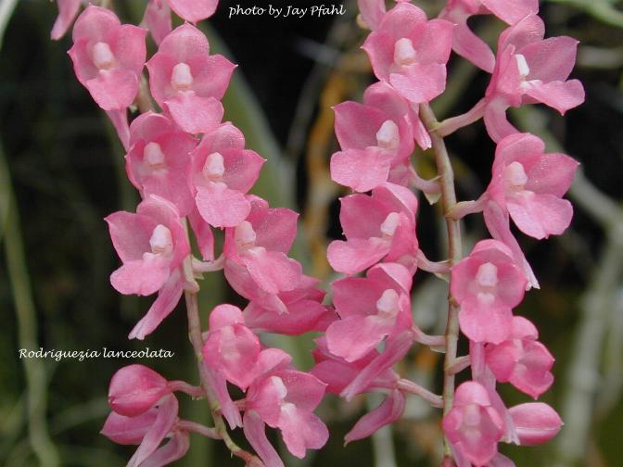
Botanical Varieties (if any):

Synonyms: Rodriguezia rosea, R. secunda, R. secunda var. panamensis

Awards:

Origin | AM | AWD | CHM | CCA | CCM | CBM | Total
 | 2 | 1 | 1 | 5 | 5 | 1
Years | 1973-2007 | 2010 | 1994 | 1958-1099 | 1964-1999 | 1968
Other awards and when given: 1 BM (2012), 1 SM (2012), 1 JC (1971)

Outstanding clones of species and reason they are considered outstanding:

F-1 Hybrids:
Before  1940 | 1940-49 | 1950-59 | 1960-69 | 1970-79 | 1980-89 | 1990-99 | After 1999
 |  | 4 | 12 | 10 | 5 | 9 | 11
Total Progeny:
Before  1940 | 1940-49 | 1950-59 | 1960-69 | 1970-79 | 1980-89 | 1990-99 | After 1999
 |  | 4 | 13 | 23 | 30 | 49 | 222

Outstanding progeny and reason they are considered outstanding:

Rodrumnia Phyllis has produced 14 F-1 crosses and has contributed to a total progeny of 219. It has been awarded 5 times including 3 AM’s and 2 HCC’s.
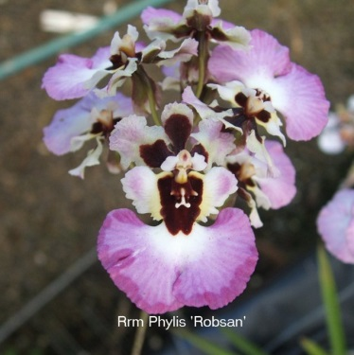

Leomesia Mini-Primi has 17 awards and has contributed to 25 total progeny including 15 F-1 crosses. Seven of the awards are cultural. They are popular in Australia.
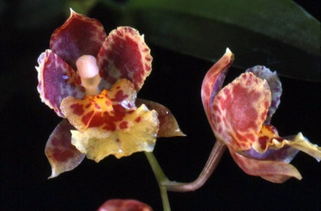

Desirable characteristics which can be passed to progeny:
Very brightly colored flowers, nicely presented on arching and pendant inflorescences. Nice round flower shape in some crosses.

Undesirable characteristics which can be passed to progeny:
Relatively small flower size.

Other information:

