BUILDING BLOCK DATA

Species Rodriguezia venusta

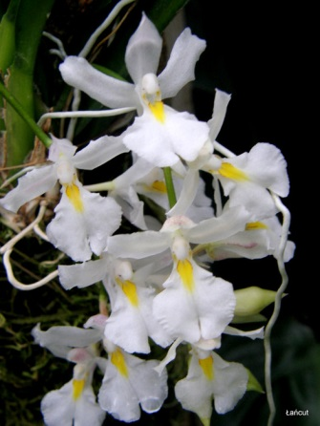
Botanical Varieties (if any):

Synonyms: Burlingtonia venusta, B. fragrans, B. knowlesii, Rodriguezia flavida

Awards:

Origin | HCC | AM | FCC | CCA | CCM | ACC | Total
 | 4 | 2 | 0 | 1 | 11 | 3
Years | 1977-2011 | 1982-1990 |  | 1958 | 1960-2011 | 1993-1999
Other awards and when given:

Outstanding clones of species and reason they are considered outstanding:

F-1 Hybrids:
Before  1940 | 1940-49 | 1950-59 | 1960-69 | 1970-79 | 1980-89 | 1990-99 | After 1999
 |  | 2 | 5 | 3 | 8 | 7 | 16
Total Progeny:
Before  1940 | 1940-49 | 1950-59 | 1960-69 | 1970-79 | 1980-89 | 1990-99 | After 1999
 |  | 2 | 5 | 8 | 20 | 38 | 222

Outstanding progeny and reason they are considered outstanding:

Rodriguezia Burgundy – This primary hybrid between Rodriguezia lanceolata and Rdza. venusta has been part of 248 progeny and has been awarded 10 times.
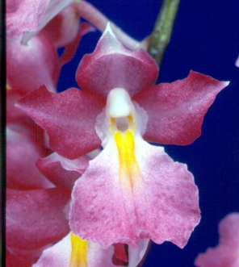

Desirable characteristics which can be passed to progeny:
Pleasing form, yellow throat.

Undesirable characteristics which can be passed to progeny:
Short lifespan of a twig epiphyte.

Other information:

