Comparettia Hybrid Genera
Rhynchorettia (Ryrt) – This genus is a product of crosses between Rhynshostele uroskinneri ans/or R. bictoniensis and several species of Comparettia. Comparettia falcate has produced 3 Rhynchorettia hybrids, C. speciose 6 and C. macroplecton 1. Although the genus has been awarded 18 times, it is of limited significance in breeding with only 6 progeny.
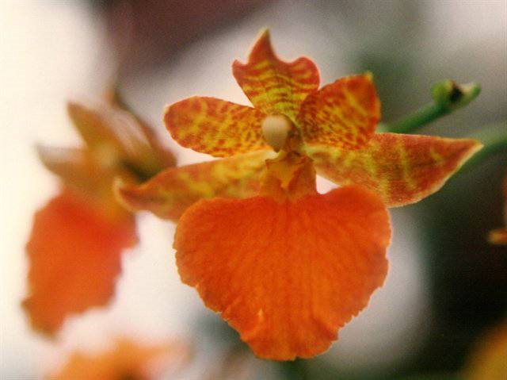
Rhynchorettia Hanni Isler

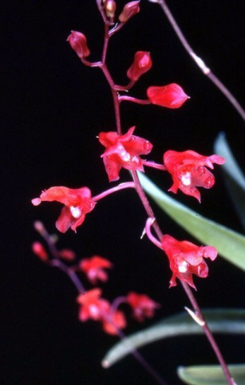
Rodrettia (Rdtta) – Breeders have registered 26 crosses between various species of Comparettia and Rodriguezia since 1976 with modest success. Comparettia speciosa, C. macroplecton, and C. falcata were tried in crosses with 9 species of Rodriguezia. The hybrid genus has received 6 awards and has produced a total progeny of 24 grexes.
Rodrettia Fiesta

Gomettia (Gmtta) – Fifteen grexes have been registered for this genus comprising various species of Comparettia and Gomesa. Since 1967, 4 awards have been given but the linage does not seem to be going anywhere with no progent produces.
Gomettia Royal Marble
Hybridization with other genera has been explored with no particular breakthroughs.

