Ionopsis Hybrid Genera
The genus Ionopsis has not been a very successful candidate for hybridization. It has only produced 29 progeny with all but 4 stopped at the first generation. Although the species Ionopsis utricularioides has been awarded 12 times, its registered grexes have garnered only 1 CCM. Breeders have tried crosses with 8 other genera in various bi and tri-generic hybrids. The only cross to be awarded is Ionmesa Popcorn (Ionopsis x Gomesa). Other combinations tried are:
Ioncentrum (Ionopsis x Trichocentrum) 1 grex
Ionmesettia (Ionopsis x Gomesa x Comparettia) 2 grexes
Ioncidium (Ionopsis x Oncidium) 5 grexes
Ionumnia (Ionopsis x Tolumnia) 4 grexes
Ionettia 9Ionopsis x Comparettia) 7 grexes
Ionmesidium (Ionopsis x Gomesa x Oncidium) 1 grex
Notylopsis (Ionopsis x Notylia) 1 grex
Rodriopsis (Ionopsis x Rodriguezia) 4 grexes
Rodretttiopsis (Ionopsis x Rodriguezia x Comparettia) 1 grex

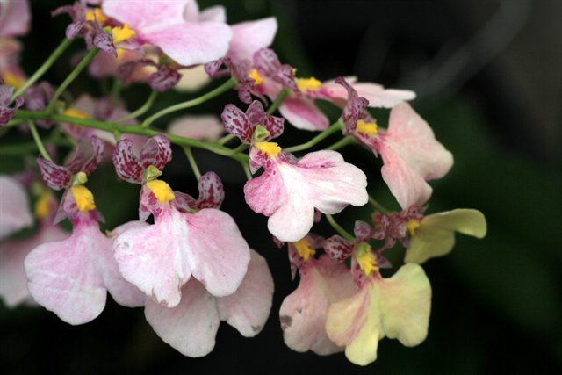
Ionmesa Popcorn ‘Havari’

