Rodriguezia Hybrid Genera
Rodrumnia - The most successful Rodriguezia crosses are with the genus Tolumnia producing the hybrid genus Rodrumnia (Rrm.) Between 1957 and the present, 253 Rodrumnia hybrids have been produced . One of the most prolific and successful hybridizers is William Savage of Orchidom. Between 2002 and 2010, he developed 26 hybrids which received 57 awards. Overall, the hybrid genus Rodrumnia has received 171 awards.
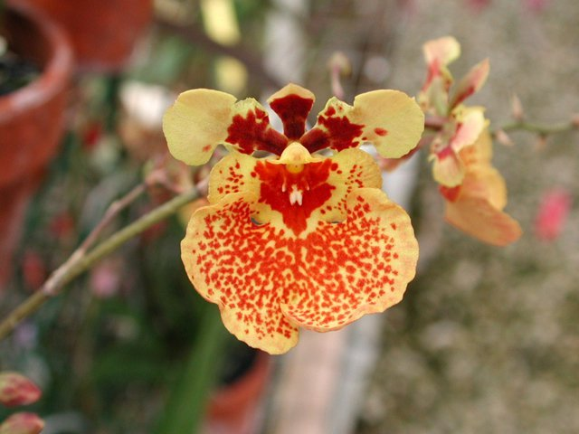
Rodrumnia Spunky
Leomesezia – This tri-generic hybrid between Rodgiguezia, Gomesa and Leochilus has only produced 8 crosses but has garnered 24 awards and has produced 21 offspring.
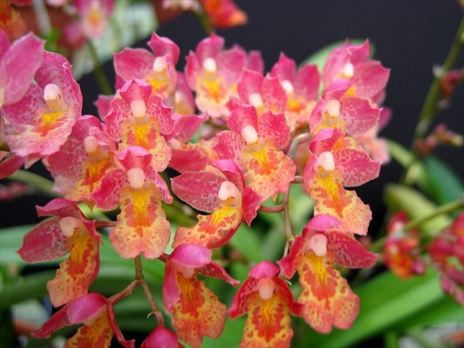
Leomesa Lava Burst

Gomguezia – Crossing Rodriguezia with Gomesa produces Gomguezia hybrids. Thirteen have been produced since 1959 with awards given to 2.
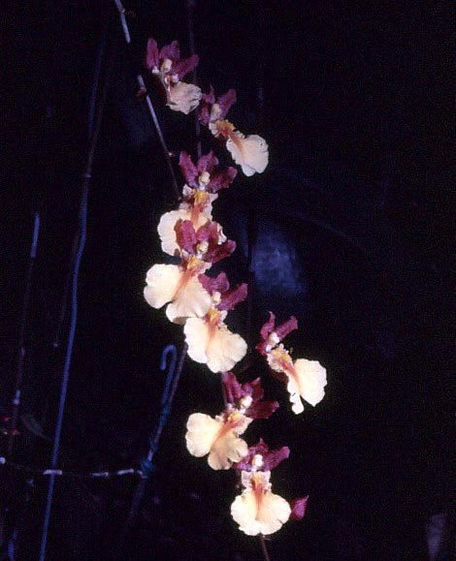
Gomguezia Tahiti
Other less successful crosses include:
Blumeara (Gom x Lchs x Rdza x Rst)
Bradeara (Comp x Gom x Rdza)
Eliara (Brs x Onc x Rdza)
Harveyara (Asp x Brs x Gom x Milt x Rdza)
Ilonara (Gom x Rdgza x Toul)
Komarovara (Gom x Lchs x Rdza x Tolu)

