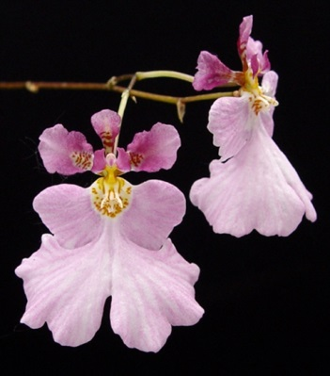
Tolumnia pulchella AM
Twenty-four well-formed flowers and 16 buds on two inflorescences; sepals mauve, basal quarter yellow with mustard spots; lip pale pink, yellow basally with mustard spots; column lavender; substance medium; texture of sepals and petals crystalline, lip matte.

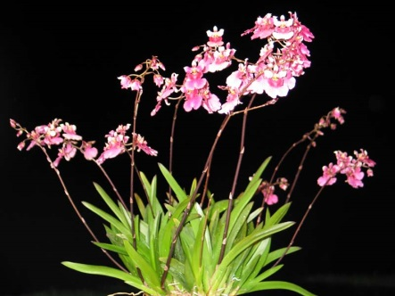
Tolumnia Popki HCC
Forty-one flat flowers and twenty-one buds well presented on ten inflorescences; sepals and petals ivory overlaid pink basally; lip medium rose medially, side lobes and callus darker raspberry, yellow centrally; substance soft; texture matte.

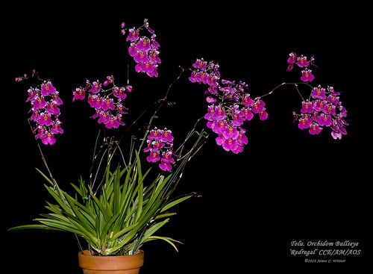
Tolumnia Orchidom Bulls Eye CCM
Eighty-four flowers and 25 buds on seven arching inflorescences averaging 37 cm in length presented on a 40 cm diameter plant grown in bark in a 9 cm clay pot; sepals and petals fuchsia, centrally cream, spotted cinnamon basally; lip light fuchsia, side lobes darker fuchsia with pale cinnamon spots around callus; column and anther cap pale rose, column wings darker rose; substance medium; texture crystalline.

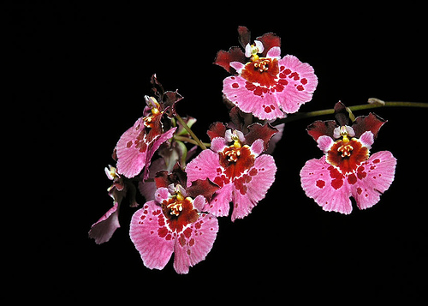
Rodrumnia Orchidom Happy Choice HCC
Twelve flowers and 3 buds well presented on one arched inflorescence; sepals burgundy; petals medium pink, blotched red basally; lip medium pink, striated deeper pink, blotched red proximally; callus flushed yellow; substance firm; texture crystalline.

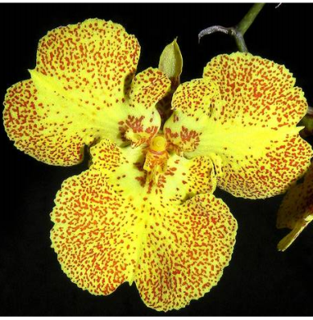

Zelemnia Midas HCC
Thirty-one flowers and seven buds well presented on two branching inflorescences; flowers clear, bright yellow with chestnut speckling on proximal two-thirds of petals and on entire lip, larger chestnut speckles basally on lit and petals.

