BUILDING BLOCK DATA
Species Tolumnia henekenii
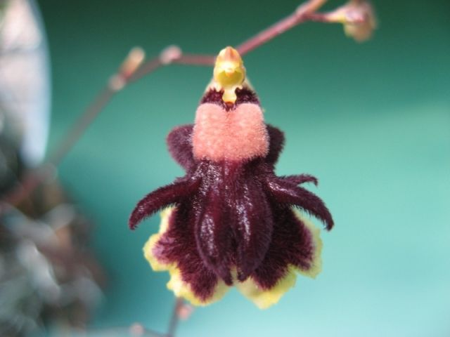

Botanical Varieties (if any):

Synonyms: Hispaniella henekenii, Oncidium henekenii

Awards:

Origin | HCC | AM | FCC | CCA | CCM | CHM | Total
 | 1 | 1 |  |  | 5 |  | 7
Years | 1986 | 1980 |  | 1970-1971 | 1971-1986
Other awards and when given:

Outstanding clones of species and reason they are considered outstanding:

Hybrids:

Before  1940 | 1940-49 | 1950-59 | 1960-69 | 1970-79 | 1980-89 | 1990-99 | After 1999
 |  | 2 | 40 | 229 | 302 | 221 | 490

Outstanding progeny and reason they are considered outstanding:

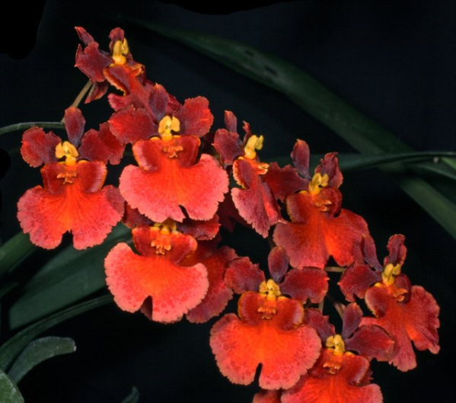
Rodrumnia Orchidom Valentine A cross between Rodrumnia Orchidom Red Love and Tolumnia Aleka combines Tolumnia urophylla, T.guianensis, T. pulchella, T. triquetra and T. henekenii. In spite of being assigned to the genus Rodrumnia, the cross is 98% Tolumnia. It has been awarded 18 times but has not been very fertile producing only 2 offspring.

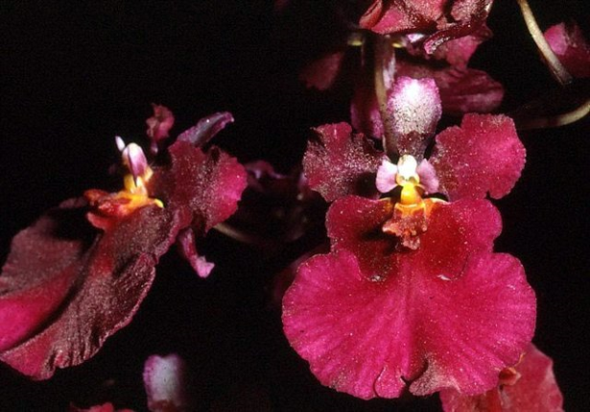
Tolumnia Tom Wilson Produced by crossing Tolumnia Pink Panther with Tolumnia Passionate Red, Tom Wilson has good form, wide petals that close the window with the lateral lobes of the lip and has a strong red color due to the T. henekenii influence. This cross contains genetic material from six species of Tolumnia with Tolumnia henekenii representing 10.16%. Tom Wilson has garnered 9 AM and 7 HCC. It has 14 F-1 progeny and 21 Total.

Desirable characteristics which can be passed to progeny:
Tolumnia henekenii was first used in hybrids by Moir to intensify the red shades of Tolumnia pulchella. Along with T. pulchella, T. henekenii improves arrangement and shingling of flowers on the inflorescence.

Undesirable characteristics which can be passed to progeny:
Dorsal sepal and petals strongly reflexed, irregular shape to the lip.

Other information:

