BUILDING BLOCK DATA
Species Trichocentrum cebolleta
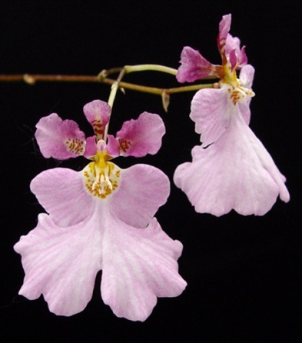

Botanical Varieties

Synonyms: Oncidium cebolleta

Awards:

Origin | SM | AM | JC | CCM | CCM | CBM | Total
 | 1 | 1 | 1 | 2 | 1 | 1 | 25
Years | 1978 | 1978 | 1988 | 2009-2010 | 2009 | 1976
Other awards and when given:

Outstanding clones of species and reason they are considered outstanding:

Hybrids: F1

Before  1940 | 1940-49 | 1950-59 | 1960-69 | 1970-79 | 1980-89 | 1990-99 | After 1999
 |  | 1 | 4 | 2 | 3 | 1 | 5

Outstanding progeny and reason they are considered outstanding:

Tolumnia Stanley Smith 1967
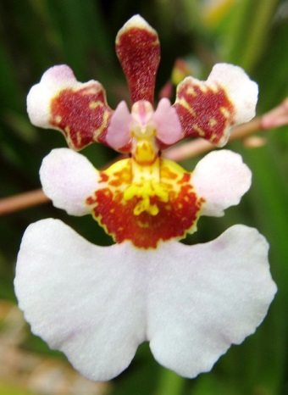
Stanley Smith is a cross between Tolumnia Red Belt and T. pulchella. T. Red Belt in turn is a cross between T. triquetra and T. urophylla. Its T. pulchella 50% parentage shows in its large petals, great form and presentation on the inflorescence but also displays the negative in its large windows. The spotting and hint of patterning may be attributed to its T. triquetra genes and the distinctive notch in the labellum may be attributed to its T. urophylla genes.
Tolumnia Stanley Smith has 44 F-1 offspring and 1151 Total Progeny. It has been awarded 6 times with 3 AM, 1 HCC and 2 CCM. It was crossed with T. Tiny Tim in 1975 to produce T. Golden Sunset which garnered 57 awards combining all four of Tolumnia building block species.

Tolumnia Golden Sunset

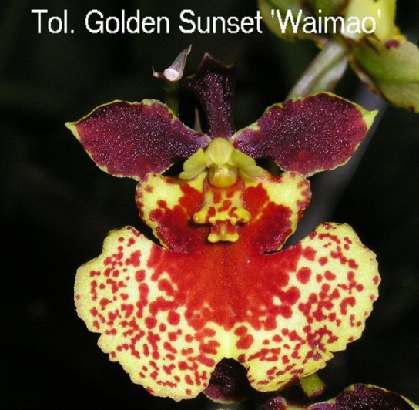
This hybrid combines the best of the four Building Block species of Tolumnia. It is a key component in most awarded lines of Tolumnia breeding with 137 F-1 offspring and 834 total progeny. It has been awarded 57 times with 19 Am, 3 CCM, 31 HCC and 3 SM. Its F-1 offspring include T. Robsan, T. Irene Gleason, T. Sniffen, T. Magic to name a few. These four alone have 50 awards.

Desirable characteristics which can be passed to progeny:
Pink to white color with pink dominant. The flower has a great form and a great presentation on the inflorescences. The large petals are passed onto its progeny. Improves arrangement and shingling of flowers on the inflorescence. Improves flower count. Helps with full, round lip.

Undesirable characteristics which can be passed to progeny:
Along with its large petals, Tolumnia pulchella passes on large “window’ spacing between the petals. This can be overcome by breeding with Tolumnia guianensis.

Other information:

Tolumnia pulchella is the type species of Tolumnia.

Pronunciation: pul-KEL-la