BUILDING BLOCK DATA
Species Tolumnia triquetra
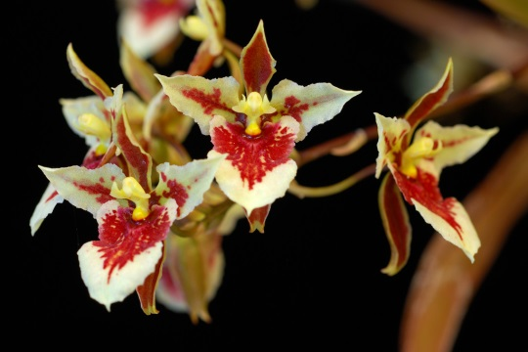

Botanical Varieties (if any):

Synonyms: Jamaiciella triquetra, Oncidium triquetrum, Oncidium dubium, Tolumnia triquetrum

Awards:

Origin | HCC | AM | FCC | CCE | CCM | CHM | Total
 | 3 | 5 |  |  | 3 |  | 11
Years | 1980-1987 | 1969-2013 |  |  | 1967-2006
Other awards and when given:

Outstanding clones of species and reason they are considered outstanding:

Hybrids: F-1
Before  1940 | 1940-49 | 1950-59 | 1960-69 | 1970-79 | 1980-89 | 1990-99 | After 1999
 |  | 10 | 20 | 47 | 16 | 5 | 3

Outstanding progeny and reason they are considered outstanding:

Tolumnia Memoria Ralph Yagi

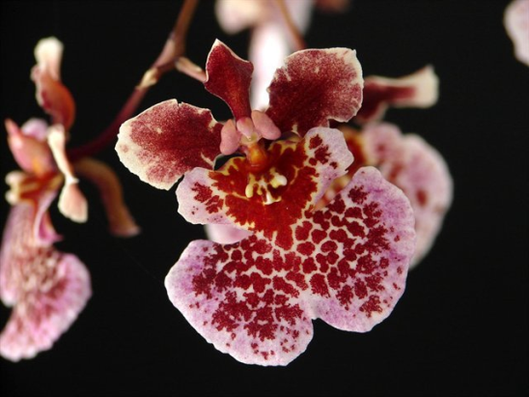
Memoria Ralph Yagi is a descendant of Tolumnia royalty including Golden Sunset, Tiny Tim, Sniffen, Irene Gleason and Rainbow. It has garnered 25 awards, mostly AM’s and HCC’s. It has produced 28 F-1 offspring and 100 total progeny. It combines the best characteristics of all four Tolumnia Building Block species.

Tolumnia Red Belt

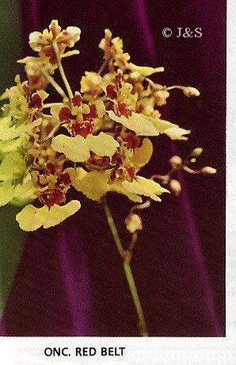
Red Belt is a cross between Tolumnia triquetra and Tolumnia Golden Glow which is T. triquetra X T. urophylla. In spite of being 75% T. triquetra, it shows the yellow and form of T.urophylla. Red Belt has 39 F-1 offspring and 1308 total progeny. It has contributed to notable hybrids including Tolumnias Golden Sunset, Memoria Ralph Yagi, Robsan, Irene Gleason Sniffin and Rodrumnia Orchidon Valentine. Seven generations of progeny have accumulated 778 awards. Red Belt itself has been awarded 6 times.

Desirable characteristics which can be passed to progeny:
Tolumnia triquetra is highly variable in its color. It is spotted and these spots are often passed on to its progeny. It produces a wide range of color patterns which is both a plus and a minus. It generally has a compact habit. These characteristics have contributed to 1757 progeny in seven generations which have been awarded a total of 956 times

Undesirable characteristics which can be passed to progeny:
The highly variable color can sometimes be undesirable as well as the wide array of patterns. Short inflorescences and the overall flower form can also be undesirable.

Other information:

Pronounced: trye-KWEE-tra referring to its triangular shape

