Rodrumnia - The most successful Tolumnia crosses are with the genus Rodriguezia producing the hybrid genus Rodrumnia (Rrm.) Between 1957 and the present, 253 Rodrumnia hybrids have been produced . One of the most prolific and successful hybridizers is William Savage of Orchidom. Between 2002 and 2010, he developed 26 hybrids which received 57 awards. Overall, the hybrid genus Rodrumnia has received 171 awards.
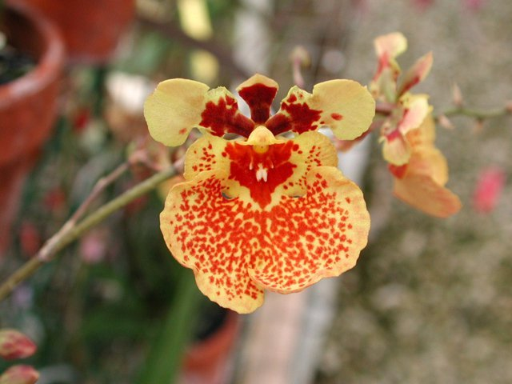
Rodrumnia Spunky

Golumnia – Crossing Tolumnia with Gomesa has produced 50 hybrids since 1043 in the genus Golumnia (Glm.). These crosses have not been particularly successful, producing 42 total progeny. Golumnia has been awarded 16 times with 7 HCC and 5 AM.

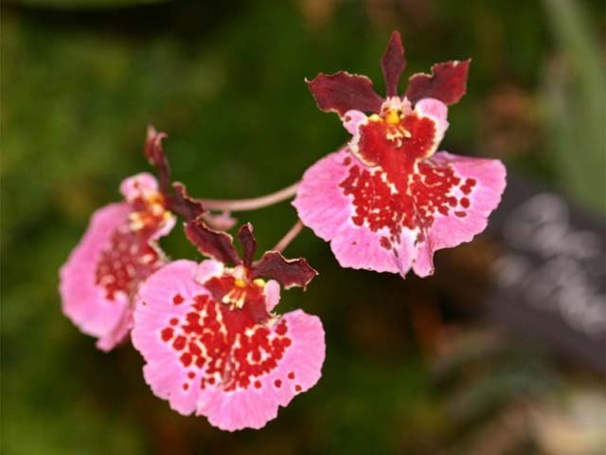
Golumnia Spectr

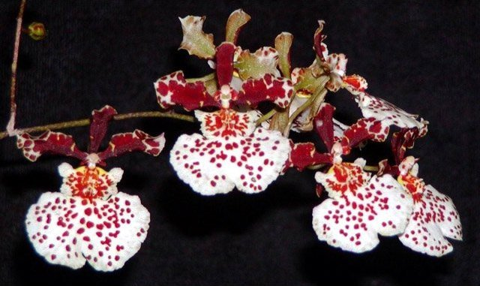
Golumnia Orchidom Saintly

Zelemnia (Zlm.) – Since 1969, orchid breeders have been crossing Zelenkoa onusta with various species of Tolumnia. Thirty grexes have been registered since 1969. This genus has shown moderate success with 21 progeny and 7 AM, 9HCC, 4 CCM and 1 JC.

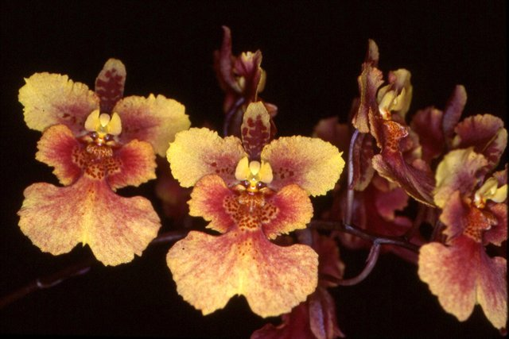
Zelemnia Barbars Blush AM/AOS

Oncidumnia – Since 1957, breeders have tried crosses between many species of Tolumnia and Oncidium. The hybrid genus Oncidumnia (Ocd.) is the result. Most of the crosses did not go anywhere. Only 23 progeny have passed on their genes and only 3 grexes were awarded, 2 AM’s and 1 HCC.
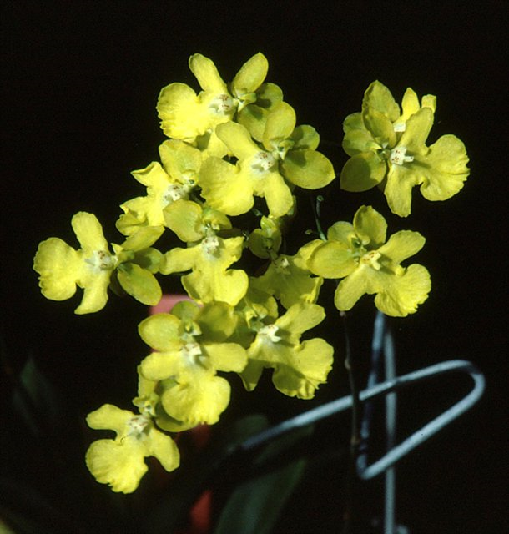
Oncidumnia Kutoo

Ilonara – Crossing Tolumnia, Rodriguezia and Gomesa creates the genus Ilonara (Ilo.). Breeding started in 1080. Again, another unsuccessful experiment with only 7 progeny from 17 grexes and 3 HCC’s. The two with photos are attractive.
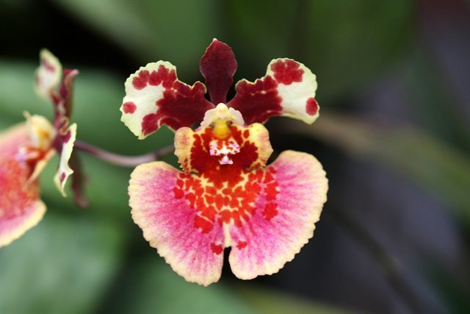
Ilonara Cameo

