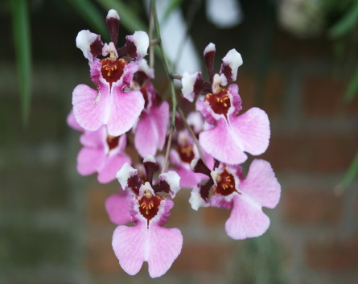
Tolumnia variegata HCC
One-hundred and sixty three well-presented flowers and forty seven buds on 11 inflorescences, sepals and petals white, dorsal sepal maroon proximal three quarters, petals maroon proximal half; lip white, suffused pink, lateral lobes darker pink, mask oxblood, callus tips yellow; column pale yellow, wings white, suffused pink; substance food; texture crystalline

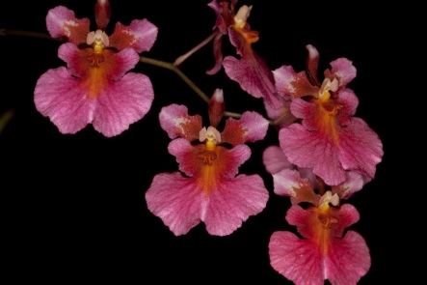
Tolumnia Redfish Reef AM
Nineteen very flat flowers and 3 buds on two 43cm inflorescences; dorsal sepal white, proximal three quarters red-orange; petals white, proximal half red-orange, spotted with white centrally, distal half pink; lip white, overlaid pink, veined darker pink, mask red, orange medially, callus red-orange; column yellow, wings cream; substance soft; texture matte.
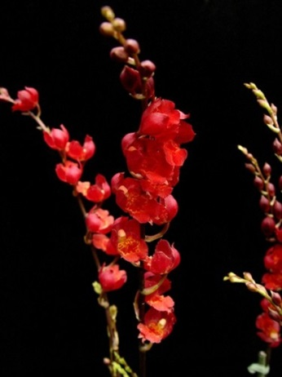
Leomesezia Lava Burst CCM
Ninety-one cup shaped flowers and twenty-seven buds on three branching inflorescences averaging 41 cm in length, presented on a 40 cm diameter plant grown in bark in a 9 cm clay pot; sepals and petals blood red, lip blood red distally, mask red-orange spotted dark red, callus; column cream with red mark on each side; substance medium; texture crystalline.

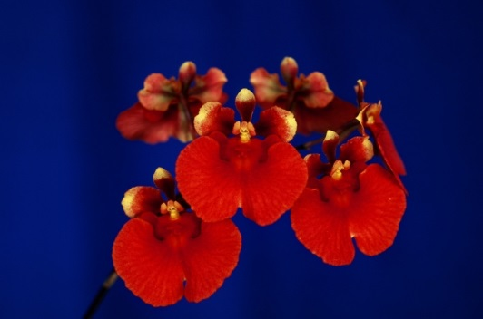
Rodrumnia Apple Hollow HCC
Six flowers well presented on one arched inflorescence; dorsal sepal brick red, tipped yellow; petals brick-red proximally, grading to blood-red then yellow distally; lip red-orange with darker veining; callus red; column yellow, column wings red-orange; substance firm; texture matte.

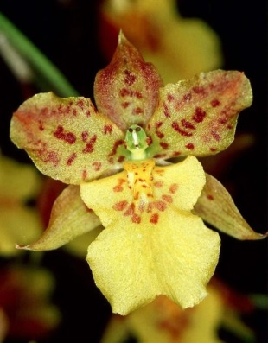
Rydbergara Mary Eliza AM
One hundred-ten flowers on ten inflorescences; dorsal sepal and petals light yellow, spotted burgundy medially, suffused burgundy marginally, lateral sepals yellow, lightly suffused burgundy; lip light yellow, center spotted burgundy; column yellow green; substance light; texture diamond dust.

