BUILDING BLOCK DATA
Species Tolumnia guianensis
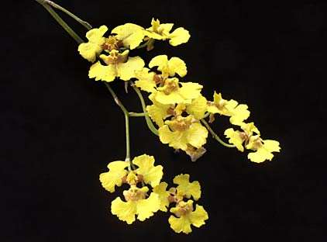

Botanical Varieties (if any):

Synonyms: Tolumnia intermedia, T. lemoniana, Oncidium desertorum, O. guianense, O. intermedium

Awards:

Origin | HCC | AM | HCC | CBE | CCM | CHM | Total
 | 3 | 3 | 4 | 4 | 2 | 1 | 14
Years | 1982-2014 | 1974-1990 | 1969-2014 | 1970-1981 | 1974-1999 | 1998
Other awards and when given: 1 CBM (1970), 1 CBR(1982)

Outstanding

Hybrids: F-1

Before  1940 | 1940-49 | 1950-59 | 1960-69 | 1970-79 | 1980-89 | 1990-99 | After 1999
 | 1 | 6 | 16 | 26 | 12 | 0 | 1

Hybrids: Total Progeny

Before  1940 | 1940-49 | 1950-59 | 1960-69 | 1970-79 | 1980-89 | 1990-99 | After 1999
 | 1 | 6 | 33 | 71 | 330 | 256 | 542

Outstanding progeny and reason they are considered outstanding:

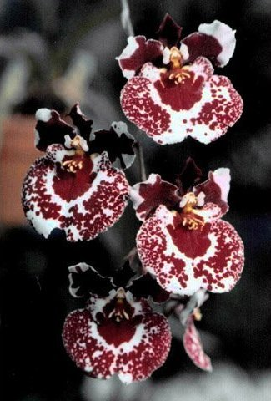
Tolumnia Sniffen This hybrid combines Tolumnia Golden Sunset and Tolumnia Irene Gleason. It has been awarded 10 times including 1 FCC, 3 HCC. 4 AM and 1 AQ. It has contributed to 5 generations of progeny including a number of awarded members of the hybrid genus Rodrumnia.

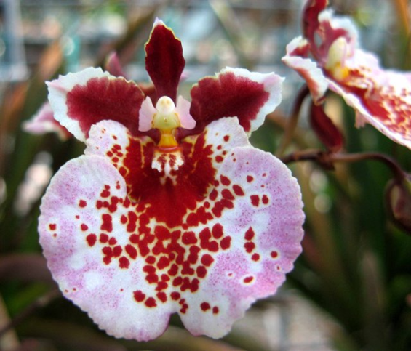
Tolumnia Irene Gleason This is a cross between Tolumnia Golden Sunset and Tolumnia Linda. It is nearly equal thirds of Tolumnia guianensis, T. triquetra and T. pulchella. It has been awarded 11 times and has contributed to 308 progeny in 5 generations. It incorporates the rounded form and no “windows” of T. guianensis, the spots and great color of T. triquetra and the pleasing pink of T. pulchella.

Desirable characteristics which can be passed to progeny:
With wide petals and a wide lip, Tolumnia guianensis brings a roundness of flower form and fills in the windows found in other species of Tolumnia. It produces larger flowers and increases spacing of flowers on the inflorescence.

Undesirable characteristics which can be passed to progeny:
One big negative is that it tends to decrease flower count.

Other information:

Pronounced: gee-uh-NEN-sis Of or from French Guiana

