BUILDING BLOCK DATA
Species Tolumnia urophylla
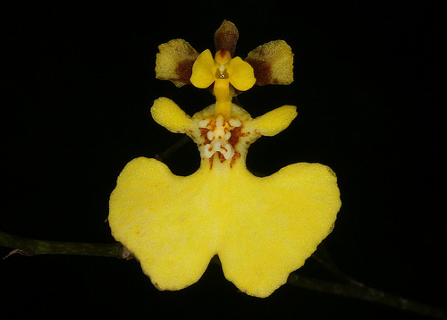

Botanical Varieties (if any): Oncidium urophyllum f. flavum

Synonyms: Oncidium urophyllum

Awards:

Origin | HCC | AM | FCC | CCE | CCM | CHM | Total
 | 3 | 5 |  |  | 3 |  | 11
Years | 1980-1987 | 1969-2013 |  |  | 1967-2006
Other awards and when given:

Outstanding clones of species and reason they are considered outstanding:

Hybrids: F-1

Before  1940 | 1940-49 | 1950-59 | 1960-69 | 1970-79 | 1980-89 | 1990-99 | After 1999
 |  | 10 | 20 | 47 | 16 | 5 | 3

Outstanding progeny and reason they are considered outstanding:

Tolumnia Golden Glow 1957 This is one of the pioneering crosses made by Goodale Moir which led to the great Tolumnia crosses of the 1970’s and 80’s. It was a simple cross between Tolumnia urophylla and T. triquetra. Although it was never awarded, it was a foundational member of the Tolumnia hybrid lineage.

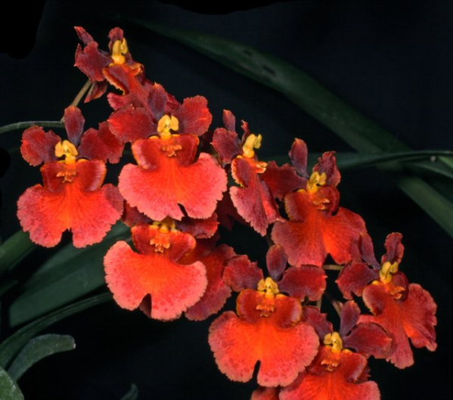
Rodrumnia Orchidom Valentine A cross between Rodrumnia Orchidom Red Love and Tolumnia Aleka combines Tolumnia urophylla, T.guianensis, T. pulchella, T. triquetra and T. henekenii. In spite of being assigned to the genus Rodrumnia, the cross is 98% Tolumnia. It has been awarded 18 times but has not been very fertile producing only 2 offspring.

Desirable characteristics which can be passed to progeny:
Tolumnia urophylla has a strong, bright yellow color. It produces large size flowers with an expanded full round lip. The lip is notched, a neutral characteristic in many cases.

Undesirable characteristics which can be passed to progeny:
In some crosses the yellow color is a negative. The notch in the lip can also be a negative.

Other information:

Pronounciation: yew-ro-FILL-ah With leaves like a tail.

