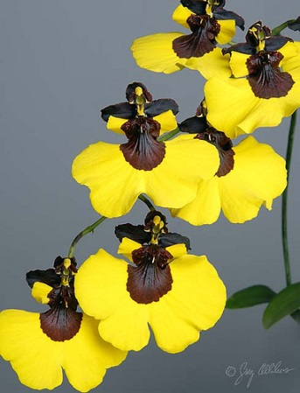
Gomesa Mulattas’ Dancing AM/AOS
Twenty-nine flowers and six buds on two branched inflorescences; sepals and petals dark chocolate brown; lip mask dark chocolate brown, wide border bright yellow, side lobes dark chocolate, distal half bright yellow; column chocolate, anther cap yellow; substance medium; texture matte.

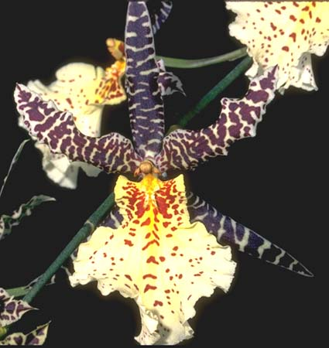
Gombrassiltonia Sweetheart Jonel HCC/AOS
Nine flowers and two buds on one arched inflorescence; sepals and petals green-yellow overlaid with mahogany bars, long and slender from Brassia ancestry; lip Sulphur yellow basally fading to pale yellow distally, barred and spotted mahogany, margins wavy; substance firm; texture crystalline.

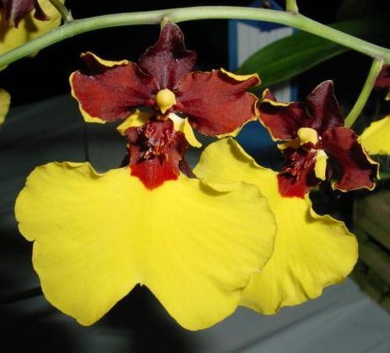
Gomesa Killer Bees AM/AOS
Fourteen flowers and three buds on two inflorescences; sepals and petals deep oxblood, thin margin yellow; lip bright yellow, isthmus and crest oxblood, lateral lobes oxblood proximally, yellow distally, column oxblood; substance good; texture matte.

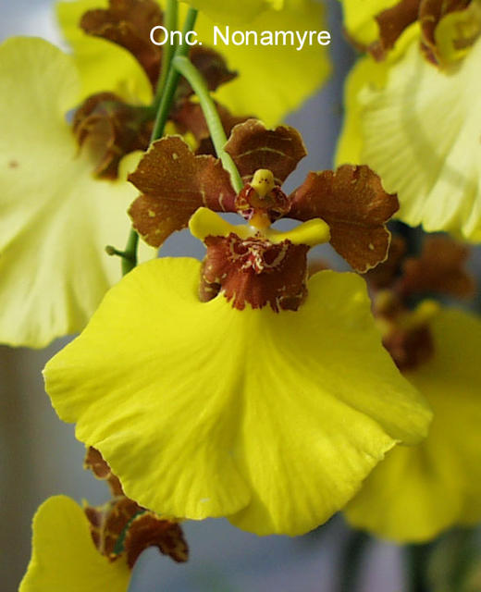
Gomesa Nonamyre HCC/AOS
Nineteen flowers and one bud on one branched inflorescence; sepals and petals chestnut brown, sparsely spotted yellow; lip bright canary yellow, side lobes yellow, crest overlaid chestnut brown; substance firm; texture matte.

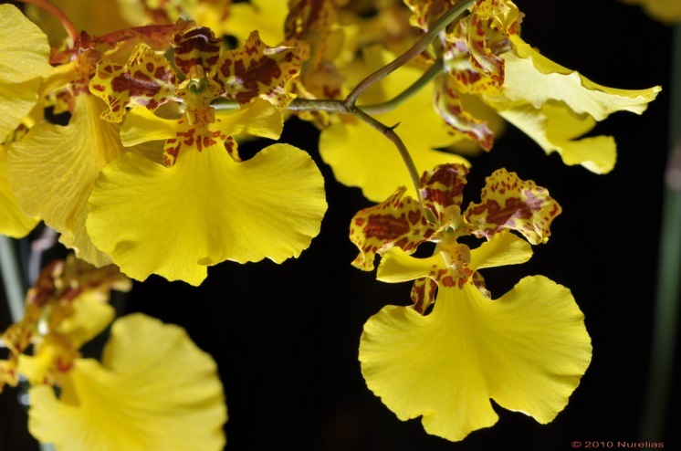
Nohagomenkoa Kai’s Sunshine HCC/AOS
Twenty-two bright yellow flowers and ten buds on two branched inflorescences; sepals and petals yellow, irregularly barred and blotched rust brown; lip and side lobes bright yellow, isthmus and callus sparsely spotted rust brown; column mahogany, anther cap yellow; substance firm; texture crystalline.

