BUILDING BLOCK DATA

Species Gomesa marshalliana

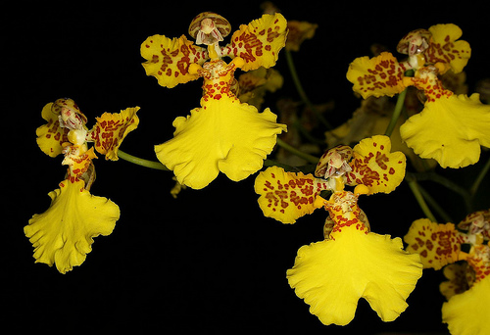
Botanical Varieties (if any):

Synonyms: Oncidium marshallianum, Anettea marshalliana, Brasilidium marshallianum

Awards:

Origin | HCC | AM | FCC | CCA | CCM | ACC | Total
 | 4 | 2 | 0 | 1 | 11 | 3
Years | 1977-2011 | 1982-1990 |  | 1958 | 1960-2011 | 1993-1999
Other awards and when given:

Outstanding clones of species and reason they are considered outstanding:

F-1 Hybrids:
Before  1940 | 1940-49 | 1950-59 | 1960-69 | 1970-79 | 1980-89 | 1990-99 | After 1999
 |  | 2 | 5 | 3 | 8 | 7 | 16

Total Progeny:
Before  1940 | 1940-49 | 1950-59 | 1960-69 | 1970-79 | 1980-89 | 1990-99 | After 1999
 |  | 2 | 5 | 8 | 20 | 38 | 222

Outstanding progeny and reason they are considered outstanding:

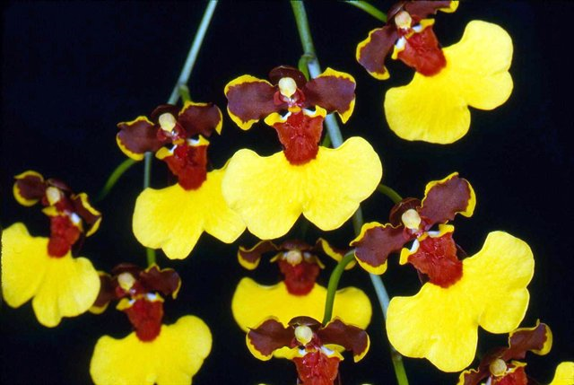
Gomesa Killer Bees ‘Enza Wilson’ HCC/AOS
This cross is one half Gomesa concolor, a quarter Gom. marshalliana and a quarter Gom. viperina. It has been crossed 8 times and has 15 total progeny. It has been awarded 17 times with 8 AM and 9 HCC, mostely in the 1990’s.

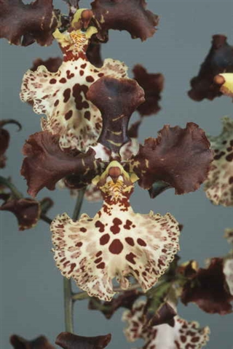
Gomesa Jorge Verboonen 'La Jolla' HCC/AOS

This cross is a primary between Gomesa marshalliana and Gomesa imperatoris-maximiliani. It has not been particularly prolific with 3 F-1’s and 8 progeny but it has been awarded 11 times, one of which is a CCE. This is a rare occurrence in the genus Gomesa which is not overly floriferous.

Desirable characteristics which can be passed to progeny:
Large lip and spotting are desirable traits often passed on.

Undesirable characteristics which can be passed to progeny:

Other information:

