BUILDING BLOCK DATA

Species Gomesa varicosa
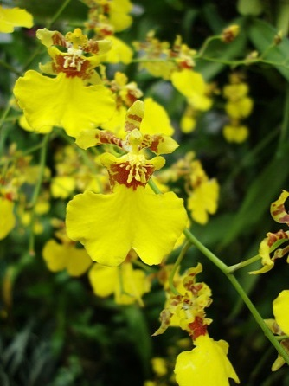

Botanical Varieties (if any):

Synonyms: Oncidium varicosum, Burlingtonia venusta, B. fragrans, B. knowlesii, Rodriguezia flavida
The Oncidium varicosum group, consisting of 17 species was moved to the genus Gomesa and the specific epitaph varicosum became varicosa to align with the gender of the genus Gomesa.

Awards:

Origin | HCC | AM | FCC | CCA | CCM | ACC | Total
 | 4 | 2 | 0 | 1 | 11 | 3
Years | 1977-2011 | 1982-1990 |  | 1958 | 1960-2011 | 1993-1999
Other awards and when given:

Outstanding clones of species and reason they are considered outstanding: Gomesa varicosa ‘Baldin’ is the most highly awarded of the varicosa cultivars.

F-1 Hybrids:
Before  1940 | 1940-49 | 1950-59 | 1960-69 | 1970-79 | 1980-89 | 1990-99 | After 1999
 |  | 2 | 5 | 3 | 8 | 7 | 16
Total Progeny:
Before  1940 | 1940-49 | 1950-59 | 1960-69 | 1970-79 | 1980-89 | 1990-99 | After 1999
 |  | 2 | 5 | 8 | 20 | 38 | 222

Outstanding progeny and reason they are considered outstanding:
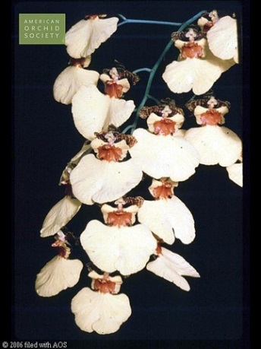
Gomesa Palmyre ‘San Damiano’ HCC/AOS
Created in 1951 by Vacherot & Lecoufle, Palmyre is a cross between Gom. Saladin and Gom. varicosa. It is 78.13% Gom. varicosa, 15.63% Gom. forbsii and 6.25% Gom. marshalliana. It has 27 F-1 offspring and 249 total progeny. The Palmyre grex has been awarded 7 times since 1953.

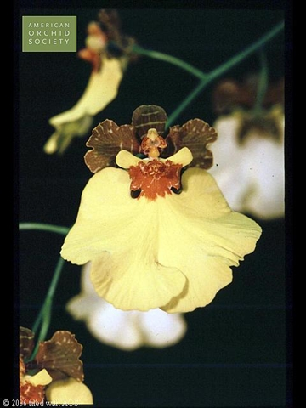
Gomesa Nonamyre ‘Lydia’ AM/AOS
This is another older cross that is part of may outstanding Gomesa and its intergeneric crosses. Nonamyre has been awarded 8 times including 2 AM’s and 6 HCC’s. It has 25 F-1 offdpring and 152 total progeny right up to 2015.

Desirable characteristics which can be passed to progeny:
Gomesa varicosa has a large lip, usually but not always with spots. The lip is a dominant trait passed onto progeny. Other things passed onto progeny are great vigor, large pseudobulbs and a multi-branched highly floriferous spike.

Undesirable characteristics which can be passed to progeny:
Yellow, yellow, yellow

Other information:

Pronunciation : var-ee-KO-suh
Translation: With dilated veins

