The genus Gomesa was named in honor of Portuguese botanist Bernardo Gomes (1768 – 1823). Gomesa plants are epiphytic or terrestrial. The pseudobulbs are oval, two-edged with 3 or 4 deciduous leaves. Gomesa produce one or two inflorescences, usually exceeding the length of the leaves, that produce 3 to 60 flowers. Flowers are resupinate, spur less, yellow, green or white often with brown markings. The dorsal sepal is free, the lateral sepals fused and directed downward (the pants of the Little Man Orchid). The petals are free and similar in shape and size to the dorsal sepal. The labellum is obovate with lanceolate lateral lobes which in some species arch up over the callus. The callus can be a complicated structure and in all cases it secretes oils. The column has a pair of arms on the sides, the anther is terminal, there are 2 pollinia.
There are 125 species of Gomesa, primarily in Brazil but extending to northern Argentina, Bolivia, Paraguay, Venezuela and Amazonian Peru. The plants grow in mountainous coastal tropical rain forest at altitudes from 1500 to 4000 feet. The flowers are usually strongly fragrant.
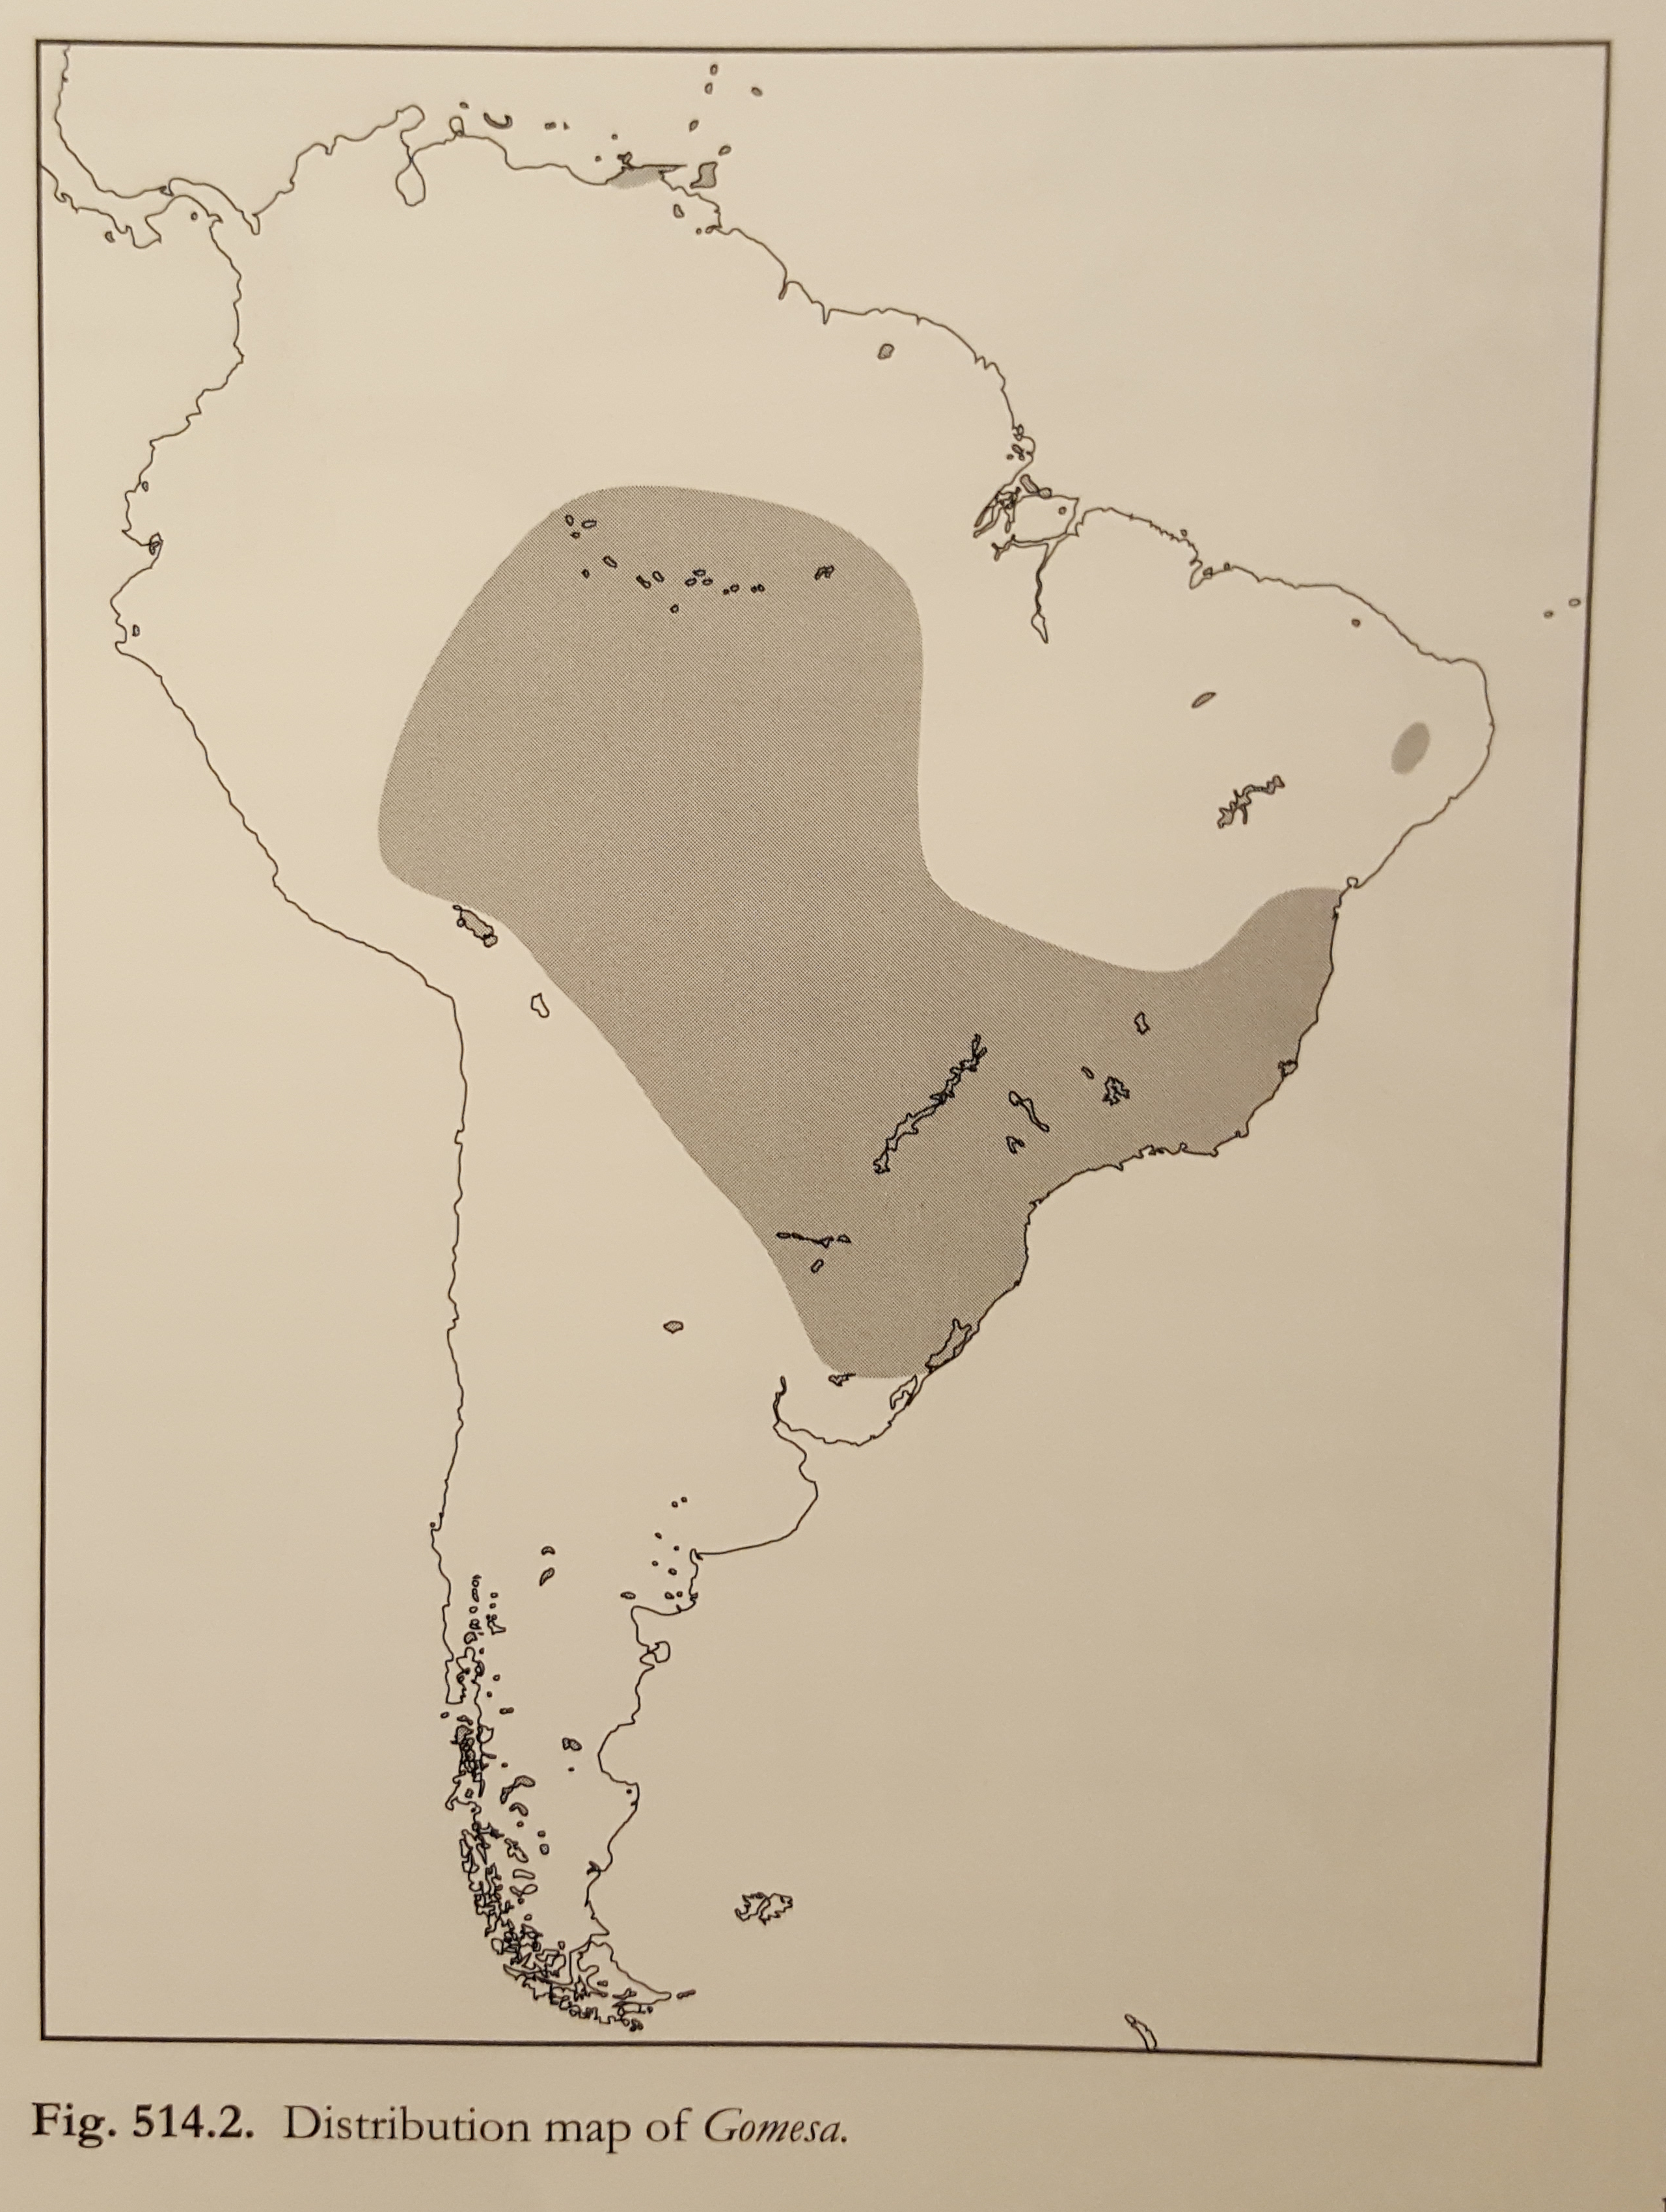
Before the publication of Genera Orchidacearum Volume 5, there were 13 species of Gomesa. Genetic analysis found that the Crispum and Varicosum groups of Oncidium (among others) belonged in Gomesa, swelling its ranks and bringing lots of large bright yellow lips to the genus. Most of these Brazilian Oncidiums have the fused lateral sepals characteristic of Gomesa.
Gomesa flowers produce lipid-rich oils as a pollinator reward. The oils attract female Centris bees. Specialized combs on the bee’s front legs glean the oil which is transferred to brushy patches on the hind legs. The oil provides food for the larvae and is used in construction of the nest.

