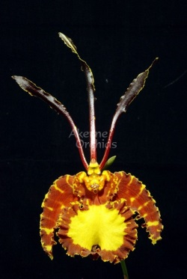
Psychopsis Mariposa AM/AOS
One flat, well presented flower on one inflorescence; dorsal sepals and petals chestnut with yellow-green margins; lateral sepals yellow, irregularly marked chestnut brown; lip yellow, edged chestnut brown; column and anther cap dark yellow; substance firm; texture matte.

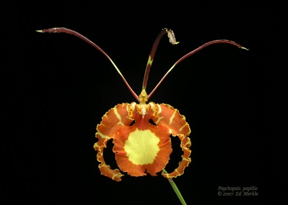
Psychopsis papilio HCC/AOS
Four flowers and two buds on six inflorescences; dorsal sepal and petals light green overlaid brown; lateral sepals pale yellow, completely overlaid light chestnut except for thin yellow bars; lip pale yellow, border uniform light chestnut; column pale yellow; substance firm; texture crystalline.

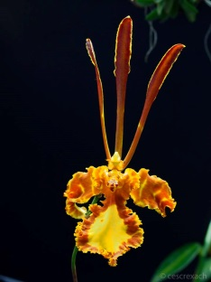
Psychopsis Kalihi CCM/AOS
Twenty-two flowers and eighteen buds on forty inflorescences; plant robust, 60 cm in diameter, grown in a 25 cm clay pot; dorsal sepal and petals overlaid brown, distal third with a thin yellow margin; sepals reflexed, ruffled, barred light brown; lip yellow, margin irregularly overlaid brown; substance light; texture matte.

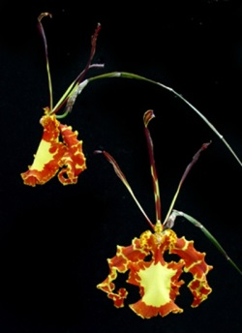
Psychopsis Mendenhall AM/AOS
Two large, pendant flowers on two inflorescences; dorsal sepal and petals green, heavily overlaid mahogany; lateral sepals bright yellow, broadly banded rust brown, ruffled; lip center and picotee bright yellow, mottled overlay rust brown; substance firm; texture sparkling.

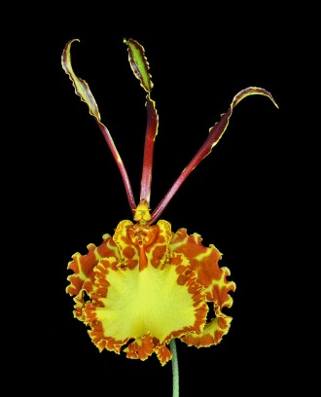
Psychopsis kramerianum HCC/AOS
Three flowers and two buds on five inflorescences; dorsal sepal and petals dark chestnut red, edged green, back green medially; lateral sepals curling down around the lip, mottled light chestnut; lip golden yellow, margin mottled chestnut; substance light; texture sparkling.

