BUILDING BLOCK DATA

Species Paychopsis krameriana
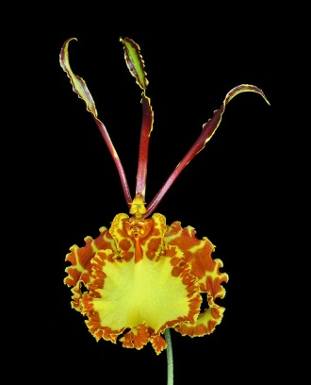

Botanical Varieties (if any):

Synonyms: Oncidium krameriana, Oncidium nodosum, Oncidium papilioniforme

Awards:

Origin | HCC | AM | FCC | CCA | CCM | CHM | Total
 | 3 | 7 | 0 | 1 | 3 | 0 | 15
Years | 1971-1987 | 1966-1984 |  | 1993 | 1961-1990

Other awards and when given:

Outstanding clones of species and reason they are considered outstanding:

Hybrids: F-1
Before  1940 | 1940-49 | 1950-59 | 1960-69 | 1970-79 | 1980-89 | 1990-99 | After 1999
 | 1 |  | 2 | 1 | 2 | 2 | 4

Hybrids: Progeny
Before  1940 | 1940-49 | 1950-59 | 1960-69 | 1970-79 | 1980-89 | 1990-99 | After 1999
 | 1 |  | 2 | 3 | 7 | 5 | 5

Outstanding progeny and reason they are considered outstanding:

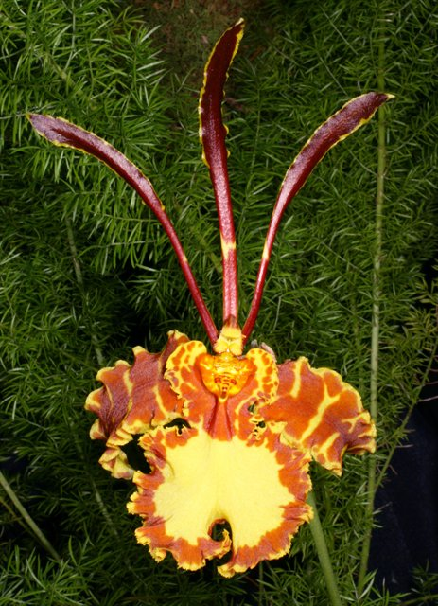
Psychopsis Kalihi
Kalihi is a cross between Psychopsis krameriana and Psychopsis papilio. Since 1945 it has been awarded 34 times and has produced 9 F-1 offspring and 11 total progeny. For a Psychopsis it is large with a natural spread of 9 cm and averages almost 4 flowers per spike.

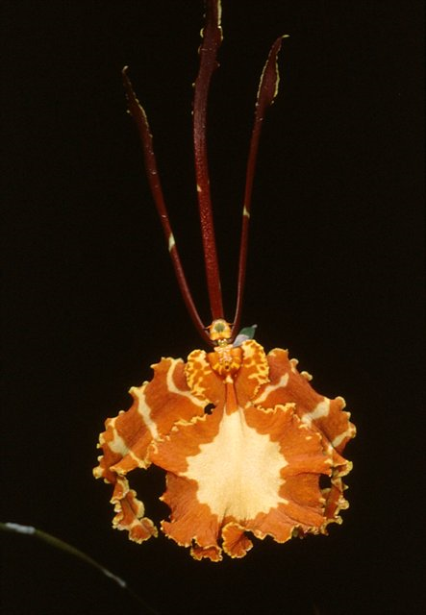
Psychopsis Mariposa ‘Woodland Swallowtail’ AM/AOS
Mariposa is one of Kalihi’s offspring crossed back to Psychopsis papilio. It has been awarded 13 times. It is a larger flower with a natural spread as large as 11.1 cm. but with a much smaller flower count of 1 per spike. It has only 1 offspring.

