BUILDING BLOCK DATA
Species Paychopsis papilio
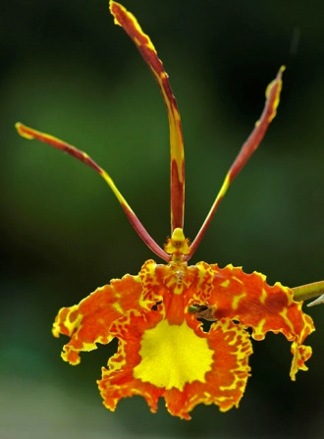

Botanical Varieties (if any):var. albiflora, var. latourae, forma. latourae

Synonyms: Oncidium papilio, Psychopsis latourae

Awards:

Origin | HCC | AM | FCC | CCE | CCM | CHM | Total
 | 39 | 34 | 4 | 1 | 12 | 0 | 100
Years | 1970-2012 | 1960-2012 | 1971-1993 | 2012 | 1963-2012

Other awards and when given: 2 AWD, 1 CCC, 3 JC, 1 SM, 1 AD, 1 2P

Outstanding clones of species and reason they are considered outstanding:

Hybrids: F-1
Before  1940 | 1940-49 | 1950-59 | 1960-69 | 1970-79 | 1980-89 | 1990-99 | After 1999
1 | 1 | 3 | 3 | 6 | 6 | 3 | 2

Hybrids: Progeny
Before  1940 | 1940-49 | 1950-59 | 1960-69 | 1970-79 | 1980-89 | 1990-99 | After 1999
1 | 1 | 3 | 3 | 7 | 10 | 7 | 7

Outstanding progeny and reason they are considered outstanding:

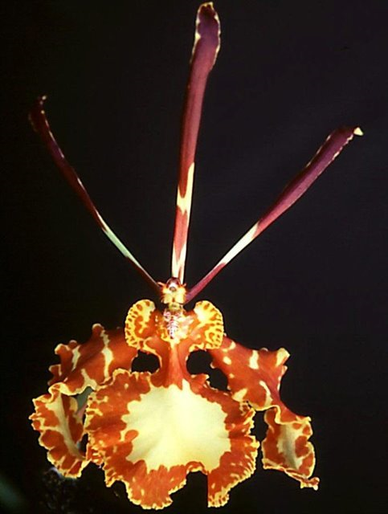
Psychopsis Mendenhall ‘Hildos’ AM/AOS

The Mendenhall grex is from a cross between Psychopsis Butterfly (papilio x sanderae) crossed back to papilio. It has 26 awards and 9 progeny.Desirable characteristics inherited from it’s parents are the down-turned lateral sepals with a very frilly form.

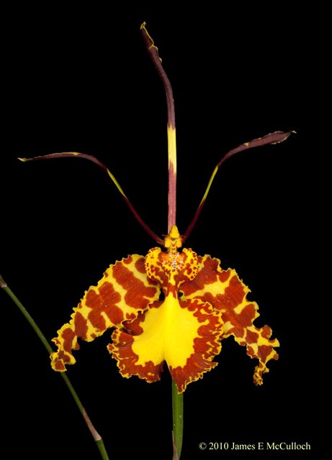
Phychopsis Memoria Bill Carter ‘Garfields Butterflies’ HCC/AOS
The Memoria Bill Carter grex produces a very large flower. The cultivar ‘Monarch’ has a natural spresd of 18 horizontal and 15 vertical cm. It has 18 awards and 4 progeny.

Desirable characteristics which can be passed to progeny:

Undesirable characteristics which can be passed to progeny:

Other information:

