Trichocentrum lanceanum AM 80 points
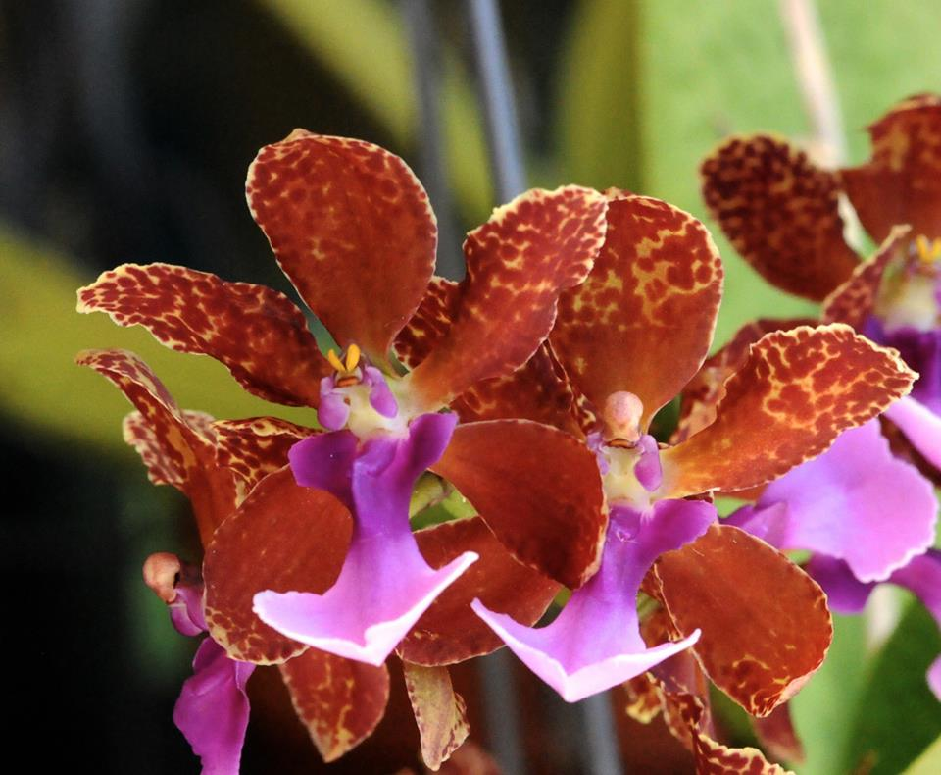
Twenty-five flowers on one branched inflorescence; sepals and petals cream, heavily spotted and blotched red brown; lip midlobe pink grading to white distally, darker violet basally, side lobes dark fuchsia; column and anther cap cream overlaid fucsia; substance firm; texture matte.

Trichocentrum Maureen HCC 77 Points
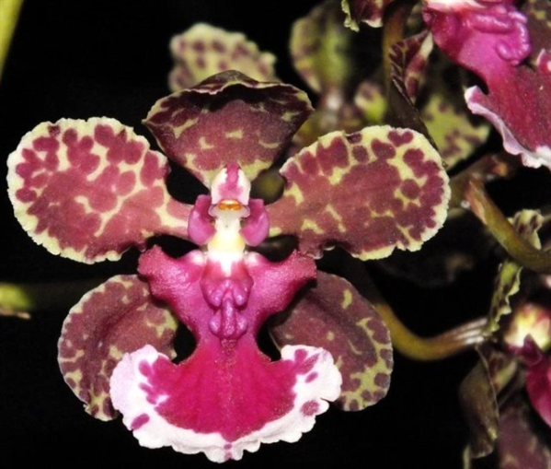
Thirty-seven flowers on one branched inflorescence; sepals and petals cream- green, spotted and blotched gray-purple, margin clear; lip midlobe red-violet, margin white spotted red-violet, crenulated, side lobes uniform red-violet; column cream, wings fuchsia; substance medium; texture matte.

Trichocentrum luridum CCM 83 Points
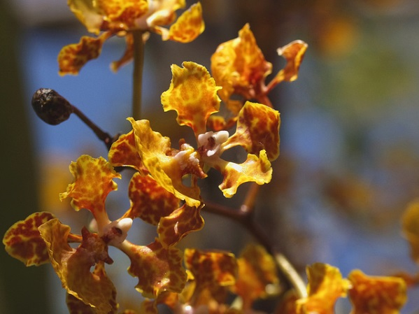
Nine hundred and seventy two flowers and seventeen buds on three, two meter long inflorescences, plant 60 cm tall and 50 cm wide grown in a 25 cm clay pot; sepals and petals orange-yellow mottled red-brown, spatulate, margins wavy; lip yellow, faintly mottled red-brown, callus tubercles white; column and wings white; substance firm; texture matte.

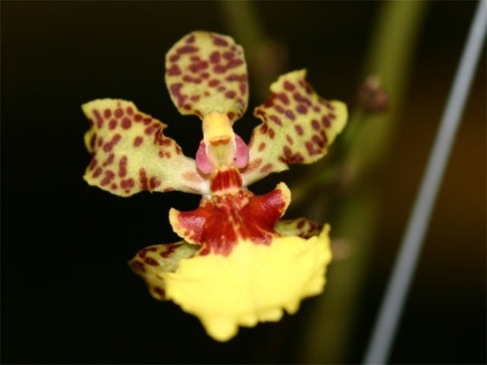
Trichocentrum Noel Schoenrock HCC 78 Points
Fifty-one flowers and 5 buds on one branched inflorescence; sepals and petals yellow, spotted red-brown; lip medial lobe bright yellow, base maroon, edhe irregular, side lobes maroon, distal edges yellow; column yellow with maroon base and pink wings, anther cap yellow; substance heavy; texture waxy.

Psychocentrum Kristi Leigh AM 84 Points
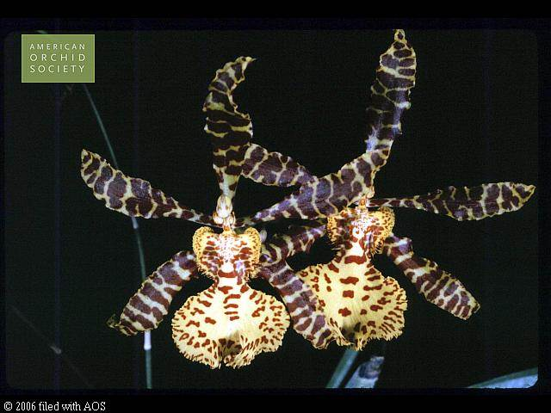
Four flowers on one inflorescence; sepals and petals cream, barred mahogany-brown, lanceolate; lip pale yellow, medial lobe evenly spotted red-brown, larger spots centrally, lip side lobes orange-yellow, barred mahogany medially, edges spotted mahogany; column cream; substance firm; texture satin.

