BUILDING BLOCK DATA

Species Trichocentrum jonesianum

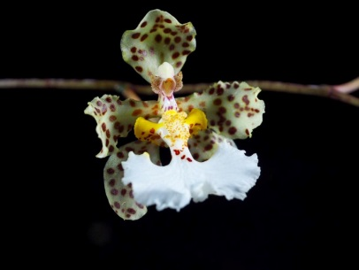
Botanical Varieties (if any):

Synonyms: Odontoglossum jonesianum, Cohniella jonesianum
The Cebolleta group of the genus Oncidium, consisting of 8 species, was moved to the genus Trichocentrum. These orchids are known as the Rat-tail Oncidiums

Awards:

Origin | HCC | AM | CBM | BM | SM |  | Total
 | 1 | 8 | 1 | 2 | 4 |  | 18
Years | 1970 | 1973-2014 | 1965 | 2011 | 1979-2013
Other awards and when given:

Outstanding clones of species and reason they are considered outstanding:

F-1 Hybrids:
Before  1940 | 1940-49 | 1950-59 | 1960-69 | 1970-79 | 1980-89 | 1990-99 | After 1999
 | 1 | 0 | 1 | 3 | 6 | 0 | 1
Total Progeny:
Before  1940 | 1940-49 | 1950-59 | 1960-69 | 1970-79 | 1980-89 | 1990-99 | After 1999
 | 1 | 0 | 1 | 3 | 7 | 1 | 1

Outstanding progeny and reason they are considered outstanding:

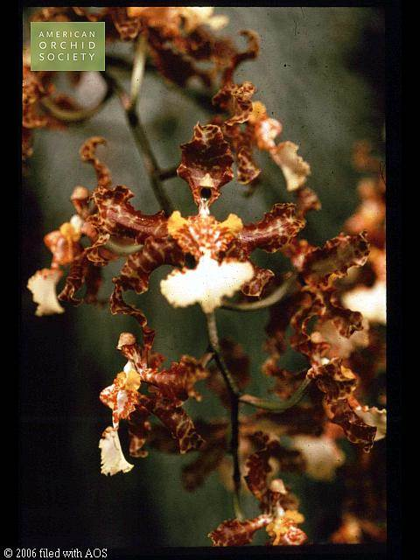
Trichocentrum Jason FuchsAM/AOS

This grex is a primary cross between Trichocentrum stacyi and Trichocentrum jonesianum created in 1981 by R, F. Orchids. A natural hybrid of this cross was found near Santa Cruz, Bolivia by Marv E. Ragan where the two species ranges overlap. Jason Fuchs has been awarded 3 AM, 2 HCC and 3 CCM. It retains the yellows of stacyi and the white lip of jonesianum.

Desirable characteristics which can be passed to progeny:
Showy white lip with basal spots, bright yellow column, spotted dorsal sepal and petals.

Undesirable characteristics which can be passed to progeny:
Extensive curling and/or ruffled margins on sepals and petals.

Other information:
Named for Rev. M. Jones, an orchidists in the 1800’s.

