BUILDING BLOCK DATA

Species Trichocentrum lanceanum
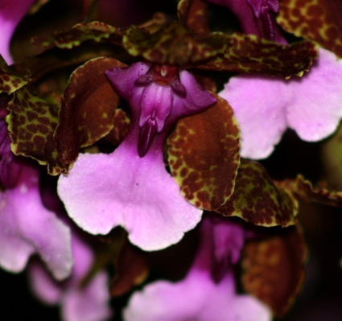

Botanical Varieties (if any):

Synonyms: Oncidium lanceanum
The Lanceanum group of the genus Oncidium, consisting of 17 species, was moved to the genus Trichocentrum. These orchids are known as the Mule Ear Oncidiums

Awards:

Origin | HCC | AM | CCA | CCM | SM | 10 HCC | Total
 | 10 | 22 | 1 | 10 | 1 |  | 48
Years | 1965-2011 | 1963-2013 | 1949 | 1962-2005 | 1963 | 1965-2011
Other awards and when given:

Outstanding clones of species and reason they are considered outstanding:

F-1 Hybrids:
Before  1940 | 1940-49 | 1950-59 | 1960-69 | 1970-79 | 1980-89 | 1990-99 | After 1999
 | 4 | 6 | 6 | 14 | 14 | 7 | 2
Total Progeny:
Before  1940 | 1940-49 | 1950-59 | 1960-69 | 1970-79 | 1980-89 | 1990-99 | After 1999
 | 4 | 6 | 15 | 28 | 32 | 39 | 21

Outstanding progeny and reason they are considered outstanding:

Trichocentrum Jason MaureenAM/AOS

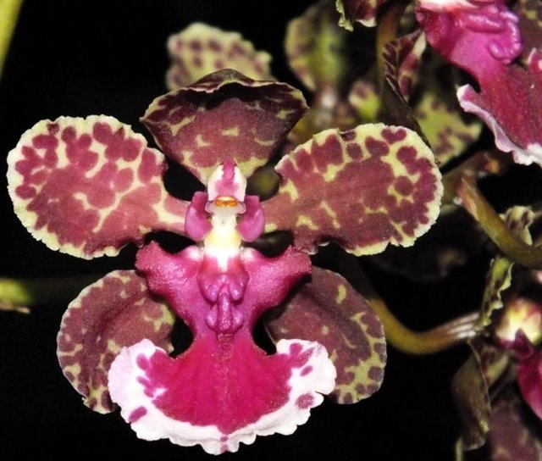
This grex is a primary cross between Trichocentrum lanceanum and Trichocentrum carthagense created in 1942 by F. Atherton. The grex has 20 awards, 7 F-1 offspring and 20 total progeny. In spite of being an old cross, it was used in 2014 in the creation of Trt. Kendra Maria.

Trichocentrum Doctor Schragen AM/AOS

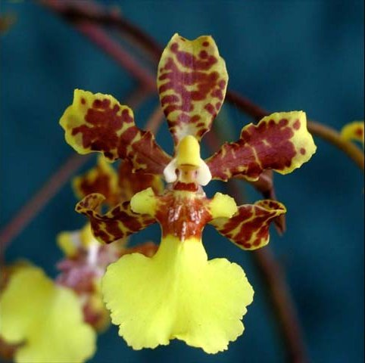
This grex is another primary between Trichocentrum lanceanum and Trichocentrum splendidum, both Mule Ears. It is fairly highly awarded with 8 AM and 10 HCC. It is prolific with 28 total progeny. The yellows and browns of its splendidum parent are dominant in the grex.

Trichocentrum Maui Gold AM/AOS

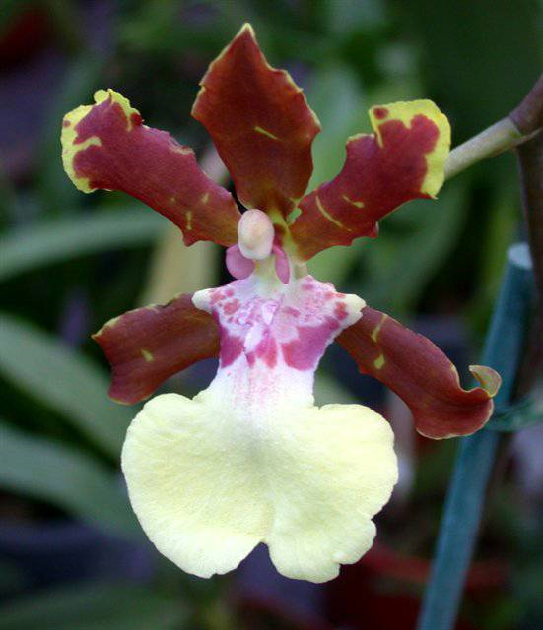
This grex is a cross between Trichocentrum lanceanum and Trt Florida Gold. Florida Gold is a primary between Trichocentrum splendidum and Trichocentrum bicallosum. All three species anr Mule Ears. Maui Gold has 9 progent and has been awarded 11 times. It has 7 AM, 2 CCM and an HCC. It has a beautiful white lip with a pink base from its lanceanum parent.

Desirable characteristics which can be passed to progeny:
Fantastic colors from a deep rusty red transitioning to a light pink on the lip. Yellow margins on the dorsal sepal and petals. The upright inflorescence is of a reasonable length, not more than 16 inches. The flowers are large, about 2.5 inches natural spread.

Undesirable characteristics which can be passed to progeny:
Very small spatulate lip, very open form, patterning highly variable.

Other information:
Named for John Lance, a collector of orchids In S America during the 1800’s.

