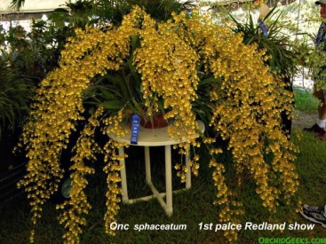
Oncidium sphacelatum CCM 87 Points
Six thousand five hundred forty-two flowers and twenty-seven buds beautifully displayed on 26 inflorescences averaging 110 cm in length on a plant 79 cm in diameter and 62 cm tall; flowers deep golden yellow, sepals and petals yellow, barred chestnut; lip distal two-thirds solid golden yellow, base chestnut; substance firm; texture matte.

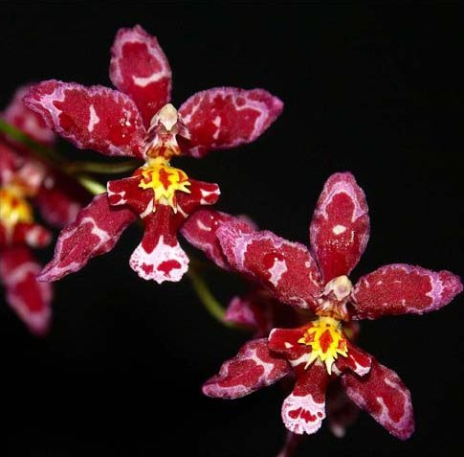
Cyrtocicidum Kolibri HCC 78 Points
Forty-one flowers and 15 buds on four arching inflorescences; sepals and petals dark pink with irregular deep red patterns; lip white, distal third spotted deep red, base and side lobes deep red, crest orange yellow; column pink, anther cap white; substance firm; texture matte.

Oncostele Golden Trident AM 83 Points
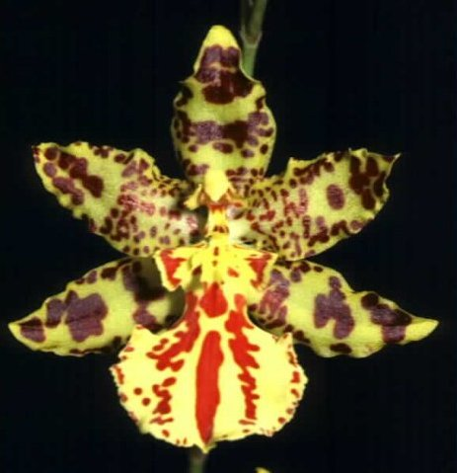
One hundred twenty flowers and 17 buds on four branched inflorescences; sepals butter yellow, blotched and barred brown-burgundy, petals butter yellow, finely spotted brown-burgundy proximally, blotched distally; lip pale yellow with fine cordovan-red spots at edge, three bold cordovan-red central stripes; column cream, spotted mahogany; substance firm; texture waxy.

Oncidium leucochilum HCC 79 Points
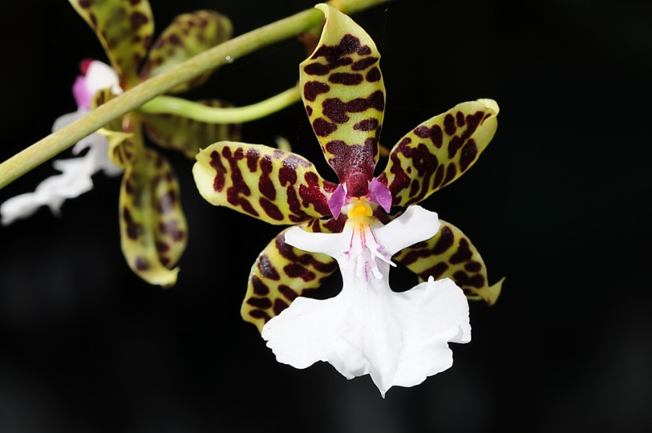
Fifty-three flowers and 6 buds on one 162 cm inflorescence; sepals and petals light yellow-green, heavily barred dark red-brown; lip white, throat with pink streaks, callus gold; column yellow, wings pink, anther cap maroon; substance firm; texture waxey.

Otorhynchocidium Cherry Fudge AM 84 Points
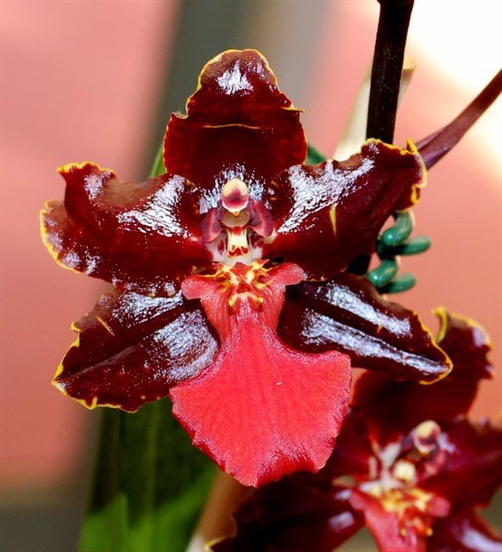
Sixty-one richly colored flowers and 21 buds on four branched inflorescences; sepals and petals oxblood-red, margins ruffled, edged bright yellow; lip brick-red, callus red spotted yellow; column white, blotched red; substance good; sepal and petal texture waxy, lip satin.

