BUILDING BLOCK DATA
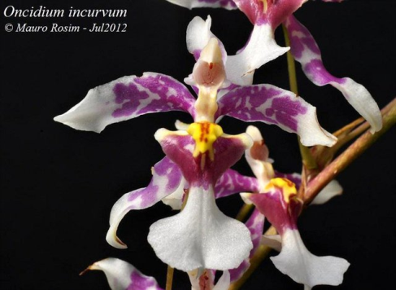
Species Oncidium incurvum

Botanical Varieties (if any):

Synonyms: Oncidium unguitigrinum

Awards:

Origin | AV3 | AM | CCE | CCM | JC | BM | Total
 | 1 | 2 | 0 | 1 | 4 | 1 | 17
Years | 2011 | 1970-1983 |  | 1958 | 1977-1982 | 2013
Other awards and when given:

Outstanding clones of species and reason they are considered outstanding:

F-1 Hybrids:
Before  1940 | 1940-49 | 1950-59 | 1960-69 | 1970-79 | 1980-89 | 1990-99 | After 1999
12 | 2 | 2 | 9 | 54 | 64 | 29 | 42
Total Progeny:
Before  1940 | 1940-49 | 1950-59 | 1960-69 | 1970-79 | 1980-89 | 1990-99 | After 1999
12 | 2 | 3 | 12 | 73 | 154 | 203 | 262

Outstanding progeny and reason they are considered outstanding:

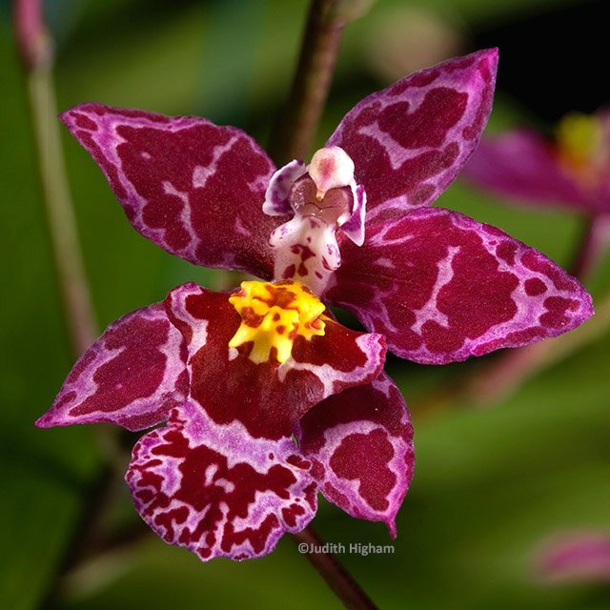
Cyrtocidium Kolibri ’Pink Angel’ HCC/AOS

This hybrid is an interresting layering of pink from Onc. sotanum overlaid by the darker colors of Onc. nobile and Onc incurvum. Incurvum’s narrow petals and sepals were not oassed on. This cross made in 1984 has produced 12 progeny in 2 generations and has been awarded 11 times including 2 AM and 7 HCC.

Desirable characteristics which can be passed to progeny:

Undesirable characteristics which can be passed to progeny:

Other information:

