BUILDING BLOCK DATA

Species Oncidium leucochilum

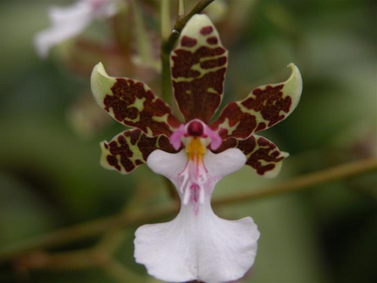
Botanical Varieties (if any):

Synonyms: Cyrtochilum leucochilum

Awards:

Origin | HCC | AM | CCE | CCM | CC |  | Total
 | 8 | 4 | 1 | 3 | 1 |  | 17
Years | 1964-1994 | 1967-2009 | 2002 | 1964-1967 | 1982
Other awards and when given:

Outstanding clones of species and reason they are considered outstanding:

F-1 Hybrids:
Before  1940 | 1940-49 | 1950-59 | 1960-69 | 1970-79 | 1980-89 | 1990-99 | After 1999
1 | 1 | 2 | 12 | 7 | 23 | 20 | 36
Total Progeny:
Before  1940 | 1940-49 | 1950-59 | 1960-69 | 1970-79 | 1980-89 | 1990-99 | After 1999
1 | 1 | 2 | 23 | 50 | 87 | 148 | 435

Outstanding progeny and reason they are considered outstanding:

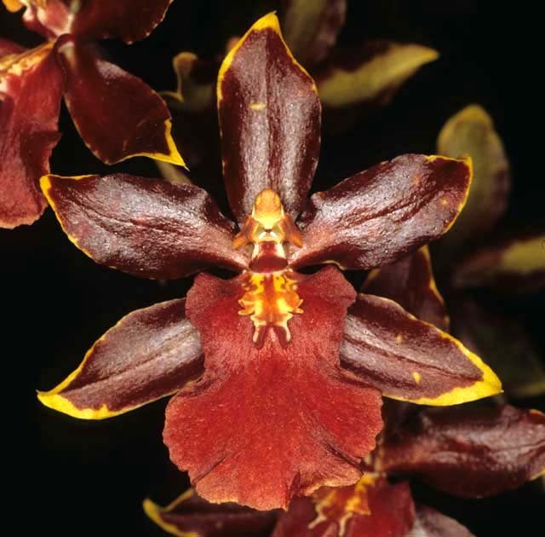
Oncostele Wildcat ‘Dandi’s Bloodshot’ AM/AOS

This outstanding grex has produced 47 F-1 offspring and 78 progeny in 3 generations. The color intensity and contrasts are exquisite. It is a cross between Oncostele Rustic Bridge and Oncidium Crowborough and has Ons. leucochilum, uroskinneri and fuscatum in its background.

Desirable characteristics which can be passed to progeny:
The white lip is passed on the majority of its progeny as well as the lavender lip base and column. The absence of patterns on the tips of the dorsal sepal and petals seems to breed true.

Undesirable characteristics which can be passed to progeny:
The flower is relatively open with narrow petals and sepals.

Other information:
Loo-koe-kye-lum – White Lip

