BUILDING BLOCK DATA

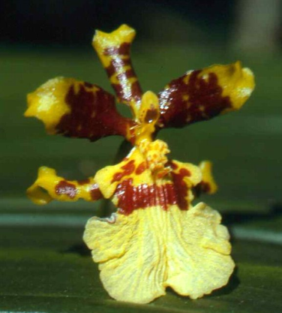
Species Oncidium sphacelatum

Botanical Varieties (if any):

Synonyms: Cyrtochilum leucochilum

Awards:

Origin | HCC | AM | CCE | CCM | CC |  | Total
 | 2 | 4 | 3 | 14 | 4 |  | 17
Years | 1966-1989 | 1990-2011 | 2006-2013 | 1990-1997 | 1945-1965
Other awards and when given:

Outstanding clones of species and reason they are considered outstanding:

F-1 Hybrids:
Before  1940 | 1940-49 | 1950-59 | 1960-69 | 1970-79 | 1980-89 | 1990-99 | After 1999
1 | 2 | 3 | 7 | 16 | 22 | 13 | 28
Total Progeny:
Before  1940 | 1940-49 | 1950-59 | 1960-69 | 1970-79 | 1980-89 | 1990-99 | After 1999
1 | 2 | 3 | 10 | 28 | 41 | 90 | 362

Outstanding progeny and reason they are considered outstanding:

Oncostele Catante AM/AOS

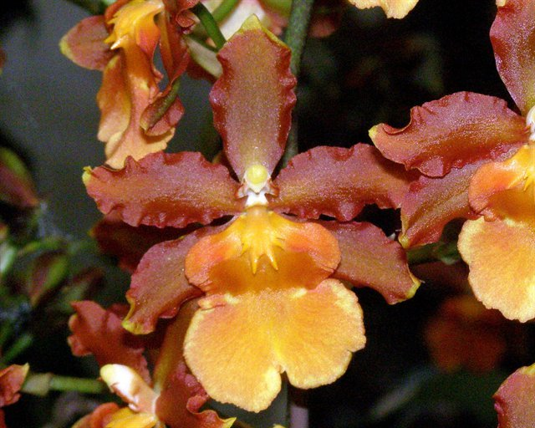
Created in 2002, this grex has been prolific with 44 F-1’s and 53 total progeny in2 generations. It’s Oncidium and Rhynchostele species ancestry is two generations back with Onc. fuscatum, cariniferum, leucochilum and Rst. uroskinneri. Onc. sphacelatum is 1 generation back. The yellows and rusty browns of sphacelatum are strong.

Desirable characteristics which can be passed to progeny:
Vigorous plant with multiple inflorescences per bloom cycle. Great typical Oncidium color.

Undesirable characteristics which can be passed to progeny:
Oncidium sphacelatum grows like a weed getting too large for a greenhouse bench in no time.

Other information:

