BUILDING BLOCK DATA

Species Oncidium tigrinum
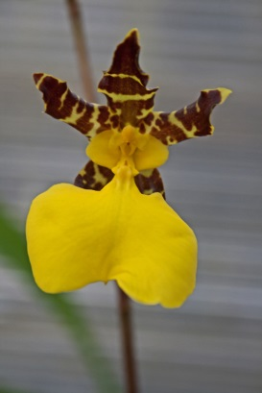

Botanical Varieties (if any):

Synonyms: Oncidium unguitigrinum

Awards:

Origin | AV3 | AM | CCE | CCM | JC | BM | Total
 | 1 | 2 | 0 | 1 | 4 | 1 | 17
Years | 2011 | 1970-1983 |  | 1958 | 1977-1982 | 2013
Other awards and when given:

Outstanding clones of species and reason they are considered outstanding:

F-1 Hybrids:
Before  1940 | 1940-49 | 1950-59 | 1960-69 | 1970-79 | 1980-89 | 1990-99 | After 1999
12 | 2 | 2 | 9 | 54 | 64 | 29 | 42
Total Progeny:
Before  1940 | 1940-49 | 1950-59 | 1960-69 | 1970-79 | 1980-89 | 1990-99 | After 1999
12 | 2 | 3 | 12 | 73 | 154 | 203 | 262

Outstanding progeny and reason they are considered outstanding:

Brassidium Pagan Lovesong

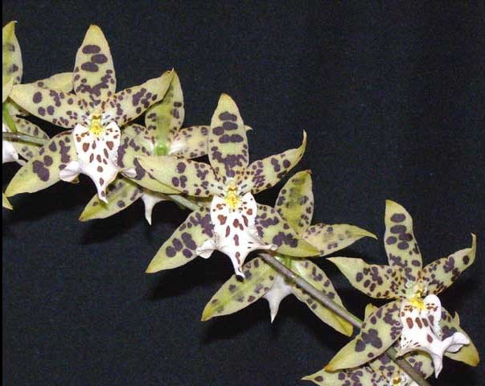
This grex has produced 37 progeny in 2 generations and has been awarded 60 times. It is a cross between Brassia verrucosa and Onc. Tiger Butter which is in turn Onc. tigrinum by Onc. Avalanche. Brings together the high flower count of Oncidium and the longer sepals and petals of Brassia

Desirable characteristics which can be passed to progeny:
Intense yellow lip, narrow base of medial lobe of the lip flaring out to the lip lateral lobes. High flower count.

Undesirable characteristics which can be passed to progeny:

Other information:

