Oncidium Sw., Kongl. Vetensk. Acad. Nya Handl., 21, 239 (1800)
Type species: Oncidium altissimum
Description
Small to large epiphytic orchid, leaves 2 to 4, bifacial. Inflorescences usually 1 to3, branched or unbranched, erect to pendant, usually longer than the leaves. Inflorescences with 2 120 flowers, species in the former genus Sigmatostalix flowering repeatedly from the same spike. Flowers are resupinate, cream, white, yellow or pink with reddish brown markings. Sepals and petals are free, lanceolate and similar in shape and size. Lip highly variable, linear, hastate to trilobed. Callus a complex toothed structure at the base of the lip. Column straight, with or without wings, often with a tabula infrastigmatica, pollinarium with a tubularized stipe.
Delineation of Oncidium has been one of the most contentious issues in Orchid taxonomy. For years the angle of the lip to the column was used to delimit Oncidium, but this often placed closely related species in different genera. Floral morphology in Oncidium is highly plastic and subject to selective pressure as pollinators change. The use of vegetative traits in combination with a few floral characteristics is a better basis for generic delimitation.
In regard to the three Oncidium Groups assigned for October, a cladogram from Genera Orchidacearum Volume 5 shows some interesting relationships between and within the Groups.
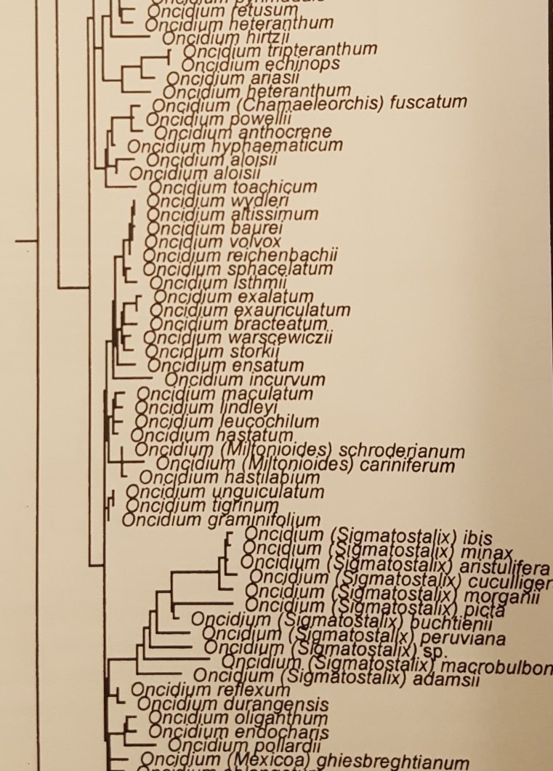
The Sphacelatum Group species are all low elevation plants with the flower morphology and coloration typical of the oil-bee syndrome pollinated by Centris bees. The species are fairly well grouped around Onc. sphacelatum with a couple of odd balls more closely related to the former Sigmatostylix.
The Hastatum Group, from higher elevations, has coloration more attractive to bees other than Centris and not mimicking the Malpighiaceae. The cladogram affirms close affinities but with a group of three species in their own subclade.
The Heteranthum Group, also from higher elevations, are typified by many aborted flowers on the inflorescence. The relatedness of this group is questionable as there is quite a spread of species on the cladogram.

