Genus Oncidium – Anthocrene Group

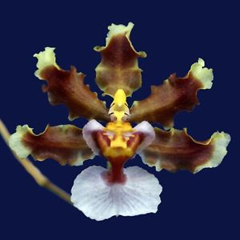
Oncidium anthocrene
The Oncidium Anthocrene Group was originally made up of 6 species, two of which ( Onc. aloisii & Onc. pardothyrsus) are now synonyms of Oncidium planilabre.
The group has contributed genetic material to 1071 progeny and has garnered 29 awards.

Species | Distribution | Light/Temp | Progeny | Awards
Onc. anthocrene | Panama | Hi/Warm-Hot | 38/210 | 2 HCC, 1 CHM, 1 CCM, 1 CBM
fuscatum | Peru, Ecua, Colo, Panama | Lo/Cool-Warm | 129/841 | 4 AM, 1 HCC, 1 CBM
maduroi | Panama | Hi/Cool-Warm | 1/1 | 1 CHM
planilabre | Peru, Ecu, Nicar | Lo/Warm-Hot | 5/20 | 1 HCC, 1 CHM, 1 CBR
Detailed discussion following.
References:
www.orchidspecies.com
Pridgeon, Cribb, Chase, Rasmussen, ed. Genera Orchidacearum, Vol. 5, Epidendroideae
Chase, ed., Orchids-The Pictorial Encyclopedia of Oncidium
OrchidWiz Database X3.0
La Croix, The New Encyclopedia of Orchids
Alrich, Higgins, Illustrated Dictionary of Orchid Genera
Meisel, Kaufmann, Pupulin, Orchids of Tropical America

