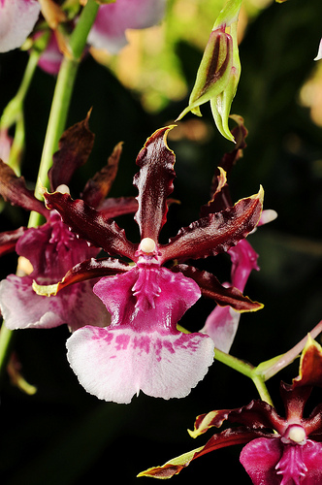
Oncidium Debutante – AM/AOS 81 points
One-hundred and seventy-two flowers and seventeen buds on three arching inflorescences; sepals and petals mahogany, tipped yellow, edges crenulated; lip white, mask magenta, row of radiating magenta spots and stripes at distal edge of mask, callus magenta; substance average; texture matte.
Note for Emily: Oncidium fuscatum hybrid

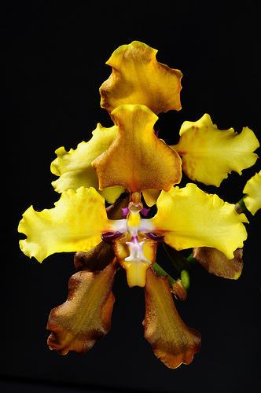
Cyrtochilum McBeanianum – HCC/AOS 77 points
Fifty-three flowers and nine buds on one twining inflorescence; sepals yellow overlaid bronze, margins ruffled, picoted yellow; petals yellow, base white grading to fuchsia; lip yellow, side lobes picoteed red-brown; callus white; substance average; texture matte.
Note for Emily: Cyrtochilum macranthum hybrid.

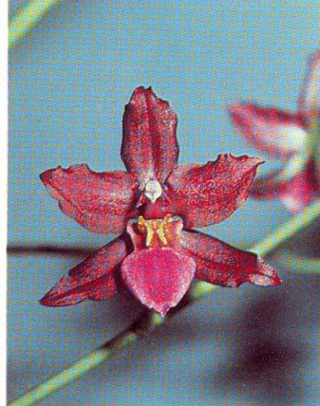
Cyrtostele Groganiae - HCC/AOS 76 points
Forty-one flowers and eleven buds widely spaced on one 100 cm, branched inflorescence; sepals solid red-maroon, lateral sepal tips blushed white; petals solid red-maroon; lip fuchsia lighter at edge; callus yellow; substance firm; texture waxy.
Note for Emily: Cyrtochilum edwardii hybrid

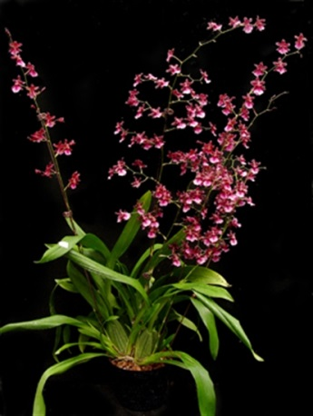
Oncidium Sharry Baby – CCM/AOS 82 points
Four hundred twenty-seven flowers and nine buds on four upright, branched inflorescences and one immature inflorescence; sepals and petals deep red mahogany; lip central lobe white, crest and lip base streaked red-purple; anther cap pale yellow; substance light; texture matte.
Note for Emily: Oncidium anthocrene hybrid
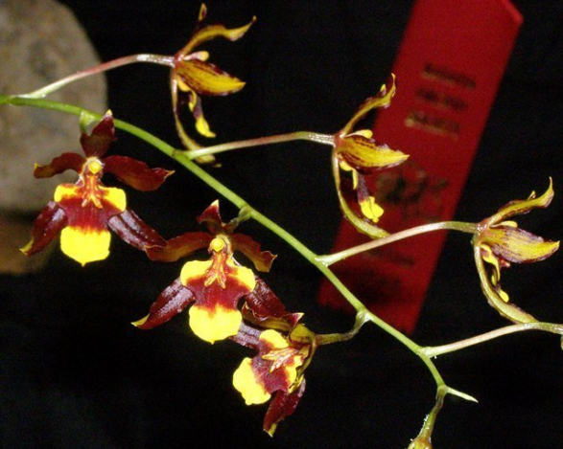
Cyrtocidium Roger Cole AM/AOS 82 points
One hundred twelve well presented, flat flowers and sixteen buds on four branched inflorescences, sepals and petals deep brown, tipped lemon yellow; lip bright yellow, banded mahogany centrally, side lobes bright yellow; callus golden; anther cap yellow; substance firm; texture glossy.
Note for Emily: Cyrtochilum retusum hybrid

