SPECIES DATA SHEET
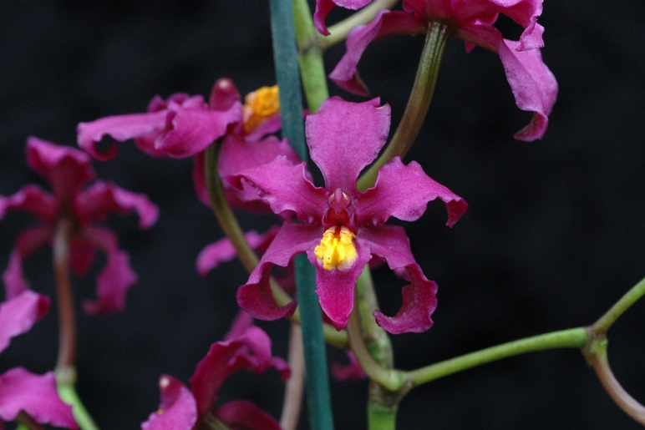
Cyrtochilum edwardii (Rchb. F.) Kraenzl. 1917
This species is found in Colombia and Ecuador. It is a medium sized, cold growing epiphyte at elevations of 2300 to 2700 meters. It has ovoid, pyriform pseudobulbs enveloped basally by several pairs of leaf -bearing sheaths carrying 2 apical, ligulate, subcoriaceous, acute leaves that change below into a conduplicate base that blooms on a usually erect, many branched, to 3' [90 cm] long, many flowered inflorescence with fragrant, showy flowers occurring in the spring and summer. The species grows near the ground, and it’s long, vining inflorescence climbs up through the vegetation to reach brighter areas. The species was named for Eduard Klaboch, a Nineteenth Century German collector in South America. Odontoglossum edwardii is a synonym.
Awards:
Origin | AM | HCC | CBM | CCM | CHM
AOS | 1 | 1 | 2 | 1 | 1

Total: 6

Hybrids: Total of 222 registered to the 6th generation
Intergeneric hybrids have been made with Brassia (Brassochilum -1), Oncidium & Rhynchostele (Cyrtocidistele - 17), Oncidium & Miltoniopsis (Cyrtoncidopsis – 17), Miltoniopsis (Cyrtoniopsis – 15), Oncidium & Brassia (Cyrtobrassidium – 2), Oncidium (Cyrtocidium – 150), Caucaea (Cyrtocauceae – 1), Rhynchostele (Cyrtostele – 4), and Otoglossum ( Otoglochilum – 2).
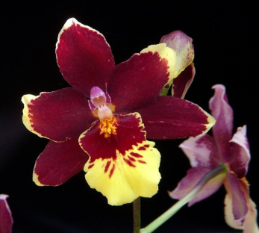
Cyrtoncidopsis Rustic Midnight
(Cyrtoniopsis Bragelonne x Miltoniopsis Memoria Ida Seigel)

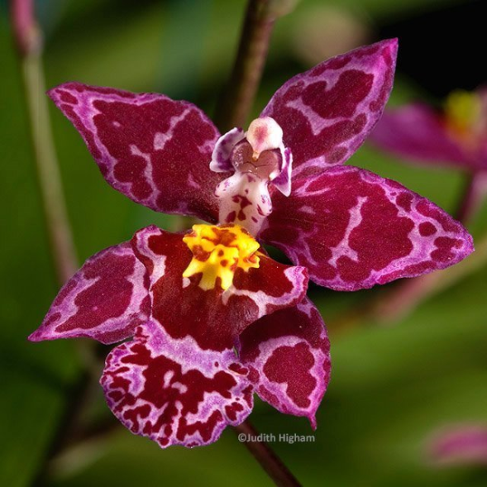
Cyrtocidium Kolibri ‘Pink Angel’ HCC/AOS
(Cyrtochilum Intermezzo x Oncidium nobile)

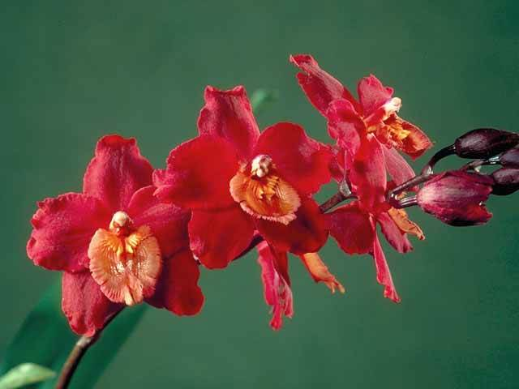
Cyrtocidium Imperial Red ‘Vulvan’s Flame’ AM/AOS
(Oncidium Lautrix x Cyrtocidium Alliance)

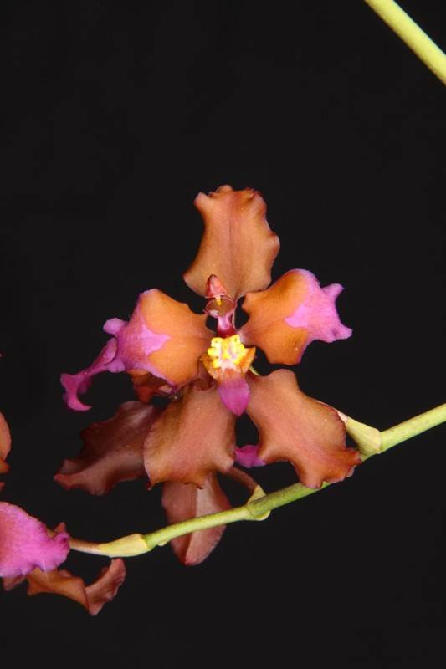
Cyrtochilum Rustic Harlequin AD/AOS
(Cyrtochilum Edwardatum x Cyrtochylum undulatum)

