SPECIES DATA SHEET
Cyrtochilum macranthum [Lindley] Kraenzlin 1917
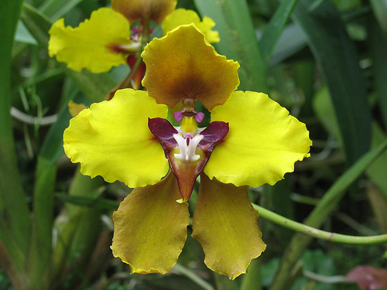
This species is large, cold growing epiphyte from the mountain cloud forests (up to 3000 meters) of Colombia, Peru and Ecuador. The flowers are the largest in the genus at up to 10 cm natural spread. The pseudobulbs are slightly compressed, ovoid to conical enveloped basally by 3 to 4 imbricating sheaths and carrying 2 apical, linear-oblong to oblanceolate, acute leaves and blooms in the fall through spring on an axillary, stout, woody, to about 12' [360 cm] long, ascending to arcuate, long, paniculate, each branch 2 to 5 flowered, several flowered inflorescence arising on a mature pseudobulb through the axil of the basal sheath carrying showy, long-lasting flowers. The species grows near the ground, and it’s long, vining inflorescence climbs up through the vegetation to reach brighter areas.
Awards:
Origin | FCC | AM | HCC | CCE | CCM | CBM | JC | Total
AOS | 1 | 16 | 12 | 1 | 3 | 1 | 1 | 35

Hybrids: Total of 73 registered to the 4th generation
Intergeneric hybrids have been made with Brassia (Bss. Brassochilum -5), Aspasia (Cpas. Cyrtopasia – 2), Miltonia & Oncidium (Mld. Miltochilidium – 3), Miltoniopsis (Crn. Cyrtoniopsis – 1), Miltonia (Mtc. Miltochilum – 7) Oncidium (Ctd. Cyrtocidium – 30), Maxillaria (Clr. Cyrtollaria – 1) and Rhynchostele (Cye. Cyrtostele – 2). Within the genus Cyrtochilum (Cyr.), 17 hybrids has been created

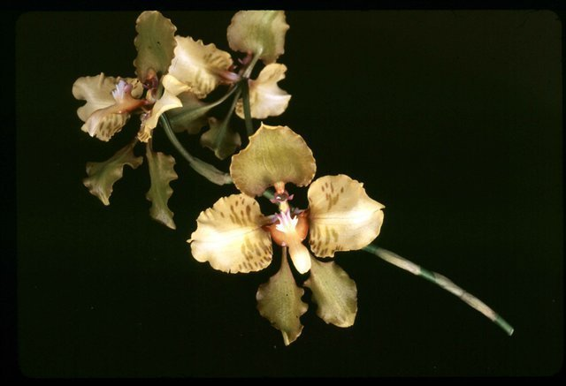
Cyrtochilum McBeanianum
(Cyrtochilum macranthum x Cyrtochilum halteratum)

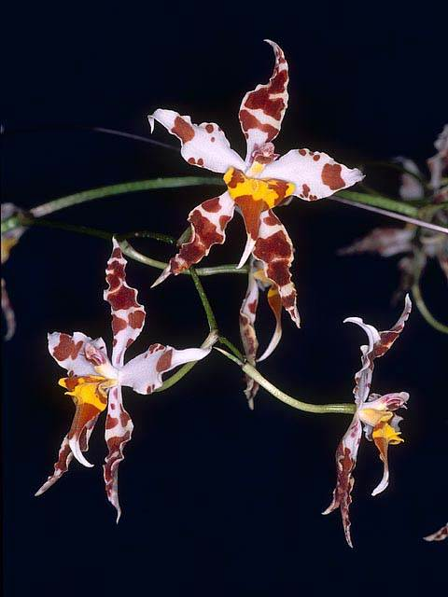
Cyrtocidium Ecuador ‘Marsh Hollow Star’ HCC/AM
(Oncidium cirrhosum x Cyrtochilum macranthum )

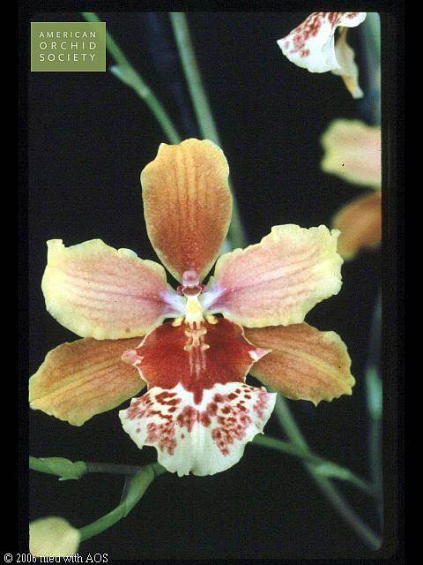
Cyrtoniopsis Maxine ‘Newton’ AM/AOS
(Miltoniopsis vexillaria x Cyrtochilum macranthum)

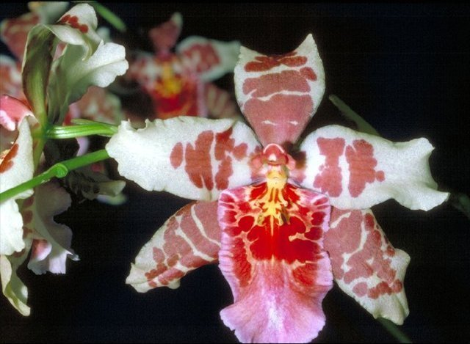

Miltochilum Jacob’s Coat ‘Glamor” AM/AOS
(Miltochilum Ecuador x Oncidium Yukon Harbor)

