SPECIES DATA SHEET
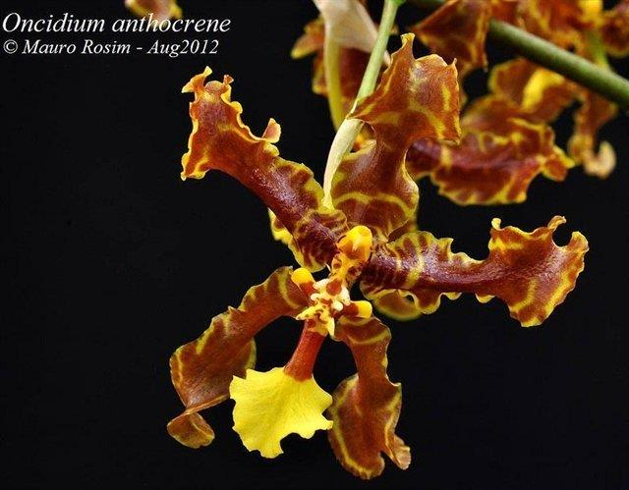
Oncidium anthocrene
Found from Panama, Colombia and Ecuador at elevations of 100 to 1000 meters as a large sized, hot to warm growing epiphyte or sometimes terrestrial orchid with ovate, ribbed, laterally compressed, ancipitous pseudobulbs enveloped basally by several leaf-bearing sheaths and carrying 2 apical, linear-lanceolate, conduplicate below into the base leaves and blooms in the winter and spring on an erect to arching, 60 to 120 cm long raceme with several short basal branches of 2 to 3 flowers each of several to many, showy, waxy, very fragrant flowers on the rest.

Awards:
Origin | CHM | CCM | CBM | HCC
AOS | 1 | 1 | 1 | 1

Hybrids: Total of 210 registered to the 6th generation
Like the other Anthocrene Group species, Oncidium anthocrene has been hybridized most often with other Oncidium species with 128 crosses. The intergeneric hybrids have utilized:

Miltonia and Brassia = Aliceara - 3 (Alcra.)
Brassia and Gomesa = Brassidomesa – 2 (Bdm.)
Brassia = Brassidium – 21 (Brsdm.)
Cyrtochilum = Cyrtocidium – 2 (Ctd.)
Miltonia = Miltonidium – 7 (Mtdm.)
Miltoniopsis = Oncidiopsis – 10 (Oip.)
Gomesa = Oncidesa – 19 (Oncsa.)
Rhynchostele = Oncostele – 8 (Ons.)

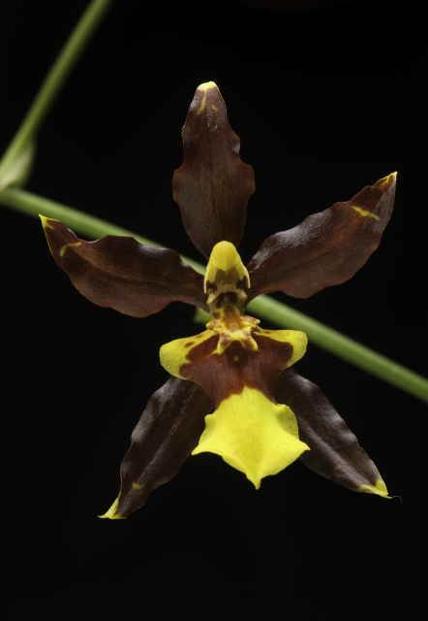
Cyrtocidium Dark Chocolate ‘Godiva’ AM/AOS
(Cyrtocidium Roger Cole x Oncidium anthocrene)

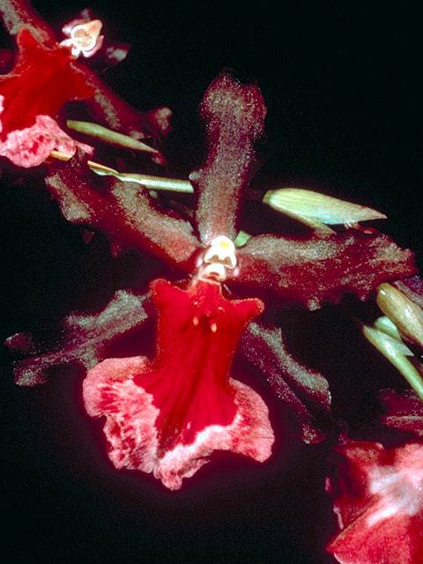
Miltonidium Howard Gerber ‘Remar’ HCC/AM
(Miltonidium Gatum Lake x Oncidium Elegance)

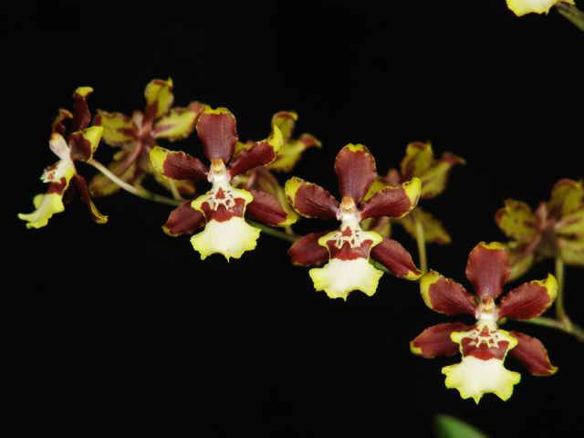

Oncidesa Kona Boy ‘Aka’ HCC/AOS
(Oncidesa Makalii x Oncidium Sharry Baby))

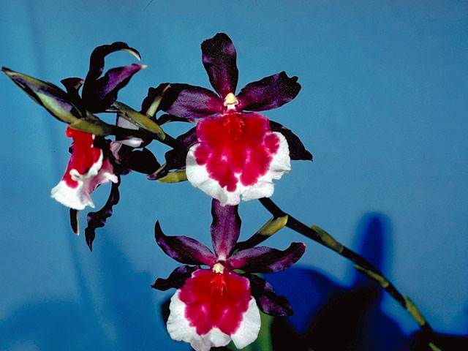
Miltonidium Jupiter ‘Leilehua’ AM/AOS
(Miltonidium Royal x Oncidium Elegance)

