SPECIES DATA SHEET
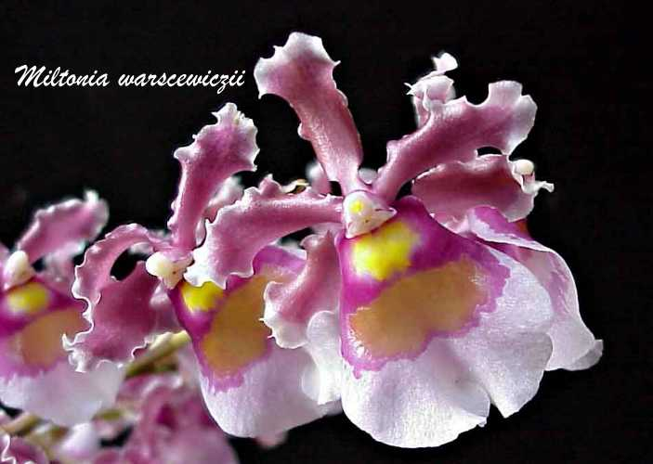
Oncidium fuscatum

This large sized, hot to cool growing epiphytic orchid found from Panama south to Peru, with oblong-cylindrical, compressed pseudobulbs enveloped basally by 1 or 2 leaf-bearing sheaths and carrying a single, apical, linear-lanceolate to oblong, acute or rounded leaf that blooms in the spring on an axillary, from the basal leaf sheaths of the pseudobulb, to 2' [60 cm] long, racemose or often paniculate inflorescence that is longer than the leaves, carrying many, fragrant, waxy, variable in color flowers and has lanceolate-acuminate bracts. Was included in Miltonia as the species Miltonia warscewiczii and when moved to Oncidium, the epithet was occupied and was assigned to Onc. fuscatum.

Awards:
Origin | AM | HCC | CBM | Total
AOS | 4 | 1 | 1 | 6

Hybrids: Total of 841 registered to the 6th generation
This species has been used extensively in hybridization with a large number of genera in the Oncidium Alliance. Hybrids between Onc. fuscatum and other species of the genus Oncidium number 403, almost half of the registered crosses. Intergeneric hybrids have been made with :
Brassia & Miltonia - Aliceara – 26
Aspasia - Aspasium – 4
Brassia - Brassidium – 41
Cyrtochilum - Cyrtocidium – 6
Gomesa & Miltonia - Gomeltidia – 7
Cyrtochilus and Miltonia - Miltochilidium – 3
Miltonia - Miltonidium – 74
Tolumnia - Oncidumnia – 11
Miltoniopsis - Oncidiopsis – 38
Gomesa - Oncidesa – 35
Rhynchostele - Oncostele – 148
Oncostele & Miltoniopsis - Oncostelopsis – 9
Trichocentrum - Trichocidium – 5
Zelenkoa - Zelenkocidium – 3
Oncidium fuscatum is a compact species used by breeders to create floriferous spray-flowered orchids with adaptable requirements. The compactness is a result of close growing pseudobulbs. A red-maroon pattern is present on the upper part of the lip of most offspring. Flowers tend to bunch closely on branched inflorescences. An interesting negative trait is a coal-tar odor often passes on to progeny.
Additional Reference:
Fitch, Charles M., Orchids Magazine, July 2004, Vol 73, No7, Oncidium Fuscatum Hybrids

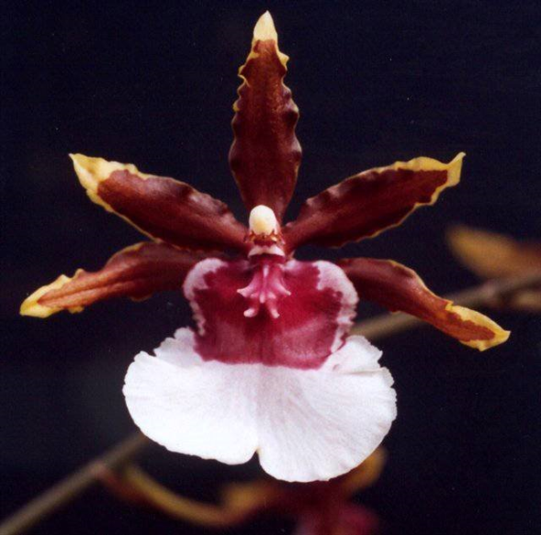
Oncidium Debutante ‘Oxbow’ AM/AOS
(Oncidium fuscatum x Oncidium cariniferum)

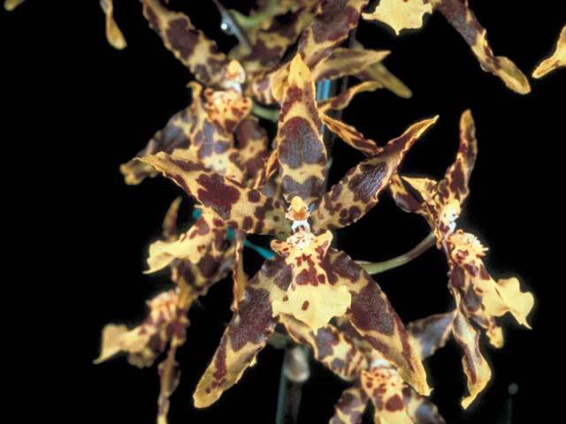
Brassidium Whidbey Island ‘Jan’s Jewell’ HCC/AM
(Brassidium Pacesetter x Oncidium Gold Basin)

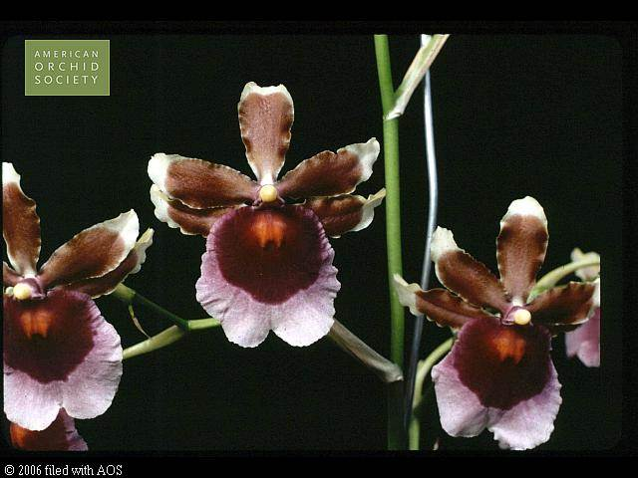
Miltonidium Delaware ‘Okemos’ HCC/AOS
(Miltonidium Delectable x Oncidium fuscatum)

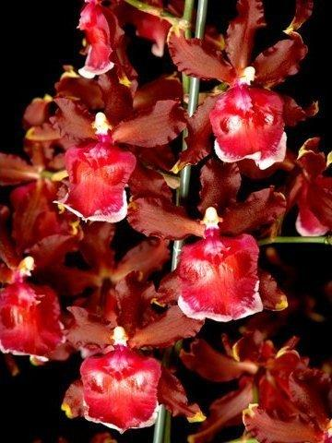
Oncostele Piquant ‘Von Helstron’ HCC/AOS
(Oncidium Linda Isler x Oncidium fuscatum)

