Rhynchostele bictoniensis AM/AOS 81 points
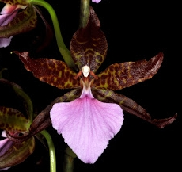
Twenty-one flowers and seven bids on two upright inflorescences; sepals and petals dark green, heavily barred and spotted mahogany; highly contrasting lip rose-pink, darker at base with radiating darker veins; column maroon, anther cap white; substance good; texture matte.

Oncidium hallii HCC/AOS 77 points
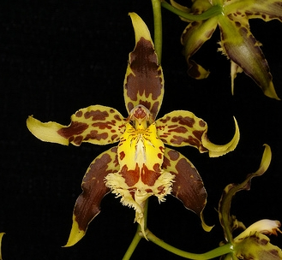
Nine flowers and eleven buds on two inflorescences; sepals orange-yellow, solid brown centrally, tip unmarked; petals orange-yellow, spotted brown, curled; lip fringed, golden yellow, spotted oxblood marginally, tip solid oxblood, crest gold, striped oxblood; column gold; substance heavy; texture waxy.

Aliceara Hani HCC/AOS 78 points
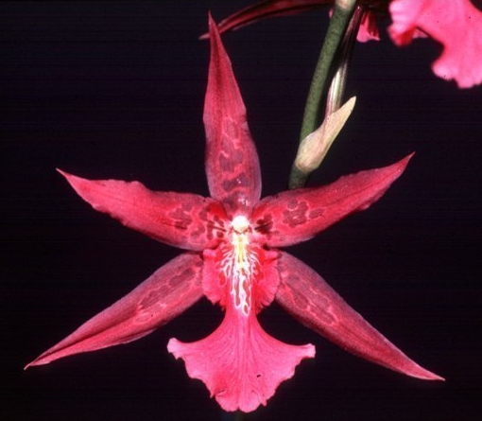
Nine flowers and 3 buds on two inflorescences; sepals and petals narrow, base color red-violet, medial blotching darker; lip distal edge ruffled, pink with darker side lobes, callus white; column and cap white; substance medium; texture matte.

Oncidium Vanilia AM/AOS 80 points
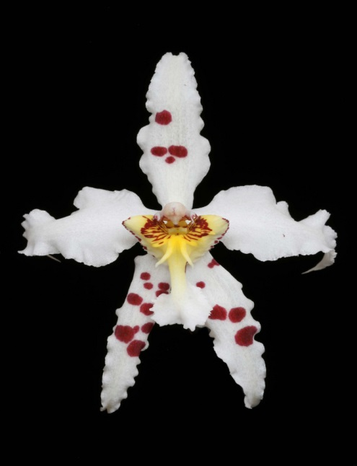
Twenty-three flowers and seven buds on one inflorescence; sepals, ruffled, pure white, spotted maroon; petals ruffled, reflexed at tip, pure white; lip white, callus canary yellow, splotched red; column and anther cap cream; substance good; texture crystalline.

Rhynchostele rossii CCM/AOS 83 points
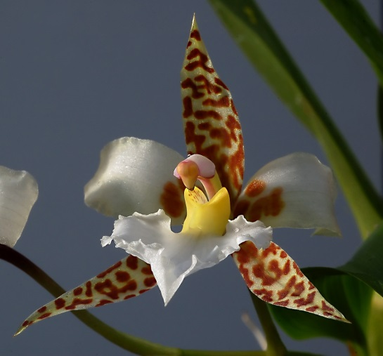
Forty-three stellate flowers on six inflorescences on a well-grown 40 cm tall plant grown in a 23 cm clay pot; leaves stiff and clean; sepals cream, blotched mahogany over entire length; petals cream, blotched mahogany at base; lip spatulate, ruffled, white; callus golden yellow; column pale lavender; substance average; texture matte.

