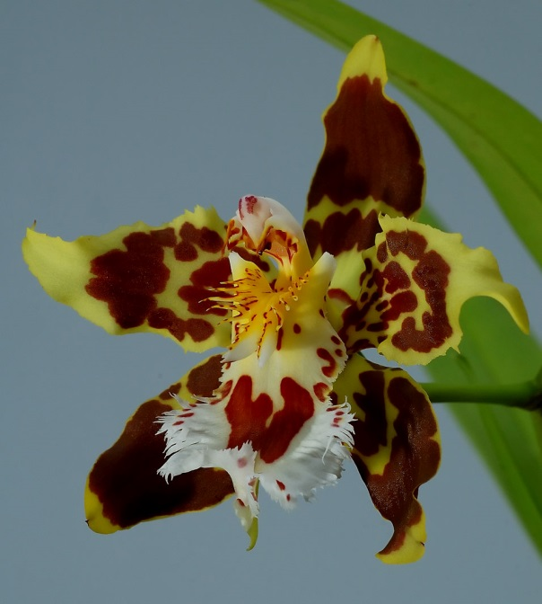
BUILDING BLOCK DATA

Species Oncidium hallii
Distribution: Ecuador
Habitat: Grows in very wet mountain cloud forests at elevations of 6500 – 10,000 ft. Most are found in humis on steep embankments and on small solitary trees.

Botanical Varieties (if any):

Synonyms: Odontoglossum chartostroma, Odontoglossum hallii
Odontoglossum hallii was moved from Odontoglossum to Oncidium with the reorganization of the Oncidiinae based on molecular biological data.

Awards:

Origin | HCC | AM | FCC | CCA | CCM | ACC | Total
 | 3 | 6 | 0 | 1 | 11 | 3
Years | 1989-2004 | 1969-1999 |  | 1958 | 1960-2011 | 1993-1999

Other awards and when given:

Outstanding clones of species and reason they are considered outstanding:

F-1 Hybrids:
Before  1940 | 1940-49 | 1950-59 | 1960-69 | 1970-79 | 1980-89 | 1990-99 | After 1999
22 | 0 | 0 | 2 | 9 | 4 | 3 | 8
It is interesting to note that there was a flurry of primary hybridizing as early as 1896 and into the 1920’s and then a long hiatus. The latest F-1 was produced in 2014 with a cross with Oncidium wyattianum.

Total Progeny:
Before  1940 | 1940-49 | 1950-59 | 1960-69 | 1970-79 | 1980-89 | 1990-99 | After 1999
60 | 2 | 10 | 10 | 43 | 107 | 160 | 392
There have been 12 generations of progeny produced using genetic material from Oncidium hallii. After generation 5, Onc. hallii disappears into the Other slice of the parentage pie diagram. Most crosses are dominated by Oncidium alexandrae.

Outstanding progeny and reason they are considered outstanding:

Oncostele Wildcat AM/AOS

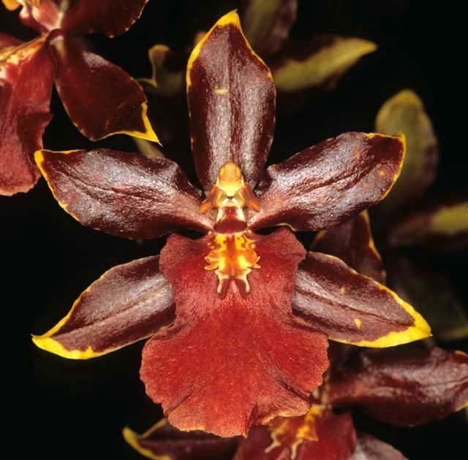
Ons. Wildcat is the most awarded progeny of Oncidium hallii, although by the 8th generation it is questionable haw much influence Onc. hallii has played. The hybrid, awarded 78 times, is a cross with Onc. Crowborough (1965). Wildcat has 47 F-1’s and 103 total progeny, so it is highly awarded and fairly prolific.

Oncidium Big Mac AM/AOS

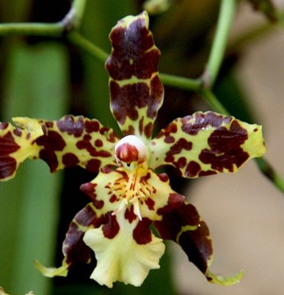
Of the F-1’s of Oncidium hallii, Oncidium Big Mac is the most awarded with 6 AM and 6 HCC. It has 16 F-1’s and 23 Total Progeny including a Gomesa cross (Oncidesa Stanley Smith) and a Cyrtochilum cross (Cyrtocidium Chocolate Mac.

Desirable characteristics which can be passed to progeny:

I was unable to find any written information on characteristics passed on to progeny. So, I propose we look at some pictures of the species and some F-1’s.

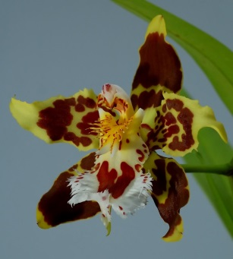
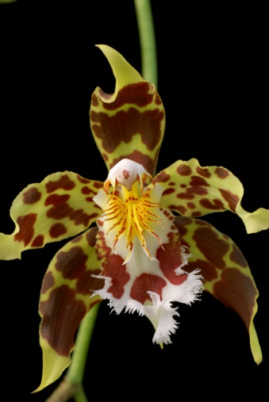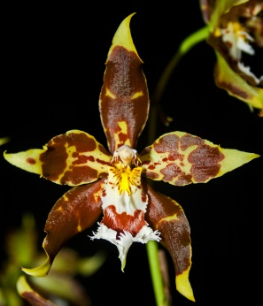
Oncidium hallii

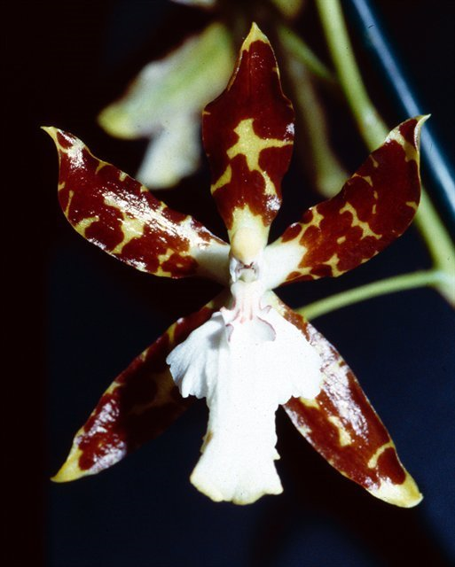 = 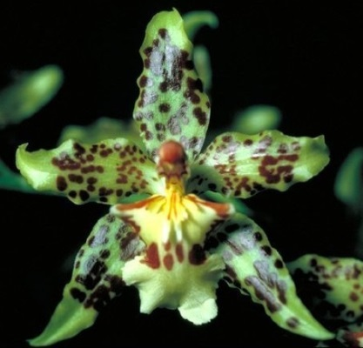
x Onc. maculatum Oncidium Big Mac

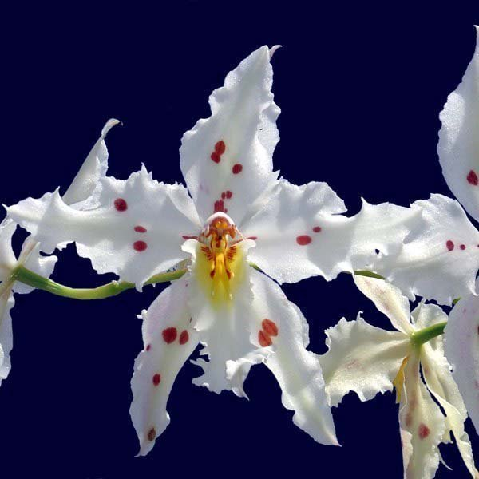 = 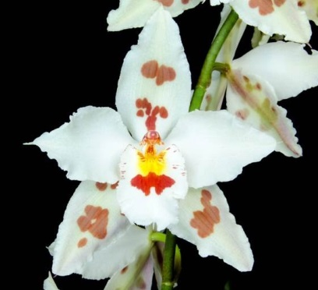
x Onc. alexandrae Oncidium Hallio-Crispum

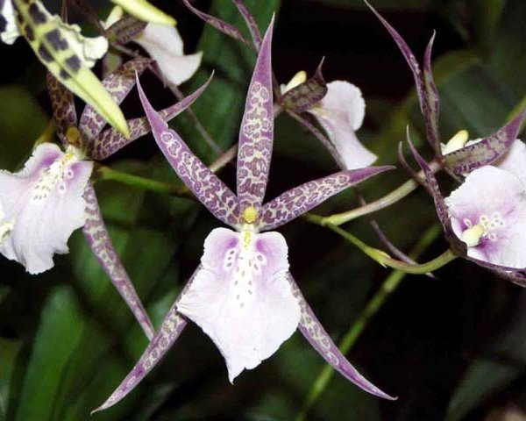 = 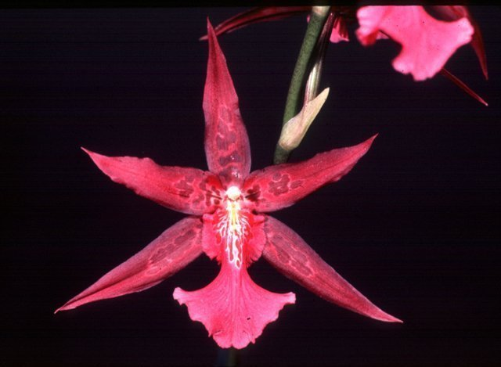
x Bratonia Charles M Fitch Aliceara Hani

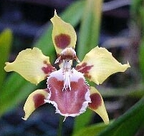 = 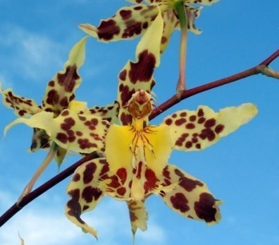
x Oncidium kegeljanii Oncidium Hallio-Xanthum

So far I see the bright red markings on the lip breeding true, at least with Big Mac and Hallio-Crispum, The spotting on the petals also came through on Big Mac. In Hani, I see the Brassia form and the Miltonia color, nothing much of hallii. In Hallio-Xanthum, the form and markings of hallii are dominant.

Undesirable characteristics which can be passed to progeny:
Don’t have a clue.

Other information:

Pronunciation : HALL-ee-eye
Named for Col. Hall, a 19th century British collector in South America.

References:

Chase MW. 2009. Subtribe Oncidiinae. In: Pridgeon AM, Cribb PJ, Chase MW, Rasmussen F, eds. Genera Orchidacearum, Vol. 5. Oxford: Oxford University Press, 211–394.

