BUILDING BLOCK DATA
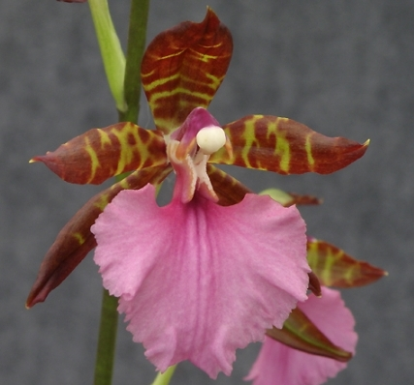
Species Rhynchostele bictoniensis
Distribution: Mexico, Guatemala and El Salvador.
Habitat: Mixed humid forest from 5200 to 10,500 ft. elevation.

Synonyms: Odontoglossum bictoniense, Lemboglossum bictoniense, Zygopetalum africanum, Cyrtochilum bictoniense
Until 1983, all species of Rhynchostele were included in Odontoglossum, section Leucoglossum. After quite a bit of wrangling, in 1984 Halbinger erected a new genus for these species, Lemboglossum. In 1993, all were transferred to Rhynchostele because of their affinity with Rhynchostele pygmaeum. Subsequent DNA analysis corroborates that relationship.

Awards:

Origin | HCC | AM | CBM | JC | CHM | CCM | Total
 | 11 | 12 | 1 | 2 | 1 | 2 | 35
Years | 1979-2000 | 1970-2009 | 1974 | 1981 - 1989 | 1978 | 1984 - 1990

Other awards and when given: 3 SM 2012 – 2014, 3 BM 2014 - 2015

Hybrids: F-1
Before  1940 | 1940-49 | 1950-59 | 1960-69 | 1970-79 | 1980-89 | 1990-99 | After 1999
1 | 0 | 0 | 7 | 31 | 69 | 56 | 49
In primary crosses, Rhynchostele bictoniense has been the seed parent 55 times and pollen parent 13 times. The most awarded primary, with Oncidium leucochilum, is Oncostele Black Beauty with 17 awards. Following close behind is Otostele Summet ( with Otoglossum brevifolium) with 15 awards and Colmanara MASAI RED (with Oncidium cariniferum) also with 15 awards.

Hybrids: Progeny
Before  1940 | 1940-49 | 1950-59 | 1960-69 | 1970-79 | 1980-89 | 1990-99 | After 1999
1 | 1 | 3 | 3 | 7 | 10 | 7 | 7

Rhynchostele bictoniensis hybridizes well with Brassia, Oncidium, Gomesa, Miltonia and to a lesser extent with Cyrtochilum, Rodriguezia, Miltiniopsis, Comparettia and Zelenkoa. Most of its hybrids, 354, are first and second generation with 50 third and fourth and 2 fifth.
Outstanding progeny and reason they are considered outstanding:

Rhynchostele Stamfordiense AM/AOC
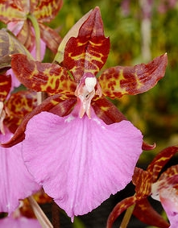
This is a Primary with Rst. uroskinneri. Although not the most highly awarded of the Rst. bictoniense hybrids, Stamfordiense has prodused 19 F-1’s out of 22 Total Progeny and has received 10 awards. It has only 2 second generation progeny, so a bit of a flash in the pan. The enhanced color intensity and great patterning from Rst. bictoniensis is apparent in this cross.

Rhynchostele Bic-ross AM/AOS
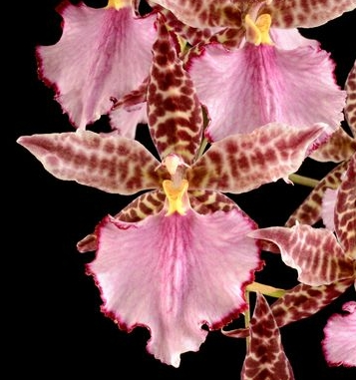
This is another Primary, this time with Rst rossi. The Australians and New Zealanders seem to like it a lot giving it 6 of its 10 awards. It has produced 15 F-1’s out of 40 Total Progeny in 4 generations. Again, intense color and good patterning is evident.

Oncostele Black Beauty ‘Ken Peterson’ AM/AOS
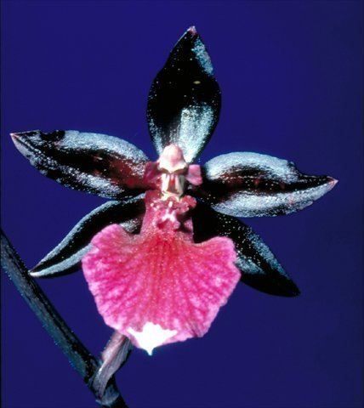
Registered in 1988, Oncostele Black Beauty is a Primary cross with Oncidium leucochilum. It has produced 11 F-1 offspring and 15 progeny in 3 generations. A hint of the white lip of Onc. leucochilum is seen in many cultivars.

Desirable characteristics which can be passed to progeny:
According to Kraus, Rst. bictoniensis imparts an upright and well-spaced flowering habit, an unexpected intensity of color and patterning. Carpenter says it “imparts its excellent vigor and ability to tolerate fairly high light levels to its progeny, particularly when it is the pod parent”. It is dominant for transmitting fine red to violet spots. Other attributes: Plant vigor, erect inflorescences, many flowers, color spotting, intensity of color, light tolerance and compact plants.

Undesirable characteristics which can be passed to progeny:
Kraus notes that Rst. bictoniensis has a narrowing effect on the sepals and petals of its hybrids and often reduces the flower size of its offspring. Carpenter had nothing bad to say.

Other information:

According to James Vetch, Rhynchostele bictoniensis (then Cyrtochilum) was “the first Odontoglot to ever reach England alive”. It was bloomed a year later by Lord Rolle.

Pronounced: bik-toh-nee-EN-sis
Refers to Bicton, an English village, seat of Lord Rolle, orchidologist at Kew

References:

Chase MW. 2009. Subtribe Oncidiinae. In: Pridgeon AM, Cribb PJ, Chase MW, Rasmussen F, eds. Genera Orchidacearum, Vol. 5. Oxford: Oxford University Press, 211–394.

Kraus, Gary. 1984. Odontoglossum bictoniense Hybridizing,
volume 53. American Orchid Society Bulletin 1: 4 - 13.

Carpenter, Robert M. 1988. Odontoglossum bictoniense and its hybrids,
volume 57. American Orchid Society Bulletin 1: 1360 - 1369.

