BUILDING BLOCK DATA

Species: Cymbidium eburneum Lindl. in Bot. Reg. 33: t. 67 (1847) & in Paxton, Mag. Bot. 15: 145-146 + plate (1849).
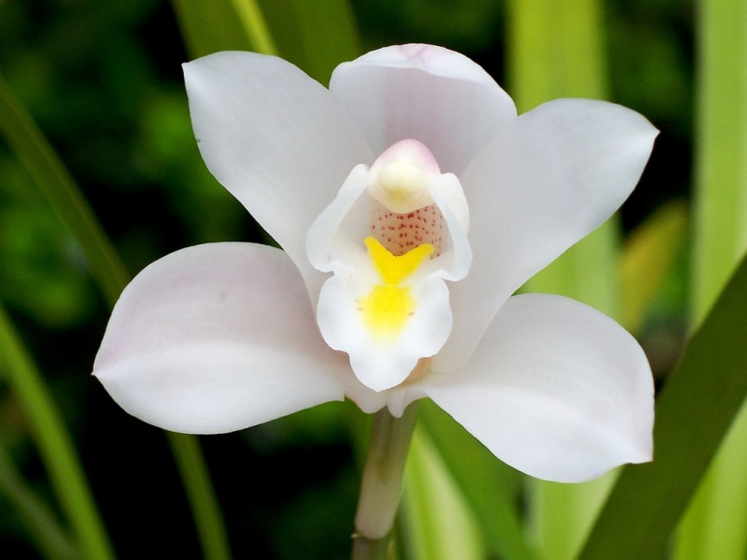
Cymbidium eburneum was described by Lindley in 1847, from a specimen cultivated by Loddiges’ nursery and said to be from the ‘East Indies’. When, in 1851, Grifﬁth described C. syringodomm, the lilac-scented Cymbidium, he gave the ﬁrst precise locality information as the Khasia Hills in Assam. Lindley (1858) reduced this name to synonymy in C. eburneum. Later, Clarke and then King & Pantling collected it from Darjeeling and Sikkim. It is likely that the distribution extends along the Himalaya to include Nepal (Hara et al., 1978) and Bhutan. Forrest collected a cultivated specimen of C. eburneum (wrongly identiﬁed as C. hookerianum) in western Yunnan where it is undoubtedly native. In 1939 a specimen from Myanmar (Burma), but without an exact locality, was sent to Kew, extending the known distribution of this species.
This species, along with C. mastersii, C. parishii and C. roseum, was placed in section Ebumea by Du Puy and Cribb (1988), which was characterized by slender and fusiform pseudobulbs that grow and flower indeterminately for two to many years. The leaf apex in these species tends to be acutely bilobed with a small mucro in the sinus. The few-flowered scape is produced from the axils of the leaves, not from the base of the pseudobulb. In common with section Cyperorchis, the ﬂowers do not usually open fully, the hypochile is relatively long, and the rostellum is beaked. The quadrangular pollinia are placed on a rectangular viscidium with two long, hair-like processes from the lower corners.
Cymbidium eburneum has short inﬂorescences that usually carry a single, large, white flower, with a single, broad, yellow callus ridge. It can easily be distinguished from the other large, white-ﬂowered species in this section by its characteristic callus ridges that are fused into one single, inﬂated, wedge-shaped structure at the apex. Cymbidium mastersii shares the tendency to grow indeterminately for several years before producing a new growth, the characteristic leaf tip shape, the elongated lip, and similar colouring. Its ﬂowers are much smaller and more numerous, the petals are much narrower, and it lacks the callus structure typical of C. eburneum. Cymbidium insigne has distinct swollen pseudobulbs which flower from the base, leaves which lack the complex leaf tip structure and much longer and more robust ﬂower spikes, bearing many more ﬂowers with two separate, hairy callus ridges.
The plants of C. eburneum seen in cultivation in the West until recently, usually imported from India or Thailand, had inﬂorescences bearing a single white ﬂower, often pale pink-tinged, with a yellow callus. Pale pink spotting was occasionally apparent on the margin of the mid-lobe of the lip.
Cymbidium eburneum was often well cultivated in the warm, humid stove greenhouses of the late l9th century, and large specimen plants were exhibited bearing upwards of 25 ﬂowers. It is among the most beautiful of the Cymbidium species and has been used extensively in hybridization. Its strong fragrance is usually not inherited when it is hybridized. It was one of the parents of the ﬁrst artiﬁcial Cymbidium hybrid, C. x Eburneo-lowianum in 1889.

Description:

A perennial, epiphytic herb. Pseudobulbs about 10 cm long, 3 cm in diameter, ovoid to fusiform, bilaterally ﬂattened, not produced annually but growing in an indeterminate fashion for about three years before a new growth is produced, often covered in persistent leaf bases and bearing about 7 fresh leaves, each pseudobulb producing about 15-17 distichous leaves in total. Leaves up to 60 x l.3(2) cm, narrowly ligulate, acute, with a finely unequally bilobed apex with a minute micro in the sinus formed as an extension of the mid-vein; articulated to a broad, sheathing base 5-10 cm from the pseudobulb. Scape about 25(36) cm long, from within the axils of the leaves; peduncle erect or suberect, covered in about 8-21 sheaths up to 15 cm long; upper sheath cymbiform, middle sheaths mostly cylindrical below, inﬂated, cymbiform above; rhachis with 1-2(3) flowers; bracts 0.4-2 cm long, triangular, acute. Flower large, 8-12 cm across, not opening fully; sweetly lilac-scented; rhachis, pedicel and ovary bright green; petals and sepals white or faintly pink; lip white with a bright yellow central and basal patch on the mid-lobe and bright yellow callus, occasionally with some purple-pink spots on the mid- lobe; column white or ﬂushed pale pink, sometimes spotted pink ventrally and with a small yellow patch at the base; anther-cap white. Pedicel and ovary 3.2-4.1 cm long. Dorsal sepal 5.6-7.6 x1.8-2.9cm, narrowly oblong-elliptic, acute, concave, porrect; lateral sepals similar, not fully spreading. Petals 5-7.3 x 1.5-2.2 cm, narrowly spatulate, slightly curved, the acute tips recurved and spreading. Lip 3- lobed, elongated, fused to the base of the column for 4-6 mm; side-lobes 1.2-1.8 cm broad, clasping the column, papillose or minutely hairy, apex broadly rounded, margin not fringed; mid- lobe 1.6-2 x 1.4-1.7 cm, ovate-triangular, rounded or mucronate, porrect or weakly recurved, minutely hairy with a dense central and basal patch of short hairs, margin entire and undulating; callus long, with 3 slightly raised ridges on a broad, glabrous disc behind, becoming confluent and strongly inflated and forming a cuneate apex terminating well behind the junction
of the mid- and side-lobes, papillose or minutely hairy. Column (3.4)4.1-4.6 cm long, narrowly
winged to the base, curved down near the apex, almost glabrous; pollinia quadrangular, about 4 mm long, on a rectangular viscidium with hair-like processes from the lower corners. Capsule about 7-l0 cm long, ellipsoid, with an apical beak.

DISTRIBUTION. Northern India (Sikkim, Assam, Khasia Hills), Nepal, northern Myanmar, China (south-west Yunnan, Guangxi, Hainan); 300-1700 m (985-5580 ft).

HABITAT. On trees in warm, damp forest, and on rocks in ravines, in shade; ﬂowering February -May (November-January in cultivation).

Botanical Varieties (if any):

Synonyms:
C. syrirlgodoram Griff, Notalae 3: 338 (1851). Type: Northern India, Khasia Hills, Myrung, Griﬂith 228 (holotype Kl).

C. eburneam Lindl. var. dayi Jennings, Orchids: t. 16 (1875). Type: Illustration cited here (lectotype selected by Du Puy & Cribb, 1988).

C. ebarneam Lindl. var. williamsianam Rchb.f. in Gard. Chron., ser. 2, 15: 530 (1881). Type: cult. Williams (holotype W).

C. eburneum Lindl. var. philbrickianam Rchb.f. in Gard. Chron., ser. 2, 25: 585 (1886). Type: cult. Philbrick (holotype W).

Cyperorchis ebamea (Lindl.) Schltr. in Fedde, Repert. Sp. Nov. Regni Veg. 20: 107 (1924).

Awards:

Origin | HCC | AM | FCC | CCE | CCM | JC | Total
AOS | 2 | 1 | 0 | 0 | 3 | 2 | 8
Years | 1991-1998 | 2005 |  |  | 1981-2008 | 1969-1981

Hybrids: Total of 14,983 to the 10th generation

Generation | Before 1940 | 1940-49 | 1950-59 | 1960-69 | 1970-79 | 1980-89 | 1990-99 | 2000-10 | After 2010
F-1 | 23 | 1 | 2 | 1 | 1 | 4 | 7 | 10 | 2
F-1 Awards | 2 | 1 | 0 | 0 | 0 | 0 | 0 | 0 | 0
F-1 – F-10 | 671 | 437 | 827 | 1493 | 1087 | 2230 | 3044 | 3240 | 1954
F-1 – F-10 Awards | 294 | 170 | 957 | 1445 | 866 | 1257 | 1016 | 825 | 140

Outstanding progeny and reason they are considered outstanding:

Cymbidium Eburneo-lowianum

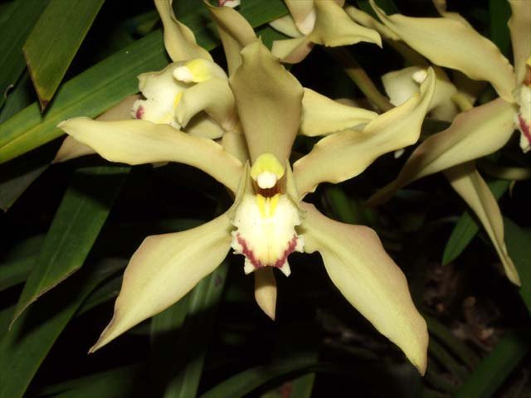
This was the first Cymbidium cross ever made. It was accomplished by Veitch in 1889. Although it was never awarded, it is part of 99% of all Cymbidium eburneum hybrids with 14,590 progeny. In 1911 it was crossed with Cymbidium insigne by Sir George Holford, creating the famous Cymbidium Alexandri.

Cymbidium Alexanderi ‘Nike’

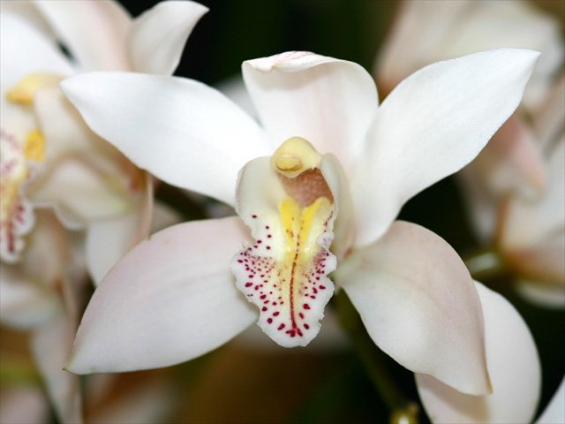
This cross may be the most famous of all Cymbidium hybrids. It has produced 413 F-1 hybrids and has contributed genes to 14,402 progeny. Some of its notable offspring are Balkis (1934), Showgirl (1962), Cleo Sherman (1956) and for awards alone, Lilian Stewart (1955) with 145 awards and San Francisco (1956) with 124 awards.

Cymbidium Balkis ‘Nevada’ HCC/AOS

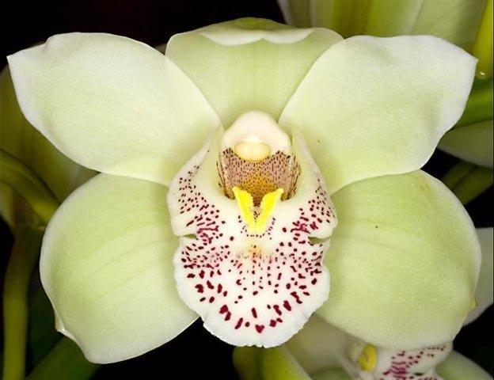
This is a third generation cross, between Cym. Alexanderi and Cym. Rosanna, made in1934. It has produced 308 F-1 crosses and is present in 2980 progeny in 8 generations. It has been awarded 96 times including 14 AM, 36 BM, 34 HCC and 12 SM. Among its highly awarded offspring are Lillian Stewart and San Francisco. A couple of its F-1’s were very prolific. Wallara (1964) produced 119 F-1 and 498 total. Joan of Arc (19430, crossed back to Alexandri, produced 99 F-1 and 190 progeny. Balkis was the premier parent during the late 1950’s and 1960’s

Cymbidium Sensation ‘Red Beauty’

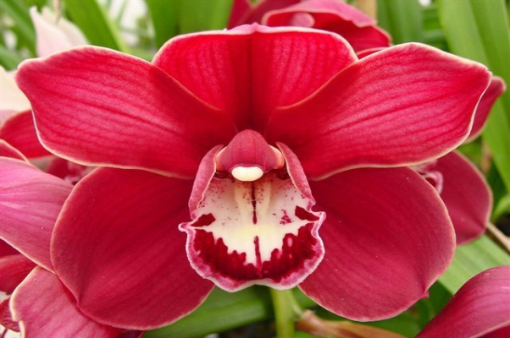
This 5th generation cross (1961) has performed well in both awards and fertility. It has 158 F-1 and 1,771 progeny. It is a fantastic red.

Desirable characteristics which can be passed to progeny:
Well shaped flowers with a heavy substance are passed on. It was the first white species to appear in Western collections. It produces lots of spikes in spite of the low flower count per spike.

Undesirable characteristics which can be passed to progeny:
The species has had to overcome a weak growth habit. It has a low flower count of 1-2 per stem. It suffers from washed lip color.

References:
Crosby, Harry W., 1952, Cymbidium eburneum, AOS Bulletin. 21;115-117

Crosby, Harry W., 1951, Cymbidium tracyanum, AOS Bulletin. 20;667-669
OrchidWiz.Database 13.1
Du Puy, David and Cribb, Phillip, 1988, The Genus Cymbidium,
Aldridge, Peggy, 2008, An Illustrated Dictionary of Orchid Genera
Pridgeon AM, Cribb PJ, Chase MW, Rasmussen FN. 2009. Genera orchidacearum, Vol. 5.
Rogerson, William P., 1991, Trends in Cymbidium Hybridization, AOS Bulletin. 60(6): 527-535
Gripp, Philip, 1978, Some Byways in Cymbidium Breeding. AOS Bulletin. 47(11): 1021-1027
Easton, Andy, 1987, Modern Cymbidium Hybridizing. AOS Bulletin. 56(1): 5-13
Fitch, Charles M., Colorful Cymbidiums. Orchids. 73(10): 742-747
www.orchidspecies.com
http://apps.kew.org/wcsp/qsearch.do
https://secure.aos.org/aqplus/SearchAwards.aspx

