BUILDING BLOCK DATA
Species Cymbidium ﬂoribundum Lindl., Gen. Sp. Orchid. Pl.: 162 (1833)
Lectotype lcon. in R. Hort. Soc.
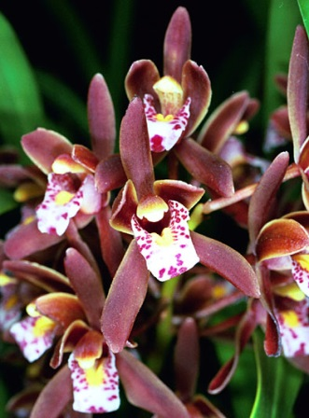
Cymbidium ﬂoribundum was described by Lindley (1833) in a footnote appended to his description of C. sinense. The short Latin diagnosis was made from a painting by a Chinese artist, now in the possession of the Royal Horticultural Society. Lindley distinguished C. ﬂoribundum from C. sinense by
its smaller, more numerous ﬂowers, its obtuse sepals and the red lip with a yellow center. Although its leaf is not unlike C. sinense, the two cleft pollinia, rather than four found in section Jensoa, indicate that it is not closely related. It has recently gained importance as one of the parents of the modern
miniature hybrids.
Cymbidium ﬂoribundum is allied to C. suavissimum, but the latter can be easily distinguished by its broader leaves and the small auricles at the base of the column. A more detailed discussion can be found under C. suavissimum.
The name C. ﬂoribundum was unfortunately ignored by later authors and the species became well known in cultivation under the later synonym C. pumilum, which was described by Rolfe in 1907, based on a specimen imported from Japan and cultivated by Barr, and a second collected by the French missionary Monbeig in Yunnan, China. This latter specimen was selected by Du Puy and Cribb (1988)
as the lectotype. The description of C. pumilum is far more detailed than that of C. ﬂoribundum, but there can be little doubt that they are the same species and that C. pumilum is therefore a later synonym. The strongly red-colored lip in the painting of C. ﬂoribundum is unusual in that the species usually has a spotted lip, but the lip turns deep red, obscuring the spots, when the rostellum is disturbed following pollination, or when the flower ages.
Cymbidium illiberale was described in l9l4, by Hayata, from a plant cultivated in Taiwan. He
differentiated it from C. pumilum (= C. ﬂoribundum) by the ‘light reddish green petals and sepals, and by the lips which are light red with red maculatum blotches on the front lobe, and numerous minute red spots on the side-lobes’. These color patterns are typical of C. ﬂoribundum, and it appears that the two taxa are not distinct. Specimens from Taiwan cannot be distinguished from those collected on mainland China (Lin, 1977).
A variant lacking the red-brown pigment in the flowers, which are consequently green with a white lip, is commonly cultivated as var. album, and has been named f. virescens by Makino (l9l2). The lip of this color variant also turns red on pollination, or as the ﬂower ages. Specimens with pale pink markings on the lip are also known.
The Japanese name ‘Kinryohen’ means ‘Golden-margined’ (Nagano, 1955). This probably refers to the narrow yellowish margin on the sepals and petals, but may also refer to the highly prized specimens with variegated leaves cultivated in Japan, although the Japanese name for the latter is ‘Jitsugetsu’. There are many named variants maintained in cultivation in Japan and China, where C. ﬂoribundum has been grown for several centuries. Long et al. (2003) redescribed this alba variant as C. chawalongense based on a collection from south-east Xizang (Tibet). Their diagnosis contrasts it with C. ﬂoribundum, distinguishing it on its 22-cm long scape and albino flowers. Both fall within the range of variation of C. ﬂoribundum. Wu & Chen (1980) recognized two varieties differentiated by the shape of the side-lobes of the lip: var. ﬂoribundum with broad, rounded side-lobes, and var. pumilum with narrower, more acute side-lobes. This difference is not apparent in the specimens we have seen, but further study may uphold this distinction.

Description:

A perennial, lithophytic or epiphytic, often clump-forming herb. Pseudobulbs small, up to 3.3 cm long, 2.2 cm in diameter, ovoid, slightly bilaterally compressed, covered by persistent sheathing leaf bases with a l mm wide scarious margin, and surrounded by about ﬁve cataphylls that become scarious, and eventually ﬁbrous with age. Leaves 5~6, up to 20-55 x 0.8—1.5(2) cm, the shortest merging with the cataphylls, linear-elliptic, arching, acute, the apex usually oblique, articulated 1.5-6 cm from the pseudobulb. Scape usually 15-25(40) cm long, robust, suberect, arching upwards from the base of the pseudobulb, with (6)l5-30(45) closely spaced ﬂowers; peduncle about 10(-l5) cm long, covered in 6-8 sheaths; sheaths up to 6 cm long, becoming scarious, cylindrical in the basal half, expanded and cymbiform in the upper half, acute; bracts short, 2-6(l7) mm long, triangular, acute. Flowers 3-4 cm across, red-brown or occasionally green, not scented; rhachis apple-green; pedicel and ovary often stained with red-brown; sepals and petals strongly flushed red-brown, with a narrow, yellow or green margin; lip white, mottled purple-red on the side-lobes and blotched with purple-red on the mid-lobe
(occasionally with pink markings instead), yellow at the base, becoming bright red on pollination or with age; callus ridges bright yellow; column yellow-green, ﬂushed red-brown above, pale
green below, dark red-purple at the base; anther- cap yellow. Pedicel and ovary 1.5-3.3 cm long.
Dorsal sepal suberect, 1.8-2.1 X 0.5-0.8 cm, oblong-elliptic, obtuse, margins recurved; lateral
sepals similar, spreading or porrect. Petals 1.6-2 x 0.5-0.8 cm, elliptic, obtuse to subacute,
curved, weakly spreading. Lip about 1.8 cm long, 3-lobed; side-lobes up to 7 mm broad, erect,
rounded or obtuse, minutely papillose; mid-lobe 0.7 x 0.8 cm, broadly ovate, subacute, weakly
recurved, minutely papillose, the margin sometimes undulating; callus of two parallel ridges that tend to converge at their apices, with a shallow channel between them. Column 1.2-1.5 cm long, curved, broadening into two narrow wings near the apex, minutely papillose, below; pollinia 2, triangular, cleft, on a small rectangular viscidium. Capsule about 3 cm long, 3 cylindrical, tapering at each end, apex with a short beak.

DISTRIBUTION. Southern China, Taiwan, northern Vietnam; 800-2800 m (2625-9185 ft).
It is not native to Japan, although it may now be found naturalised in the warmer regions (Nagano, 1955). In Taiwan and China it grows in the southern provinces, Fujian, Guangxi, Guangdong, Guizhou, Hubei, Jiangxi, Sichuan, Yunnan, Xizang and Zhejiang (Wu & Chen, 1980). Plants from Taiwan and eastern China usually have broader leaves (1.5-2 cm, 0.6-0.8 in) and flower earlier, in March and April. It is a montane plant, usually found between 1000 and 2800 m (3280 and 9185 ft) elevation, although it has been recorded from as low as 800 m (2625 ft) in Taiwan (Lin, 1977).

HABITAT. On rocks and trees in shaded gorges and ridge-tops, often in coniferous or mixed forest, in light shade or in full sun. It is normally lithophytic in mountain gorges, in shaded situations on hard limestone, often in conifer forest, although it may grow epiphytically, and has been observed in Liqaidambar formosana (Hamamelidaceae) in eastern China. One of us (PC) saw ﬂowering specimens in April 2001, growing on lightly shaded limestone ridgetops under Podocarpas in karst country in south-east Guizhou. He also saw it growing epiphytically in monsoon forest on karst limestone at c. 1200 m in northern Vietnam close to the Chinese border. It has a high tolerance of dry conditions, growing in open situations, such as on cliffs, where it can form extensive clumps. It ﬂowers between March and June.

Botanical Varieties (if any):

Synonyms:
C. pumilum Rolfe in Kew Bull; 130 (1907). Type: Yunnan, Tsekou, Monbeig (lectotype Kl, isolectotypes P, Kl).

C. illiberale Hayata in Icon. Pl. Formosa 4: 78 (1914). Type: Taiwan (Formosa), cult. Taihoku, B. Hayata (holotype TI).

C. pumilum Rolfe f. virescens Makino in Iinuma, Somoku-Dzusetsu 18: 1185 (1912).

C. ﬂoribundum Lindl. var. pumilum (Rolfe) Y.S. Wu & S.C. Chen in Acta Phytotax. Sin. 18: 301 (1980).

C. chawalongense C.L. Long, H. Li & Z.L. Dao in Novon 13: 203 (2003). Type: China: Xizang, Chayu Xian, Chawalong, Gaoligongshan Exped. I 3 727 (holotype KUN).

Awards:

Origin | HCC | AM | FCC | CCE | CCM | SM | Total
 | 3 | 2 | 0 | 0 | 3 | 3 | 11
Years | 1998-2008 | 2007-2014 |  |  | 1971-2004 | 2011-2013

Hybrids: Total of 3,708 to the 8th generation

Generation | Before 1940 | 1940-1949 | 1950-1959 | 1960-1969 | 1970-1979 | 1980-1989 | 1990-1999 | 2000-2010 | After 2010
F-1 | 0 | 2 | 7 | 110 | 25 | 38 | 23 | 41 | 13
F-1 Awards | 0 | 2 | 30 | 313 | 46 | 13 | 15 | 16 | 1
F-1 – F-8 | 0 | 3 | 7 | 165 | 150 | 648 | 1069 | 984 | 682
F-1 – F-8  Awards | 0 | 2 | 28 | 612 | 306 | 489 | 463 | 206 | 34

Outstanding progeny and reason they are considered outstanding:
Hybridization of miniature Cymbidiums has been based on the species formally known as Cymbidium pumilum. In the late 50’s and 60’s, Cymbidium pumilum was crossed with standard hybrids and then crossed back to another standard in an attempt to improve form and substance. Showgirl and Ivy Fung fit this pattern.

Cymbidium Showgirl ‘Marion Miller’ HCC/AOS

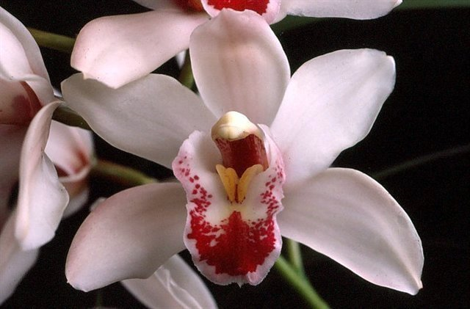
This second generation cross between Sweetheart and Alexanderi (1962) has produced 93 F-1’s and a total progeny of 396. Its genome is almost equal parts Cym. floribundum, Cym. lowianum, Cym. eburneum and Cym. insigne. It has 8 AM/AOS, 19 HCC/AOS and a boatload of Bronze and Silver Medals from CSA. It is usually white or pink with red patterning on the lip.

Cymbidium Sarah Jean ‘Helen’

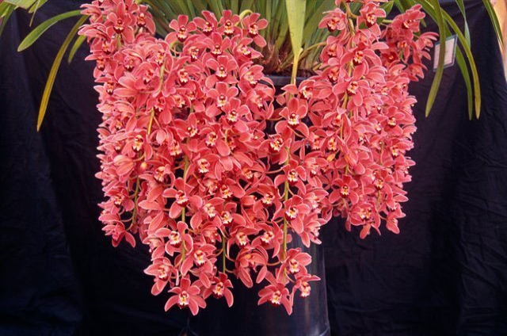
Sarah Jean is an F-1 with Cym. Sleeping Beauty (1973). It has 101 F-1’s and 235 progeny. Most of its 23 awards are Australian. It is very floriferous and has a nice range of colors from white to pink to red. One of its F-1’s with Cym. devonianum (1991) has done well in shows with

Cymbidium Ruby Eyes ‘Red Baron’ Bronze/CSA

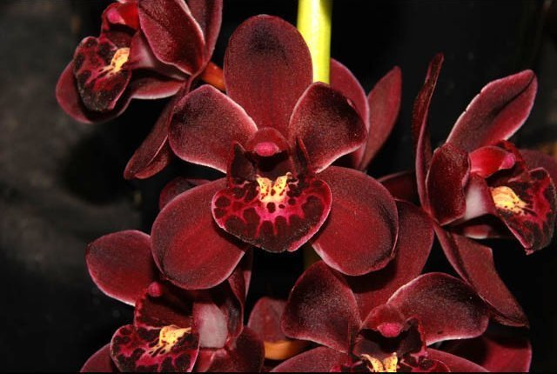
Ruby Eyes, an F-1 with Sensation desplays great red pigmentation of
Cym. floribundum with help from Cym. insigne. Ruby Eyes has gone on to produce 104 F-1’s and 211 progeny. It has garnered 17 awards, 10 from AOS and CSA, the rest from Australia. Its progeny, particularly Khairpour (1989) have done well.

Desirable characteristics which can be passed to progeny:
Cymbidium floribundum is a floriferous miniature with great red pigmentation. It averages 28.7 flowers per spike with a small 2.5cm natural spread. The plant as a whole is small, a desirable trait for many. The species is warm temperature tolerant, doing well in Cattleya growing conditions. The species and its offspring flower early, making them a great Christmas present.

Undesirable characteristics which can be passed to progeny:
Many of the early crosses, particularly the group known as Cymbidium pumilum had problems with sterility. The majority of second and third generation crosses have no offspring. Blushing often causes muddy colors.

References:

Crosby, Harry W., 1953, An Introduction to Hybrid Cymbidiums, AOS Bulletin. 22:797-799
Hetherington, Ernest E., 1953, Breeding Miniature Cymbidiums, AOS Bulletin. 22; 864-869
Du Puy, David and Cribb, Phillip, 1988, The Genus Cymbidium,
Aldridge, Peggy, 2008, An Illustrated Dictionary of Orchid Genera
Pridgeon AM, Cribb PJ, Chase MW, Rasmussen FN. 2009. Genera orchidacearum, Vol. 5.
Gripp, Philip, 1978, Some Byways in Cymbidium Breeding. AOS Bulletin. 47(11): 1021-1027
Rogerson, William P., 1991, Trends in Cymbidium Hybridization, AOS Bulletin. 60(6): 527-535
Easton, Andy, 1987, Modern Cymbidium Hybridizing. AOS Bulletin. 56(1): 5-13
www.orchidspecies.com
http://apps.kew.org/wcsp/qsearch.dohttps://secure.aos.org/aqplus/SearchAwards.aspx

