BUILDING BLOCK DATA

Species: Cymbidium iridioides D. Don, Prodr. Fl. Nepal; 36 (1824).

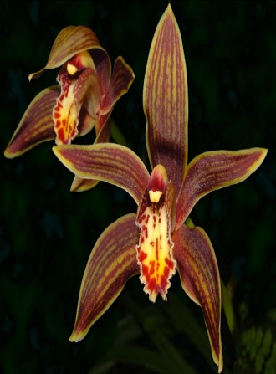
Cymbidium iridioides was described by David Don in 1825 from material collected in Nepal by
Nathaniel Wallich in 1821 and now in the Wallich herbarium. In 1832, Lindley published the name C.
giganteam, also based on a specimen collected by Wallich. He noted the previous description by Don
but questioned to which species the name referred. Don did not cite a collection number, and it was
generally assumed that the name C. iridioides was applicable to a Coelogyne and, therefore, the name
C. giganteam came into general usage. Don’s description is brief, but the only characters that do not ﬁt the present species are the leaves only 30 cm (12 in) long and the flower color (‘albi’). The Wallich
specimens do indeed have short leaves and agree with Don’s description. They also lack color notes, and it is likely that Don did not know the colour of the living ﬂowers. There is no reason why C. iridioides D. Don should not be accepted as the valid name for this species. Furthermore, Lindley’s C. giganteum is a later homonym of C. giganteum Sw. (1800).
In 2003, Liu et al. described C. gaoligongense from the Gaoligong Mountains that lie parallel and close to the Myanmar border in western Yunnan. They compared it with C. tracyanum but the ﬂowers are smaller and lack any of its distinctive red striping and spotting. It seems probable that it is no more than an albinistic form of C. iridioides which, from the description and accompanying illustration of C. gaoligongense provided by the authors, is similar and has previously been recorded from the region.
Cymbidium iridioides is one of the less showy of the large-ﬂowered species in section Cyperorchis, with yellowish sepals and petals lined with red-brown. The ﬂowers often do not open fully, hiding the relatively small, purple-spotted lip. It is similar in coloring, size and distribution to C. erythraeum, but the latter has much narrower ﬂoral parts, giving a spidery appearance, and the leaves are much narrower. Its whiter, less heavily spotted lip is also distinctive, also lacking the undulating margin and central lines of hairs present in C. iridioides.
Cymbidium tracyanum has a similar coloring, and has the lines of hairs on the mid-lobe of the lip, but it can be distinguished from C. iridioides by the larger size of its ﬂower and especially of the mid-lobe of the lip, its strongly falcate petals, the hairs conﬁned to the veins on the side-lobes and the fringe of long hairs on the margins of the side-lobes of the lip. Cymbidium iridioides is also allied to C. wilsonii.

Description:

A perennial, epiphytic or lithophytic herb. Pseudobulbs 5-17 cm long, 2-6 cm in diameter, elongate- ovoid, bilaterally ﬂattened, with about 10 leaves. Leaves up to 90 cm or more long, 2-4.2 cm broad, linear-elliptic, acute, mid-green, articulated 6-ll cm from the pseudobulb to a yellow-green, broadly sheathing base. Scape 45-85 cm long, suberect to horizontal; peduncle stiff, covered in scarious sheaths up to ll cm long; rhachis 25-50 cm long, robust, tapering above, yellowish-green, bearing 7-20 ﬂowers; bracts triangular, up to 2.5 mm long. Flowers up to 10 cm across, scented; rhachis, pedicel and ovary green; sepals and petals yellowish-green heavily stained with irregular veins and spots of red- or ginger-brown, with a narrow cream margin; lip yellowish, side-lobes dark red-veined, midlobe yellow at the base, marked with a broad submarginal band of conﬂuent deep red spots and blotches; callus ridges yellowish, spotted maroon in front, becoming muddy red behind; column yellowish-green, streaked red-brown beneath. Pedicel and ovary 2.2-4.2 cm long. Dorsal sepal 4.5-4.7 x 1.2-1.8 cm, narrowly obovate, acute, concave, porrect; lateral sepals similar, asymmetric and twisted forward
giving the ﬂower a half-open appearance. Petals 4.4-4.8 x 0.7-1 cm ligulate, curved, spreading. Lip 3- lobed, fused to the column base for 4-5 mm; side-lobes 1-1.2 cm broad, triangular, rounded at the apex, porrect, margin fringed with short hairs, the indumentum of short hairs evenly distributed; mid-lobe 1.2-1.6 x 1.4-1.8 cm, ovate, mucronate, recurved, sparsely hairy except in the center where two or three lines of long hairs extend from the callus to beyond the center of the mid-lobe, margin erose and strongly undulating, fringed with short hairs; callus ridges 2, short, reaching half way down the disc, dilated at the apex, tapering off rapidly below, covered in long hairs. Column 2.5-2.9 cm long, winged but narrowing at the base, giving a more slender appearance than in C. tracyanam, short hairs present ventrally near the base; pollinia 2.1-2.5 mm long, triangular. Capsule about 6-8 x 3-4 cm, fusiform- ellipsoidal, stalked, with the persistent column forming a short (1.5-2 cm), apical beak.

DISTRIBUTION. Nepal, northern India (Kumaon, Assam, Sikkim, Meghalaya), Bhutan, Myanmar & south-west China (Yunnan, south- west Sichuan, south-east Xizang) ; 900-2800 m (2950~9l85 ft), at higher elevations in its more southerly localities. In Kumaon, Nepal and Sikkim, the distribution of C. iridioides coincides with those of C. hookerianum and C. erythraeum, both of which, however, usually occur at higher elevations. It also occurs to the south, in Meghalaya. A region from which the latter two species are absent. The ranges of
these three species also overlap in Yunnan, but C. iridioides extends farther south. It has been accidentally imported with collections of C. lowianum, a species endemic to the
tropical forests of Thailand, Myanmar (Burma) and southern Yunnan; 900-2800 m (2950-9185 ft), highest in the more southerly localities.

HABITAT. It has usually been reported growing epiphytically on mossy trees in damp, shaded forest, the strongest specimens growing in hollows on rotting wood, or in tree
hollows which have collected humus and leaf litter. It is also found on rocks in forests or on cliffs. Generally, the habitat of this species is frost-free, with some winter rain, but in regions where night frosts occur the winters are dry, as in Meghalaya. It flowers between August and December.

Botanical Varieties (if any):

Synonyms:
C. giganteum Wall. ex Lindl., Gen. Sp. Orchid. PL: 163: (1833) & in J. Proc. Linn. Soc. Bot. 3: 29 (1859); non Sw. in Schrad. J. Bot. 2: 224 (1800) = Cyrtopera gigantea. Type: Nepal, Wallich 7355 (lectotype Kl, chosen by Du Puy & Cribb, 1988).

Cyperorchis gigantea (Wall. ex Lindl.) Schltr. in Fedde, Repert. Sp. Nov. Regni Veg. 20: 107 (1924).

Iridorchis gigantea (Wall. ex Lindl.) Blume, Coll. Orchid Arch. Ind. Jap. 1: 90, t. 26 (1858).
C. gaoligongense Z.J. Liu & J .Y. Zhang in J. Wuhan Bot. Res. 21, 4: 316 (2003), syn. nov. Type: China, W Yunnan, Gaoligong Mts, W of Baoshan, Z.J. Liu 2582 (holotype SZWN No. 518114).

Awards:

Origin | HCC | AM | FCC | SM | CCM | CHM | Total
 | 0 | 0 | 0 | 1 | 0 | 1 | 2
Years |  |  |  | 2014 |  | 2007

Hybrids: Total of 5,847 to the 11th generation

Generation | Before 1940 | 1940-49 | 1950-59 | 1960-69 | 1970-79 | 1980-89 | 1990-99 | 2000-10 | After 2010
F-1 | 13 | 1 | 1 | 1 | 0 | 0 | 1 | 3 | 1
F-1 Awards | 1 | 0 | 0 | 0 | 0 | 0 | 0 | 7 | 0
F-1 – F-11 | 35 | 17 | 58 | 165 | 185 | 690 | 1396 | 1972 | 1329
F-1 – F-11  Awards | 0 | 11 | 48 | 107 | 189 | 348 | 480 | 395 | 103

Outstanding progeny and reason they are considered outstanding:

In 1936, J. Crombleholme crossed Cymbidium iridioides with an unknown pollen parent and produced a cross registered as Cymbidium Ruby. Ruby received no awards but was the start of an excellent line of Cymbidium hybrids. In 1937, Ruby was crossed with Pearl (Alexandre x Cym hookerianum), bringing the excellent Alexandri into the mix and producing Rio Rita. In 1949, Rio Rita was crossed with Babylon (Olympus x Pauwelsii) bringing more Alexandri, Cym. lowianum and Cym. insigne genes into the mix. The result was Cymbidium Vieux Rose (1949)

Cymbidium Vieux Rose ‘Dell Park’ HCC/AOS

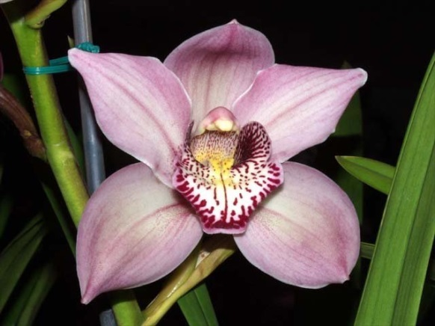
Vieux Rose has received 5 HCC/AOS and a CCM. It is a prolific breeder with 135 F-1 and 1,903 progeny. A hint of Cymbidium iridioiodes “Tiger striping” is found on most of its offspring. This cross has very desirable lap patterns.

Cymbidium Tethys ‘Black Magic’

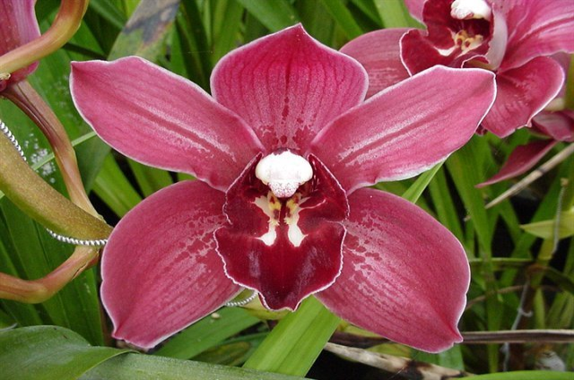
A fifth generation cross made by Stewart Inc. in 1969 is Tethys. Although not highly awarded (5), it is a prolific breeder and has produced a line of great reds and yellows. It has 131 F-1 and 389 progeny.

Desirable characteristics which can be passed to progeny:
As one of the earliest standards, it brings good size and form, Its fine stripes and red to ginger-brown color can be used to advantage by breeders. It has good lip color and patterns passed to most progeny.

Undesirable characteristics which can be passed to progeny:
The lip is heavily marked, which can be a disadvantage. The lip also has lines of hairs on the mid-lobe and an undulating, wavy margin.

Other information:
Pronounced: ir-id-ee-OY-deez referring to its resemblance to

References:

Du Puy, David and Cribb, Phillip, 1988, The Genus Cymbidium
Aldridge, Peggy, 2008, An Illustrated Dictionary of Orchid Genera
Fitch, Charles M., Colorful Cymbidiums. Orchids. 73(10): 742-747
Pridgeon AM, Cribb PJ, Chase MW, Rasmussen FN. 2009. Genera orchidacearum, Vol. 5.
Gripp, Philip, 1978, Some Byways in Cymbidium Breeding. AOS Bulletin. 47(11): 1021-1027
Rogerson, William P., 1991, Trends in Cymbidium Hybridization, AOS Bulletin. 60(6): 527-535
Easton, Andy, 1987, Modern Cymbidium Hybridizing. AOS Bulletin. 56(1): 5-13
www.orchidspecies.com
http://apps.kew.org/wcsp/qsearch.do
https://secure.aos.org/aqplus/SearchAwards.aspx
OrchidWiz.Database 13.1
Crosby, Harry W., 1953, An Introduction to Hybrid Cymbidiums, AOS Bulletin. 22:797-799

