Yellow and Orange Cymbidiums
Tracing the lineages of modern standard Cymbidiums, it becomes evident that three species dominate; Cymbidium eburneum, Cymbidium lowianum and Cymbidium insigne. Two other species are found at the root of many lineages; Cymbidium iansonii and Cymbidium sanderae. The first yellow is Cymbidium Eburneo-lowianum, a primary created by J. Veitch and Sons in 1889 using Cymbidium eburneum and Cymbidium lowianum.
Cymbidium Eburneo-lowianum
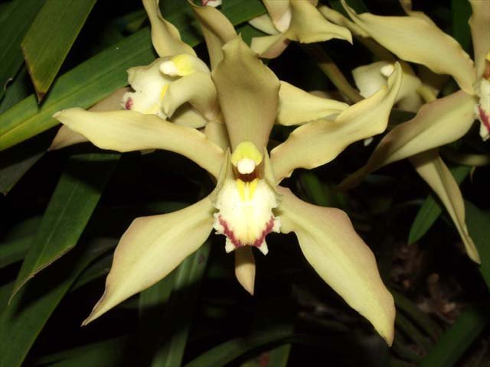

The stellate flowers of this cross are cream overall with a bit of mahogany on the lip. The cross has 42 F-1 offspring and is a genetic component of 15,082 progeny in 9 generations. Many of the offspring are yellows or oranges.

Another early primary cross between Cymbidium insigne and Cymbidium lowianum, registered as Cymbidium Pauwelsii, appears in many yellow lineages. Created by T. Pauwels & Cie of Ghent, Belgium in 1911, this grex is a deeper, richer orange-yellow.
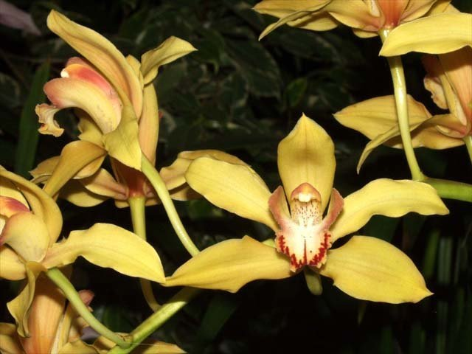
Cymbidium Pauwelsii

Continuing with the early primary experimentation, McBeans Orchids tried a cross between Cymbidium insigne and Cymbidium tracyanum. The result, registered in 1912, is a faintly striped orange called Cymbidium Doris. Doris will produce and 6,518 progeny in 10 generations.
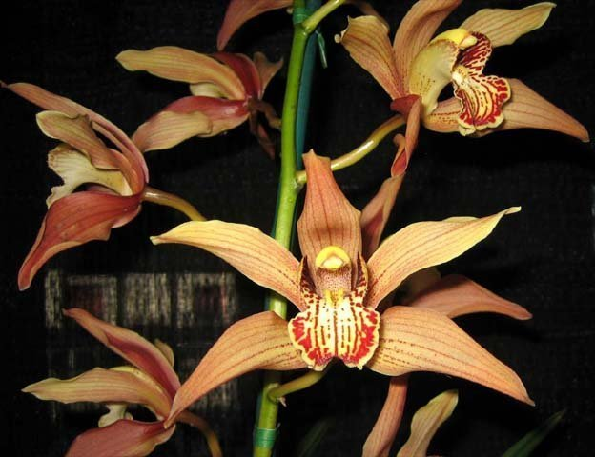
Cymbidium Doris
In 1918, McBean’s Orchids crossed Cymbidium Alexanderi (Cymbidium Eburneo-lowianum x Cymbidium insigne) with Cymbidium hookerianum and created Cymbidium Pearl, a much more saturated orange-yellow with a lot of red in the lip. Cymbidium Pearl produces 124 F-1’s and 10,089 total progeny.
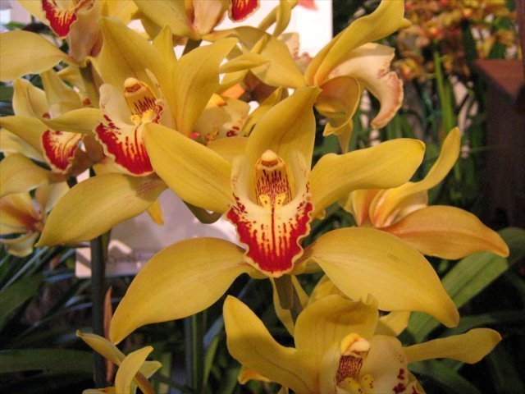
Cymbidium Pearl ‘Magnificum’
There seems to be a hiatus for a couple of decades in the development of yellows and oranges, at least the records have no particular hybrid standing out.
In 1940, McBeans registered Cymbidium Sussex, a fourth generation hybrid which is three quarters Cymbidium insigne and Cymbidium lowianum. Sussex will go on to be the progenitor of many fine yellow and orange Cymbidiums. It has similar markings and color as Doris but with much better form.
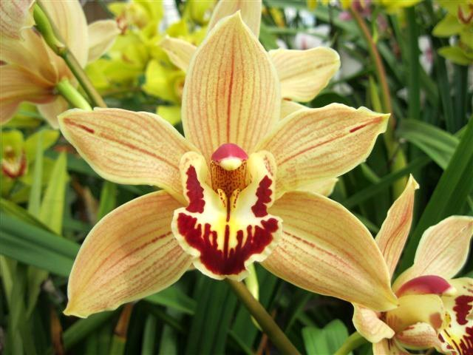
Cymbidium Sussex
Along with Cymbidium Pearl, probably the best yellow of the 5th to 6th generation group is Cymbidium Alnwick Castle. It was registered in 1954 by the Stewart Low Company in Sussex, UK. It is getting closer to a pure yellow with only faint reddish markings. It will go on to produce 56 F-1’s and 1,386 progeny. It crops up over and over in the family trees of modern yellows.
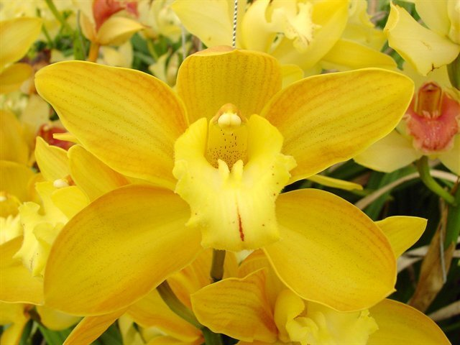
Cymbidium Alnwick Castle
Sussex and Alnwick Castle will respectively lead to Sussex Dawn and Coraki., two highly significant hybrids of the middle period (40’s, 50’s, 60’s) of yellow/orange development.
Sussex Dawn was registered by McBean’s in 1955. It is an offspring of Sussex and Ramboda, a Pearl offspring. This hybrid is prominently featured in the trees of many yellows and oranges as well as other color forms. It typically ranges from cream to greenish cream to brilliant greenish yellow.
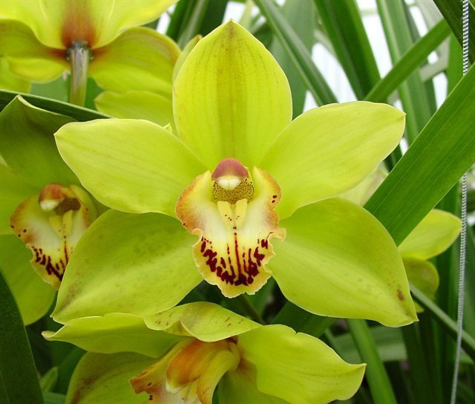
Cymbidium Sussex Dawn.
Sussex and Alnwick Castle will go on to produce Cymbidium Coraki. The cross was made by Wondabah Orchids in NSW, Australia. This is a significant portent of things to come in the yellow breeding lines. Coraki was registered in 1967. Three quarters of its genes are the big three species for yellows: insigne, lowianum and eburneum. Coraki will produce 1,140 progeny including many of the best modern yellows.
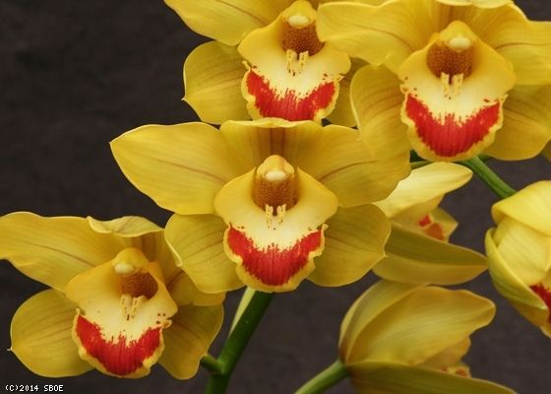
Cymbidium Coraki
The elusive pure yellow Cymbidium was finally created in 1978 by the Rod McLellan Co. in California. Cymbidium Golden Elf has an open form and is a pure lemon yellow. It is a cross between Cymbidium ensifolium and Cymbidium Enid Haupt, an old 1948 hybrid from the Pauwelsii and Eburneo-lowianum lineage. Most of Golden Elf’s progeny are fine yellows and oranges.
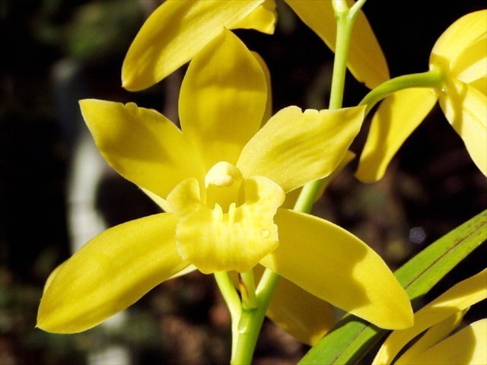
Cymbidium Golden Elf
New Lines
Finally rolling in the 1970’s, three Southeast Asian species started another pathway to achieving great yellows and oranges. Cymbidium suave and Cymbidium madidum from Australia and Cymbidium tigrinum from Burma & Thailand have successfully fostered a new group of yellows.
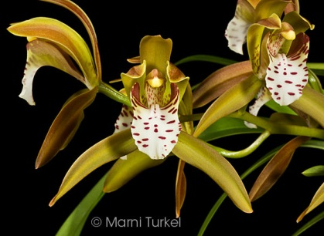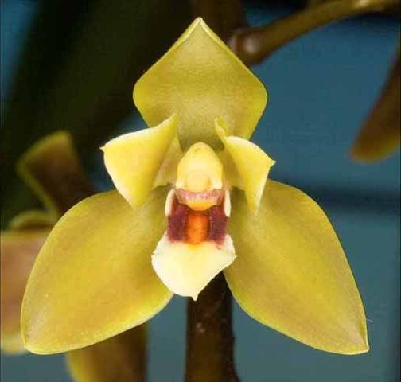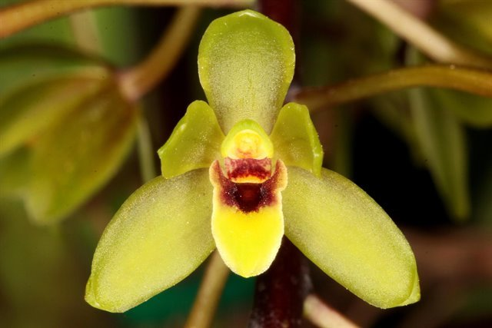
Cymbidium tigrinum Cymbidium madidum Cymbidium suave
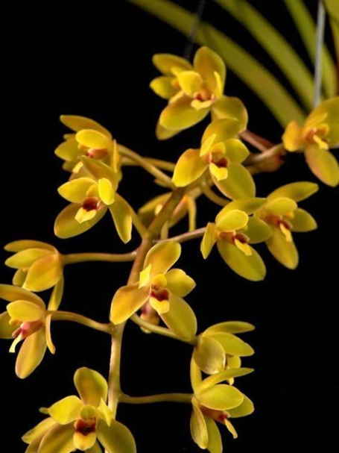
Cymbidium Kuranda AM/AOS
Cymbidium madidum x Cymbidium suave
1972

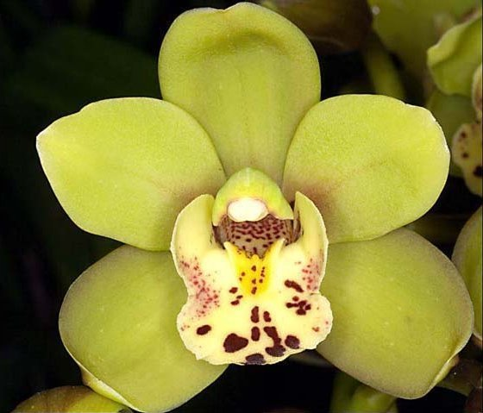
Cymbidium Sunshine Falls AM/AOS
Cymbidium King Arthur x Cymbidium madidum
1972

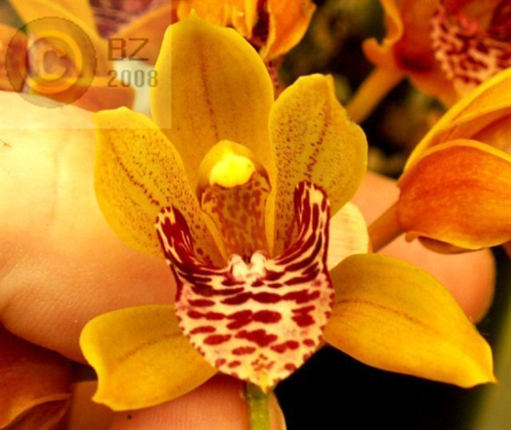
Cymbidium Tiny Tiger AM/AOS
Cymbidium tigrinum x Cymbidium devonianum
1976

These new lines have only been crossed for four generations so far. There is huge potential within these species as well as crosses with the older established species in the older lines. More to come,

