Cymbidium Black Silk HCC/AOS
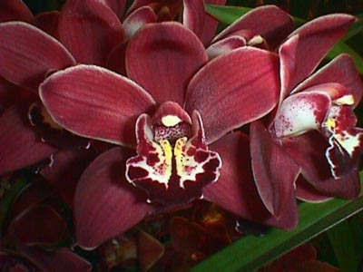
Forty-one flowers and 16 buds on four arching inflorescences; sepals and petals burgundy with narrow white edges, sparsely veined darker burgundy; lip white, distal third dark maroon, wings lighter burgundy, center golden with maroon spots; column white, anther cap burgundy; substance firm, texture matte.

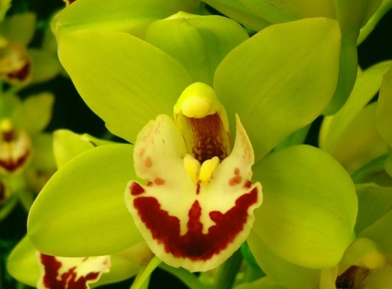
Cymbidium Little Bighorn AM/AOS
Forty seven flowers on two inflorescences; sepals and petals apple-green; lip yellow, burgundy distally and along midline, side lobes faintly spotted burgundy; column speckled maroon, cap yellow; substance medium, texture matte.

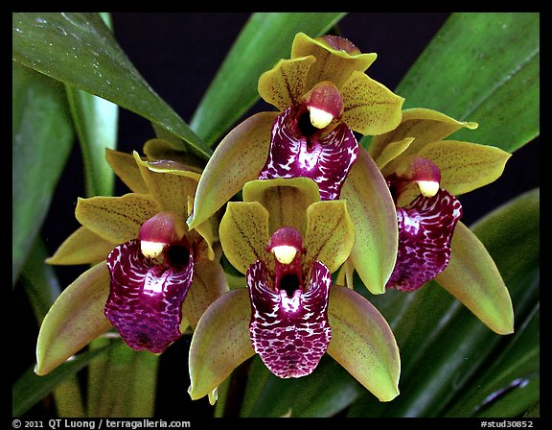
Cymbidium Tiny Tiger CCM/AOS
Two hundred twenty seven flowers and seventeen buds on twenty three cascading inflorescences grown in a 20 cm clay pot; sepals and petals olive green, finely spotted burgundy, lip white, heavily spotted burgundy throughout, callus cream; column yellow, overlaid rose, anther cap cream; substance heavy; texture matte.

Cymbidium Snow Court HCC/AOS
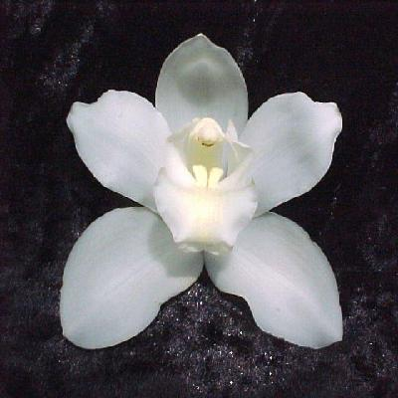
Twenty four pure white flowers well arranged on two inflorescences; sepals and petals white; lip white, blushed yellow centrally, tip reflexed; column white, blushed yellow, anther cap tipped brown; substance light, texture crystalline.

Cymbidium Doris Hirata HCC/AOS
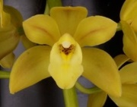
Seventy-five flowers and four buds on four arching inflorescences; sepals yellow, blushed light red; petals yellow, blushed light re along mid-line; lip yellow, throat spotted red; substance firm; texture matte.

